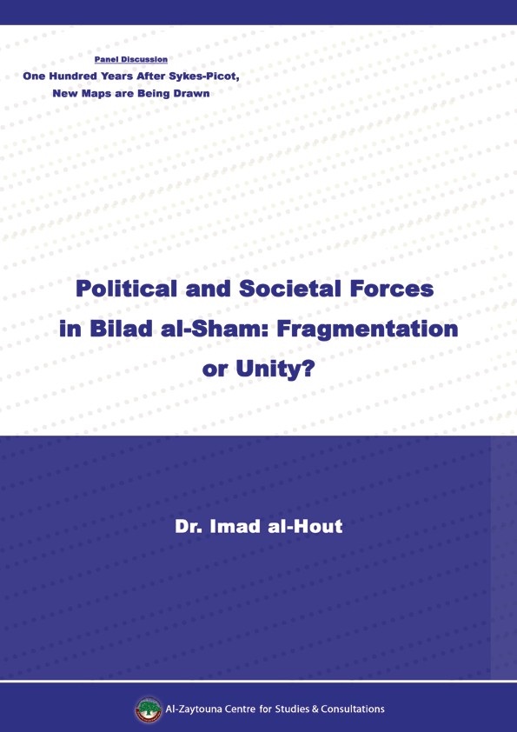
Political and Societal Forces in Bilad al-Sham: Fragmentation or Unity?
Dr. Imad al-Hout

The revolutions of the Arab Spring shook the foundations of the Arab order, which was built on a number of authoritarian regimes. The counter-revolution against the Arab Spring exposed the non-homogenous nature of the social fabric of a number of Arab countries, and the fragile relationship between this social reality and the states themselves.
Today, the political regimes of a number of Middle Eastern countries are being eroded, states are collapsing, and societies are fragmenting. Not long ago, religious, ethnic, and tribal communities coexisted peacefully in social environments that resembled mosaics, mostly under an extremely centralized nation-state.

First: The General Political Climate
In the midst of the chaos that seized the Arab republics starting from the year 2011, new maps for the re-partitioning of the Arab Orient began to emerge, in line with the interests of the rival world powers. The positions of the various stakeholders in Bilad al-Sham region (i.e., Syria, Jordan, Palestine and Lebanon) differed over these schemes as follows:
- Internationally
- On 29/2/2016, the Russian Deputy Foreign Minister Sergei Ryabkov said Syria could become a federal state if that model works in the country.
- Despite the US administration’s public commitment to Syria’s unity and territorial integrity and non-sectarian character, a number of statements hinted at the start of acceptance of partitioning. On 23/2/2016, the US Secretary of State John Kerry spoke about a plan B that could involve a partition of Syria if a planned ceasefire due to start in the next few days does not materialize.
- Regionally
- On 6/3/2016, Turkey’s Prime Minister Ahmet Davutoğlu stressed that Turkey refuses to divide Syria into mini-states.
- On 24/4/2016, Senior Adviser to Ayatollah Khamenei, Major General Yahya Safavi, declared in a statement to reporters on the sidelines of the National Forum of For Geopolitical Developments in West Asia, that Iran is opposed to the division of Iraq, Syria, and Yemen and said that Iran was seeking to shore up security and the survival of the Syrian political regime.
For his part, Secretary of the Expediency Discernment Council of the System in Iran, Mohsen Rezaee, also warned of a US plot to divide Syria, Iraq, Yemen and other countries in the region.
- On 19/2/2015, Jordan’s King ‘Abdullah II warned that any partition of Syria would create dangerous problems for the Syrian people and the whole region, and would produce fragile entities that pose a security and human burden on Syria’s neighbors and may feed dangerous separatist tendencies in the region.
- On 13/2/2016, the Israeli defense minister Moshe Ya‘alon said on the sidelines of a security conference in Munich that his country stated, “Syria as we knew it will not reunite in the foreseeable future,” and added, “At some stage, I imagine we'll see enclaves, whether organized or not, of the various groups that are fighting there.”
- Locally
- On 13/3/2016, the head of the Kurdish National Council Ibrahim Berro said that federalism does not mean the division of Syria, and that the UN Special Envoy to Syria Staffan de Mistura and the foreign ministers of the US, Russia and European countries, stressed the need to establish a federal system in Syria.
- On 17/3/2016, the Syrian National Coalition (SNC) warned against any attempt to form enclaves, cantons, or federal regions, saying the principles of the Syrian revolution were based on the need to end tyranny and establish a civil, democratic, and pluralistic state that preserves the rights of all Syrians of different nationalities, religions, and sects.
Muhannad al-Masri, general commander of Ahrar al-Sham, said the partition of Syria was something categorically rejected, a redline that cannot be accepted, and that the Syrian people will not allow for their country to become federal.
- Bashar al-Assad invoked the idea of a “Useful Syria” to which he retreated, representing 25% of the total surface area of the country, from Damascus to Qalamoun, Homs, Dar‘aa, and Hama, and Tartus, Latakia, and the Turkish border.
- The Islamic State group (ISIS) emerged in 2014 achieving contiguity between Syria and Iraq, breaking up the concept of the nation state in favor of the so-called “Islamic state.”

Second: Division and Partition Scenarios
1. Sectarian-based Partitioning of Syria
The developments of the Syrian rebellion led to sectarian massacres, forcible displacement, and ethnic cleansing that prompted a resurgence of proposals to segregate the parties to these conflicts as follows:
- Establishing an Alawite-Dominated State in the Coast
The precursors of this move were clear through the measures implemented by the regime to consolidate its control along the coastal strip:
- Forming a new Alawite division dubbed the “Coastal Shield.”
- Deploying checkpoints to prevent non-locals from entering coastal governorates.
- Issuing decisions that only natives of Latakia and Tartous may enter the area, unless they own real estates, renting there, or working there.
- Imposing a moratorium on the renewal of rental contracts held by non-Alawites in the towns and villages of the coast under regime control.
- Concurrent fortifications along the strategic hilltops north and east of the Orontes.

- Autonomy for the Kurds in the North
The Kurds account for 12% of the total population of Syria, divided into two groups:
- A group that lives in the major Syrian cities such as Aleppo, Damascus, and Hama, becoming an integral part of the Syrian fabric along with Arab Syrians.
- A group that represents the majority of Kurds in the northeast, in areas like Deir al-Zour, Qamishli, and Hassakeh, isolated from other communities. The area is of major geostrategic importance and holds significant oil and gas reserves.
Kurdish separatist attempts are led by the Kurdistan Workers’ Party (PKK) and the Kurdish Council, with a Russian green light and the blessing of the Syrian regime and the US government, under the pretext that there is a need for a partner on the ground to fight ISIS. The Kurdish People’s Protection Units (YPG) have carried out ethnic cleansing in northeastern Syria against 23 thousand Arab residents, launching a crackdown on their leaders and seizing their properties or destroying their homes in a number of villages in the countryside of Jabal Abdul-Aziz. Their goal: to link their Kurdish cantons in Ain al-Arab (Kobane), Tal al-Abyad, and Afrin. A new constitution was proposed for this entity, along with independent security institutions in an attempt to impose a federal model along the Iraqi model.
- Entrenching a Special Sectarian Status for the Druze in the South
The Druze are caught between the hammer of the regime and the anvil of Jabhet al-Nusra [rebranded Jabhet Fatah al-Sham]. This has prompted Druze leaders to threaten to seek armed support from any external source. In light of the collapse of the regime’s garrisons in Quneitra, Houran, and Sweida, there were reports of a deal concluded in ‘Amman to protect Syria’s Druze in return for their neutrality.
A report published by Chatham House in June 2015 said the Druze were able to convince the regime to exempt “its youth from fighting beyond its immediate territory,” and also managed to neutralize rebel presence in their areas.
2. Scenarios of Territorial Partitioning in Syria
In conjunction with a strategic retreat by the regime to reduce the areas of contact with the rebels and facilitate ISIS control on the areas being evacuated, we can speak of the emergence of fix sectors as follows:
- The “useful Syria” which enjoys Iranian and Russian support, comprising Damascus, Homs, Latakia, and Tartous
- The southern provinces controlled by rebel actions backed by the Military Operations Command (MOC) in Jordan.
- The area around the capital Damascus controlled by rebels led by Jaish al-Islam.
- The eastern region, representing two-thirds of Syria’s surface area, controlled by ISIS.
- The north and northeast of the country under Kurdish self-rule backed by US air cover and European funding.
- The northwest of Syria controlled by rebels led by Jaish al-Fateh, sponsored by Turkey and Qatar.
- The regional division is based on “maintaining the status quo” and preventing any decision in favor of any of the parties to the conflict, by controlling financial resources and arms shipments pending an agreement among regional powers vying to shape the final solution.
3. Lebanese Reality
Lebanon has been turned from a multi-confessional society to a multi-confessional state, where political sectarianism gradually became an entrenched culture in the collective awareness and political practices of its elites, leading to the disruption and paralysis of the state functions and decision-making.
- For the Sunnis in Lebanon, Sunni forces see that the fall of Assad could be conducive to the emergence of a free and viable Lebanon, after years of their victimization and powerlessness vis-à-vis Hezbollah’s military power. Sunni political forces have come a long way since the establishment of Lebanon in the process of accepting the state and integrate in its framework, a tendency that could collapse as Sunnis suspect the Shia forces are seeking to re-define the state unilaterally in their own favor.
- For Hizbullah, the fall of the Assad regime represents a strategic setback, disrupting Iranian supply lines to Hizbullah. This prompted its military intervention in Syria, suppressing dissent within the Shia community by invoking an existential threat to Shia Muslims in Lebanon and the region.
- The Other Religious Sects in Lebanon feel they are trapped between the two major Muslim communities, sensing their vulnerability more than any time in the past, and thus increasingly defining themselves as minorities:
- Christians have returned to the old tendency focusing on self-preservation. Christians in Lebanon have been divided over these existential questions: a section called for allying themselves with armed minorities and fight in the region as part of an alliance of minorities to protect Christians, while another segment wagered on the emergence of a liberal pluralistic project that would preserve their safety, by pledging not to go against the Arab majority, specifically the Sunnis.
- The Druze, who are facing a demographic decline, and have given their conviction that the coming decades will witness fierce infighting, veered towards self-security and neutrality in order to survive as a community.

Third: Obstacles to the Implementation of Sectarian and Territorial Division Projects
- Failure of the historical experience of sectarian cantons imposed by the French using military force.
- Demographic challenges and the intermingling of communities in a way that makes ethnic or sectarian segregation nearly impossible. Regions that contain minorities do not have the ingredients to establish viable independent states or regions.
- The absence of traditional or religious leadership: Unlike Lebanon and Iraq, the minorities in Syria do not have any tribal or political leaders with significant weight inside Syria. This is especially valid for the Alawite community, which the Assad regime has bled demographically and whose tribal leaders have been neutralized through purges and repression.
- Resistance by political elites: Despite the divergence of their ideas and premises, the majority of popular and political and military forces reject these proposals, and call for the restoration of the state and institutions, with the exception of some Kurdish groups.

- Regional opposition:
- Turkey cannot tolerate the existence of independent Kurdish regions on its borders.
- Iraq cannot tolerate a Kurdish entity that represents an extension of the Kurdistan region in Iraq.
- Jordan fears the spillover of Syrian crisis across the border.
- Iran would lose a geopolitical card with the division of Syria.
- The lack of a foreign will and foreign military support to impose partition, unlike the French campaign in 1920 to impose its mandate rule and implement the sectarian cantons scheme.

Conclusion
The projects for partition are fueled by three factors:
- The weakness of the central authority.
- Foreign intervention linked to regional and international projects, including gas supply lines to which Syria is crucial.
- The tendency of the regions to form independent administrations to address security, economic, and social issues resulting from the absence of the state.
Most likely, the idea of partition of Bilad al-Sham remains far off because of a number of factors:
- Demographic overlaps and intermingling in the region.
- The partitioning of any one of these states will pave the way for the partitioning of others, which means further conflict, displacement, and refugee influxes the world cannot afford.
- Lack of a local or regional standard bearer for the idea of partition.
The main challenge for the Syrian rebellion is not just to topple the regime of Bashar al-Assad, but also to restore the national decision by:
- The formation of a unitary motionless mature.
- The emphasis on an inclusive unitary movement.
- The formation of a collective identity.
- The production of a social contract that sets the rhythm of the relationship between the various components of society.
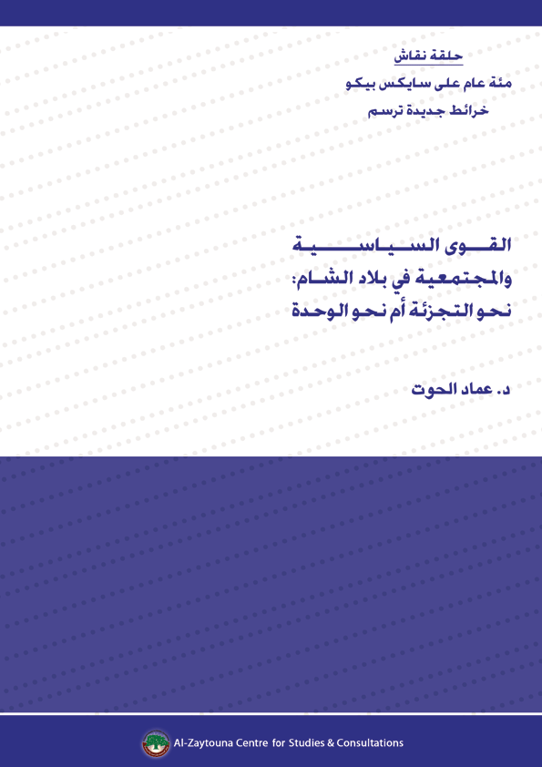

This intervention was introduced in the Panel Discussion: “One Hundred Years After Sykes-Picot, New Maps are Being Drawn,” which was conducted by Al-Zaytouna Centre, in Beirut on 26/5/2016.
Lebanese MP.

