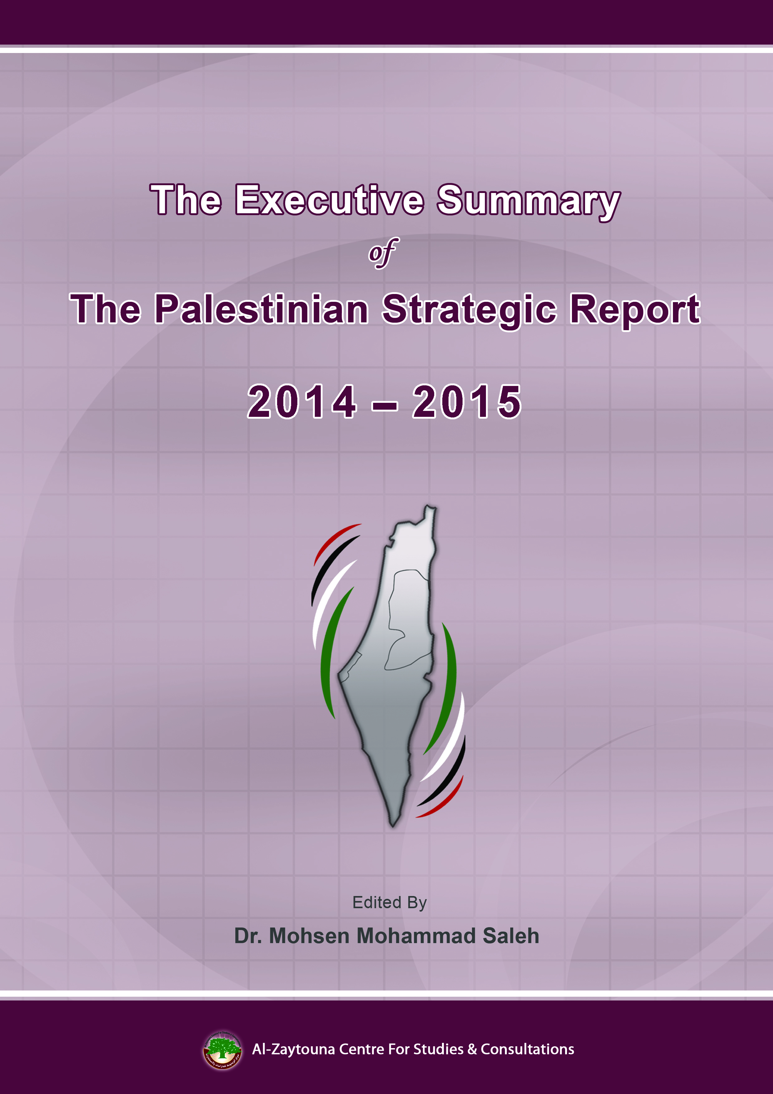

Executive summary: Palestinian Strategic Report 2014–2015
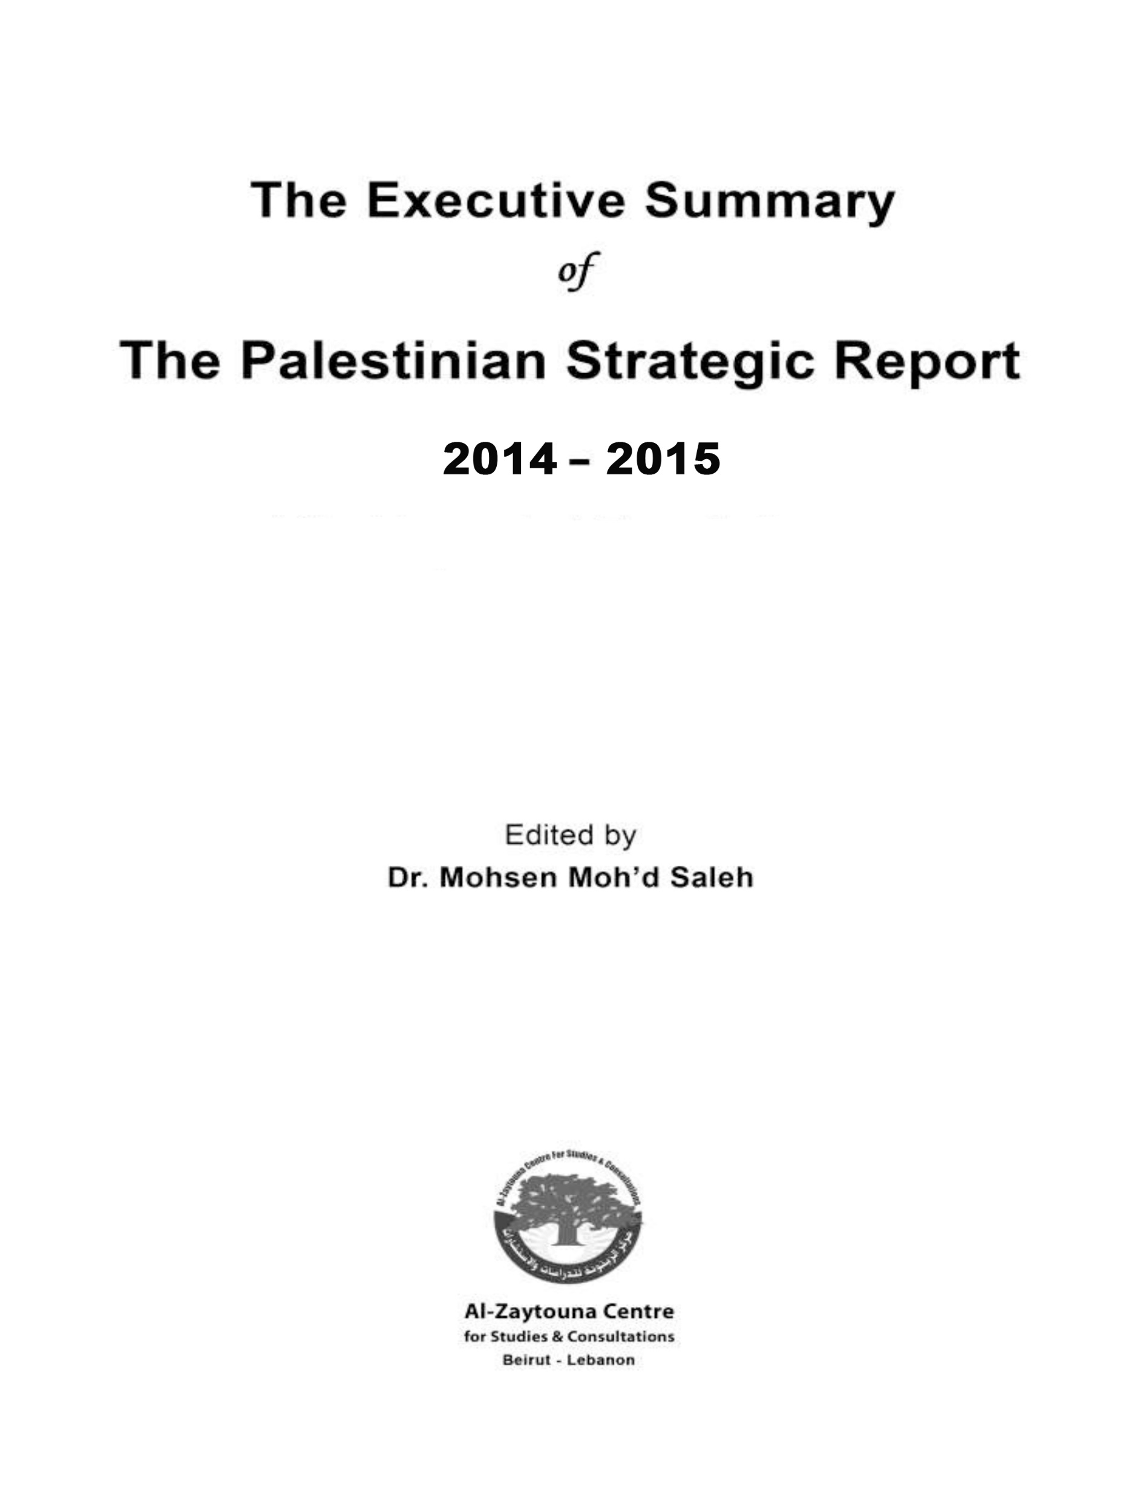
Table of Contents
Introduction ………………………………………………………………………………...5
First: The Palestinian Scene: ……………………………………………………………...6
The Internal Situation …………………………………………………….………...6
Demographic Indicators ……………………………………………………….……8
Economic Indicators in the WB and GS ………………………………………….12
Educational Indicators in the WB and GS ……………...……………………….14
Second: The Aggression, Resistance, and the Peace Process: ………………….……..16
Aggression and Resistance ………………………………………………..………16
The Suffering of Prisoners ………………………………………………..………18
Land and Holy Sites ……………………………………………………………….18
The Peace Process ………………………………………………………………….19
Third: The Israeli Situation: …………………………………………………….……….21
The Internal Situation ………………………………………………….………….21
Demographic Indicators ………………………………………………..………….23
Economic Indicators …………………………………………………….…………25
Military Indicators ………………………………………………………...……….28
Fourth: The Palestinian Issue and the Arab World …………………………...……….29
Fifth: The Palestinian Issue and the Muslim World ………………………..………….32
Sixth: The Palestinian Issue and the International Situation ………………………….35
Seventh: Possible Paths for the Palestinian Issue 2016–2017 ………………………….37

Executive summary
Palestinian Strategic Report 2014–2015

Introduction
The Palestinian Strategic Report is published by al-Zaytouna Centre for Studies and Consultations in Beirut. The center is an independent think-tank focused on strategic studies and forecasts centered on the Palestinian issue. The center relies on an advisory body of senior researchers and experts.
The PSR, edited by Dr. Mohsen Mohammad Saleh (associate professor of Palestinian studies and Zaytouna general manager), tackles, interprets, and analyses the developments of the Palestinian issue in 2014 and 2015, It examines the internal Palestinian situation, Palestinian demographic and economic indicators, the status of the land and holy sites, and discusses Palestinian Arab, Islamic and international relations, as well as the Israeli situation, resistance operations, and the peace process. The report is scientifically documented and supported by dozens of tables, statistics, and charts.
The PSR was authored by a group of specialists, including: Prof. Dr. Ibrahim Hasan Abu Jaber, Dr. Johnny Mansour, Mr. Hasan Ibhais, Mr. Ziad Bheis, Dr. Sa‘id al-Haj, Prof. Dr. Talal ‘Atrissi, Mr. ‘Abdullah ‘Abd al-‘Aziz Najjar, Mr. Mu’min Bseiso, Prof. Dr. Moein Muhammad ‘Atta Ragab, Mr. Hani al-Masri, Mr. Wael Sa‘ad and Prof. Dr. Walid ‘Abd al-Hay.

First: The Palestinian Scene
The Internal Situation
The state of crisis and division continued to be the most prominent feature of the Palestinian internal situation in 2014 and 2015. Despite the many efforts put into achieving reconciliation, implementing it on the ground has been stalled and obstructed. Perhaps the conflict between the two tracks of peace process and armed resistance was a key cause of this. In addition, Israel has the ability to hinder the reconciliation as it is inconsistent with its interests, by blocking the work of the government and elections, and undermining the reform of security forces in the West Bank (WB). Making things more difficult is the mistrust between Fatah and Hamas, and the effect of regional variables and the international climate on the calculations of the two sides in the direction of not rushing to make “concessions” for the sake of the reconciliation pending the emergence of more favourable conditions.
Throughout the period covered by this PSR, Palestinian President Mahmud ‘Abbas failed to invite the provisional leadership framework to convene even once. The PLO (which ‘Abbas chairs along with the Palestinian Authority (PA) and Fatah) did not take any concrete action to accommodate Palestinian factions, especially those that have a significant popular weight such as Hamas and the Palestinian Islamic Jihad (PIJ), into the organization. ‘Abbas did not take any real action either to activate and rehabilitate the PLO. Meanwhile, ‘Abbas’s resignation from its membership in August 2015 and invitation to convene the National Council’s old lineup in the Palestinian interior under occupation was rejected by Hamas, PIJ, and entities in the PLO itself. For one thing, it was seen as an attempt to circumvent the reconciliation agreement, and a ploy to re-form the Executive Committee to be in line with the president’s agenda. As a result, the convening of the council was postponed.
On 23/4/2014, accord was reached between Fatah and Hamas on a roadmap to end the division, known as al-Shati’ Agreement. Hamas voluntarily agreed to hand over control of the Gaza Strip (GS) to a government of national accord. Rami al-Hamadallah, who is close to Fatah, was appointed to head this government, which took over on 2/6/2014. However, this government stumbled and could not discharge its duties in GS, after refusing to instate civil servants appointed by Hamas’s outgoing government in GS led by Haniyyah, and to pay them their salaries. Another issue was the demand on Hamas to hand over control of the crossings (including Rafah) to this government, before the government resolved the issue of the civil servants. Thus, despite sending more than one delegation to GS, the government failed to assume control of GS. At the same time, Hamadallah reshuffled his cabinet without consulting Hamas.
Thus, the relationship between Fatah and Hamas saw many ups and downs, through mistrust and tension dominated. This period also saw accusations by ‘Abbas and Fatah leaders against Hamas of running a “shadow government” in GS and of “war profiteering,” and of seeking to establish an emirate in Sinai and conduct secret talks with Israel in an attempt to secede from Ramallah. Fatah leaders also voiced support for Egyptian measures along the border with GS including the destruction of tunnels. For its part, Hamas strongly denied the accusations, denouncing the smear campaigns against it. Hamas accused ‘Abbas and Fatah leaders of not being serious regarding reconciliation, of seeking to subdue Hamas, and deal with GS as a “remote village,” all while coordinating with Israel and inciting the regime in Egypt against Hamas. ‘Abbas and Fatah leaders were also accused of stalling the reconstruction of GS and efforts to lift the siege.
On the other hand, it conducted internal elections in most of the regions of the WB and abroad, but internal disputes continued. ‘Abbas expelled many supporters of Dahlan, where reconciliation efforts between the two failed, and postponed Fatah’s Seventh Conference in light of these differences.
The Popular Front for the Liberation of Palestine (PFLP) held its seventh conference in early 2014, and elected leadership bodies. Abu Ahmad Fu’ad was elected Deputy Secretary-General, succeeding ‘Abdul Rahim Mallouh. The Democratic Front for the Liberation of Palestine (DFLP) also held its fourth session in February 2014 and issued at the conclusion its national political communique.
The results of an opinion poll conducted by the Palestinian Center for Policy and Survey Research during this period, especially late in 2015, in the WB and GS, showed the extent of polarization in the Palestinian street. Fatah and Hamas each obtained a third of the favourable views, while other factions combined obtained around 10%. ‘Abbas’s popularity was shown to be in decline, with Hamas’s Isma‘il Haniyyah coming ahead in polling on who would win in the presidential election. The polls also reflected increasing frustration with the Oslo Accords; two-thirds of the respondents were in favour of abolishing the accords, and a clear majority supported a return to armed resistance.
The strong steadfastness of the resistance forces against the Israeli assault on GS in the summer of 2014 had a profound impact on the internal situation in Palestine. Resistance forces grew more popular, and Palestinians came together in the negotiations delegation sent to Cairo to discuss the terms of ceasefire. However, this did not prevent ‘Abbas and Fatah leaders from criticizing Hamas for “dragging” GS to war. This is while Hamas and resistance forces criticized the weak performance of the PA in defending GS and for insisting on reining in resistance in the WB in cooperation with the occupation.
Security coordination between security forces in Ramallah and Israeli authorities is one of the most contentious issues in the Palestinian interior. Calls were made repeatedly by Palestinian forces and figures, especially Hamas, PIJ, and the PFLP, to end this coordination. However, ‘Abbas and the leadership of the PA insisted on continuing it, even after a PLO Central Council decision, on 5/3/2015, calling for the end of security coordination and a review of all agreements signed with Israel. ‘Abbas dealt with the decision a non-binding recommendation that cannot implemented without a presidential decree. Israeli security leaders and officials expressed their relief over the conduct of the PA and its coordination with Israel against resistance forces. Perhaps the admission by Majid Faraj, director of Palestinian General Intelligence, of foiling two hundred attacks against Israelis in the first three months of the Intifadah—to widespread Palestinian condemnation—shows the extent of this coordination.
Thus, the Palestinian internal situation carried over its state of crisis into 2016, despite meetings and efforts made in late 2015 and early 2016, which do not seem to have been enough to make a real and final breakthrough that would complete the reconciliation in the near future.

Demographic Indicators
Estimates suggest that the number of Palestinians in the world at the end of 2015 was about 12.366 million people. Half of them, or 6.145 million (49.7%) live in the Diaspora. The other half, 6.221 million (50.3%) live in historic Palestine, divided into: 1.471 million in the territories occupied in 1948 and 4.75 million in the territories occupied in 1967; 2.899 million in WB (61%) and 1.851 million in GS (39%).
In Jordan, the number of Palestinians at the end of 2015 was around 3.758 million, representing around 31.5% of Palestinians in the world (63.3% of Palestinians in the Diaspora), most of whom hold Jordanian nationality. The number of Palestinians in the remainder of the Arab countries was about 1.568 million, representing 12.7% of total number of Palestinians worldwide, most of whom concentrated in neighbouring Arab countries such as Lebanon, Syria, Egypt in addition to the Gulf. The number of Palestinians in foreign countries was about 685 thousand, representing 5.5% of the total number of Palestinians in the world, concentrated in the US, South America, Canada, Britain, and other European countries.

Palestinian Population Worldwide Estimate According to Place of Residence at the End of 2014 & 2015 (thousands)
Place of residence |  | 2014 |  | 2015
 |  | Population estimate | Percentage (%) | Population estimate | Percentage (%)
Palestinian territories occupied in 1967 | WB | 2,826.4 | 23.4 | 2,898.9 | 23.4
 | GS | 1,790 | 14.8 | 1,850.6 | 15
Palestinian territories occupied in 1948 (Israel) |  | 1,462.5 | 12.1 | 1,471.2 | 11.9
Jordan* |  | 3,774.9 | 31.1 | 3,891.9 | 31.5
Other Arab countries |  | 1,566.6 | 13 | 1,567.8 | 12.7
Foreign countries |  | 675.3 | 5.6 | 685.4 | 5.5
Total |  | 12,095.7 | 100 | 12,365.8 | 100
⃰ Concerning the number of Palestinians in Jordan, it has been estimated based on the Palestinian Central Bureau of Statistics (PCBS) 2009 figures, where the number reached 3,240,473, based on annual growth rates published by the Jordanian Department of Statistics (DoS).

Palestinian Population Worldwide Estimate According to Place of Residence at the End of 2015 (%)
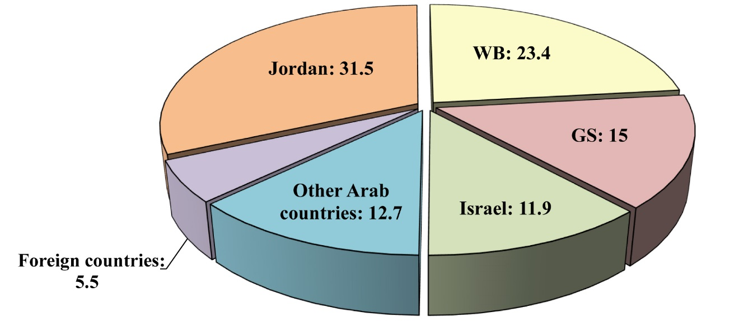

Refugees continue to account for more than two-thirds of Palestinians in the world. In addition to around 6.017 million Palestinian refugees abroad, there are nearly 1.989 million living in the WB and GS, in addition to around 150 thousand expelled from their land but still living in the Palestinian territories occupied in 1948. Thus, the total number of Palestinian refugees is around 8.156 million refugees, or around 67.4% of the total Palestinian population going by the figures of 2014. Meanwhile, the number of Palestinian refugees registered with the United Nations Relief and Works Agency for Palestine Refugees in the Near East (UNRWA) at the end of 2014 was 5.589 million. This while bearing in mind that there are many refugees, who are not registered with UNRWA for not needing its services, or for residing in countries where UNRWA does not operate such as the Gulf, Europe, and the Americas.
Palestinian Refugees Worldwide; Population Estimates in 2014 (thousands)
Country | WB | GS | Israel* | Jordan | Lebanon | Syria | Other Arab countries | Foreign countries | Total
Population estimate | 772 | 1,217 | 150 | 3,645 | 493 | 592 | 612 | 675 | 8,156
* Approximate number.

Palestinian Refugees Worldwide; Population Estimates in 2014 (thousands)
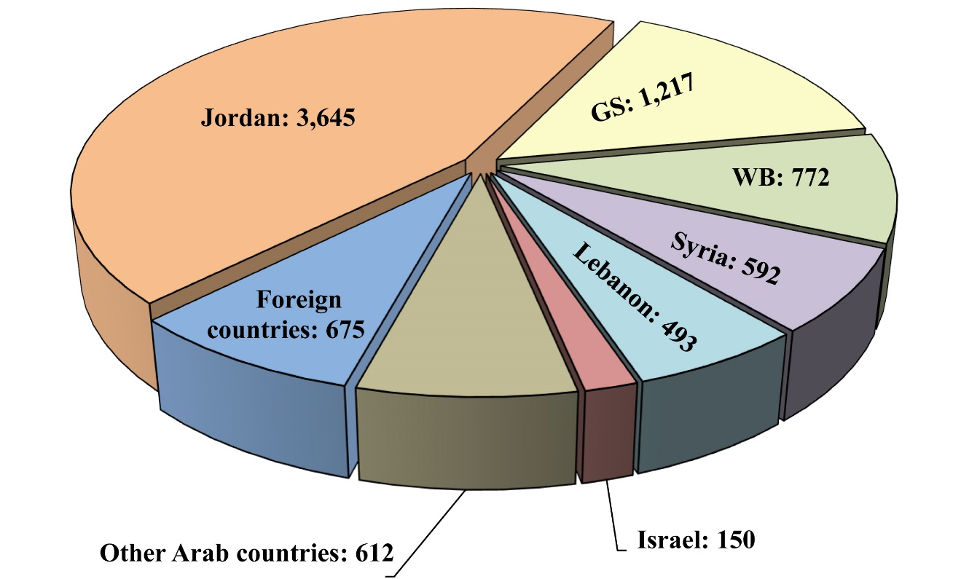

Population growth in the WB and GS in 2015 maintained its previous rate, reaching 2.9% (2.6% in the WB and 3.4% in GS), compared to 2.2% for the Palestinians in the territories occupied in 1948. If the population continues to grow at these rates in the coming few years compared to the Jewish growth rate of 1.9%, the number of Palestinians and Jews in historic Palestine will become equal roughly in early 2018, with Palestinians and Jews both numbering around 6.6 million. The proportion of the Jewish population will be only 49% of the total population in Palestine by 2022 (7.2 million Jews compared to 7.5 million Palestinians).
Estimated Population Count of Palestinians and Jews in Historic Palestine 2015–2020 (thousands)
Year | Palestinians |  |  | Jews
 | WB & GS | Palestinian territories occupied in 1948 (Israel) | Historic Palestine
2015 | 4,750 | 1,471 | 6,221 | 6,336
2016 | 4,887 | 1,504 | 6,391 | 6,456
2017 | 5,029 | 1,537 | 6,566 | 6,579
2018 | 5,175 | 1,570 | 6,745 | 6,704
2019 | 5,325 | 1,605 | 6,930 | 6,831
2020 | 5,479 | 1,640 | 7,120 | 6,961

Estimated Population Count of Palestinians and Jews in Historic Palestine
2015–2020 (thousands)
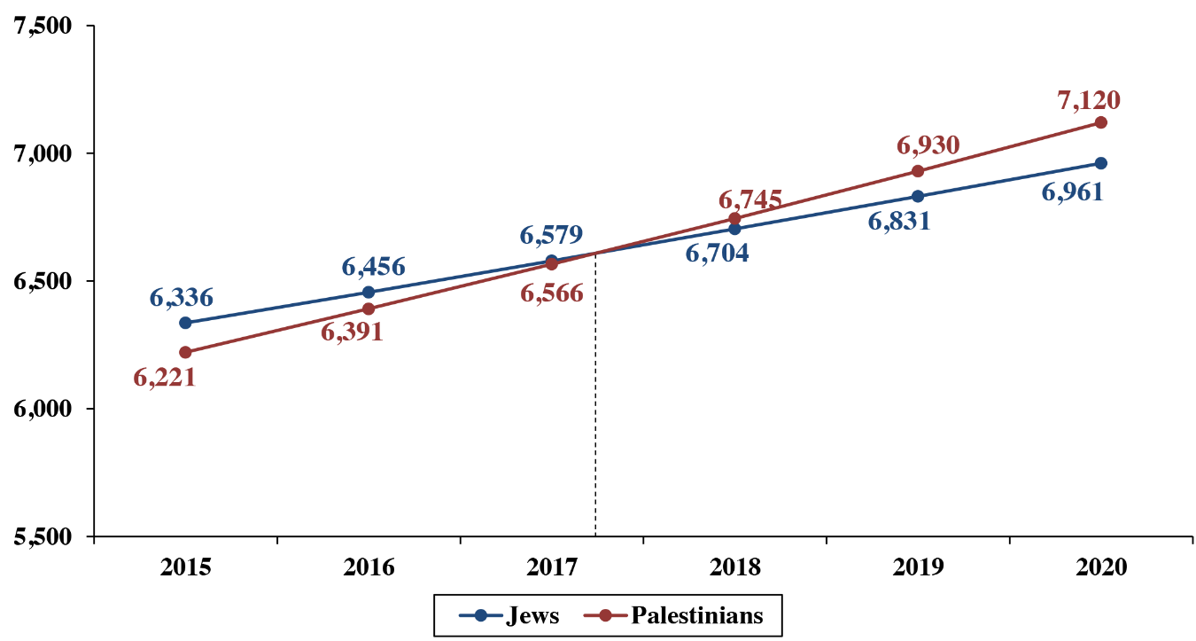
Economic Indicators in the WB and GS
In 2014 and 2015 the status quo continued, the Palestinian economy in the WB and GS continued to be directly dependent on the Israeli economy, while isolated from the Arab countries and outside world, due to Israel’s control of all Palestinian international borders and border crossings, and the concentration of foreign trade with Israel. The trade volume with Israel in 2014 was about $4.749 billion, accounting for nearly 71.7% of the PA’s foreign trade ($6.6269 billion). Imports through Israel were likewise worth around $3.9583 billion, accounting for 69.6% of the PA’s imports of $5.6832 billion. This is while exports through Israel worth $791.5 million accounted for 83.9% of the PA’s total exports worth $943.7 million. This continued to severely hurt the Palestinian economy, and renders the trade balance severely tipped in favour of the occupation. The Palestinian economy also continued to suffer the effects of blockade and the frequent closure of crossings imposed on the GS since 2007.
Economic indicators in the WB and GS show that the Gross Domestic Product (GDP) rose to $15.319 billion in 2014, compared to $14.444 billion in 2013, a 6.1% growth rate, before shrinking to $12.677 billion in 2015 (-17.2%). This underscores the huge difficulties faced by the Palestinian economy. Thus, the GDP remains very low relative to the Israeli GDP, which is about 23 times as high (2,335%) in 2015, and highlights the ugliness of the occupation and its actions against Palestine and its people.
GDP of the PA and Israel 2010–2015 at Current Prices ($ million)
Year | PA | Israel
2010 | 10,855.5 | 234,698
2011 | 12,494.7 | 261,764
2012 | 13,285.4 | 259,614
2013 | 14,444.3 | 292,416
2014 | 15,318.6 | 305,675
2015 | *12,677.4 | 296,068
* Preliminary estimates.

GDP of the PA and Israel 2010–2015 at Current Prices ($ million)
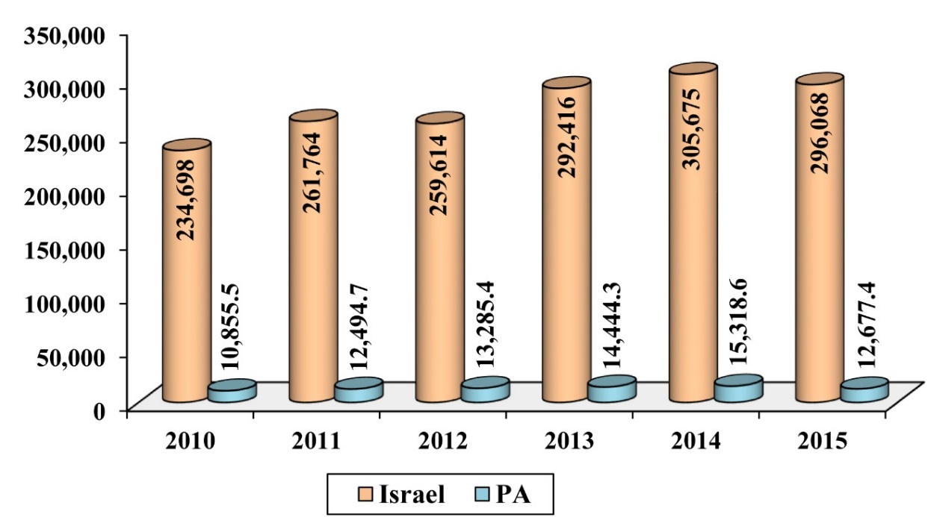
Palestinian GDP per capita (at current prices) was $2,960 and 2,866 in 2014 and 2015 respectively, meaning the figure declined by 1.1% in 2014 and 3.2% in 2015. But the disparity between the WB and GS was clear in this indicator as well, where the per capita income in 2014 amounted to about $3,866 in the WB, compared with about $1,655 in GS, while per capita income in 2015 amounted to about $3,662 in the WB, compared with about $1,727 in GS.
GDP per Capita of the PA and Israel 2010–2015 at Current Prices ($)
Year | PA | Israel
2010 | 2,339 | 30,797
2011 | 2,665 | 33,719
2012 | 2,787 | 32,833
2013 | 2,992 | 36,298
2014 | 2,960 | 37,222
2015 | *2,865.8 | 35,343
* Preliminary estimates.

GDP per Capita of the PA and Israel 2010–2015 at Current Prices ($)
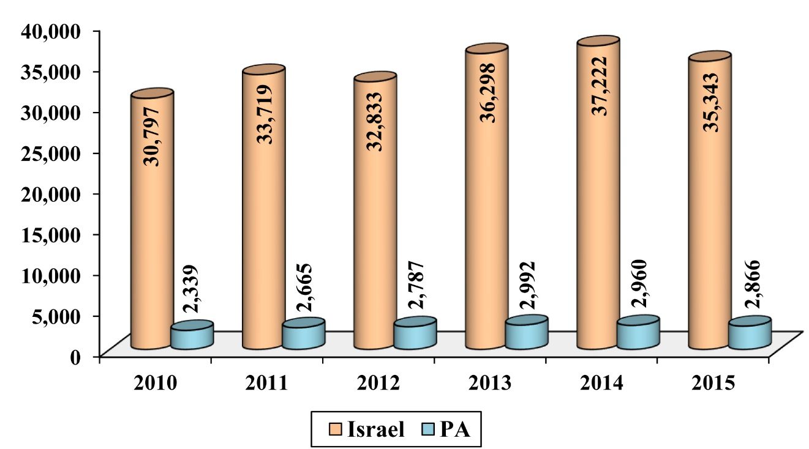
Unemployment in the WB and GS hit 25.8% in 2015, compared to 27% in 2014. This is while bearing in mind that unemployment rates vary between the WB and GS. In 2015, the unemployment rate stood at 38.4% in the Strip, compared with 18.7% in the WB, while in the year 2014, it amounted to 43.9% in the Strip compared to 17.7% in the WB.
PA’s total net revenues in 2015 increased by 3.6% compared to 2014, amounting to about $2.891 billion in 2015, compared to 2.791 billion in 2014. The total public expenditure, including development expenditure, was about $3.621 billion in 2015, compared to $3.607 billion in 2014, an increase of 0.4%. The value of the budget deficit was $20.2 million in 2015, compared to a deficit worth $29.2 million in 2014. The total value of external budgetary support (including external financing for development expenditure) was $797 million in 2015 compared to $1.23 billion in 2014.
Under the Oslo Accords and the Paris Protocol and the Israeli practices aimed at scaling the Palestinian economy, and cementing its subservience to the Israeli occupation, the prospects for real economic growth, or a substantial correction in the course of this growth in the next stage seems unlikely.

Educational Indicators in the WB and GS
Palestinians in the WB and GS are remarkably advanced relative to the Arab world in terms of literacy and education, which reached 96.3% and 96.4% in 2013 and 2014, respectively. Only Qatar comes close to these figures in the Arab world.
The total number of schools that cover basic education (elementary and intermediate) as well as secondary education was 2,856; 2,144 schools in the WB, and 712 schools in the GS, for the academic year 2014/2015. The number of students enrolled in basic and secondary education for the academic year 2014/2015 was 1.172 million: 581,095 male students and 590,501 female students. The number of teachers in these schools was 65,175 in the academic year 2014/2015.
The total number of university students for the academic year 2014/2015 in WB and GS was 132,449; 74,453 students in the WB and 57,996 students in GS—59.6% female and 40.4% male. An-Najah National University in Nablus is the largest of these universities, with 21,859 students in 2014/2015. It is followed by the Al-Aqsa University in GS with 20,081 students, and then Islamic University in GS with 19,432 students.
Number of Students in Traditional Universities in the PA 2014/2015
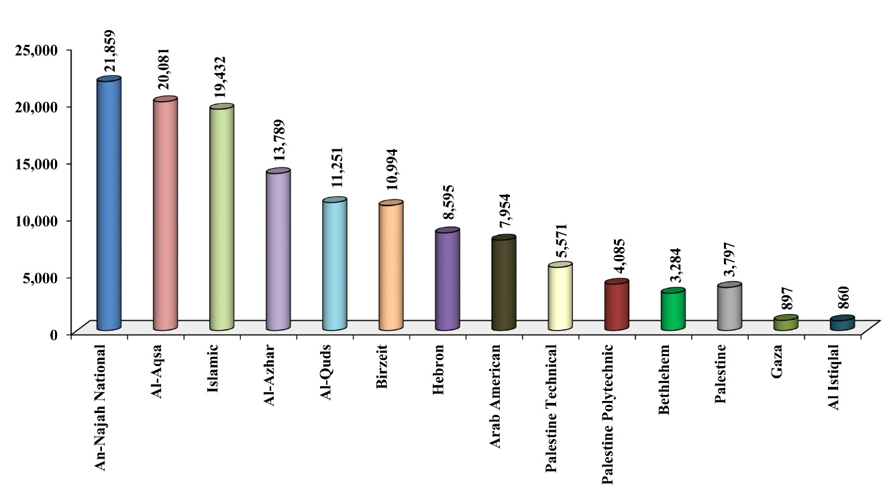
According to figures available to the Ministry of Education and Higher Education, there were 35 universities and community colleges providing education for 28,716 students in the academic year 2014/2015, including 17 college universities attended by 16,446 students which award bachelor's degrees, and 18 community colleges attended by 12,270 students which award intermediate diplomas.

Second: The Aggression, Resistance, and the Peace Process
Aggression and Resistance
In 2014 and 2015, Israel continued its assaults on the Palestinian people. In 2015, 179 Palestinians were killed in the WB and GS, while in 2014, 2,240 were killed. In 2015, 1618 Palestinians were wounded by Israeli operations, while in 2014, 11,449 were wounded.
The high number of casualties in 2014 is due to the Israeli assault on GS, dubbed by Israel Operation Protective Edge and by Palestine Operation Eaten Straw, in the period 7/7/2014–26/8/2014. The strong resistance over 51 days of war has shown how the resistance factions (Hamas in particular) was able to develop its abilities and rocket arsenal, with ranges expanded to about 120 kilometres, effectively reaching all parts of occupied Palestine. The resistance was also able to breach Israeli defences by air, sea, and land, showing new distinguished surprises such as drones…; The GS resistance was able to preserve command and control systems, which Israel could not destroy or disrupt, while the leadership was able to continue running ministries, institutions, and resistance operations effectively. The Israeli side suffered from “intelligence blindness” on the ground, weakening the possible bank of targets hit by Israel. The resistance also mustered broad popular rallying and support, despite the barbaric assaults by Israeli forces on civilian targets.
The fierce Israeli war on GS, in which all means of destruction and death were deployed, killed 2,147 Palestinians and injured 10,870 others, mostly women, children, and elderly people. Around 17 thousand homes were destroyed and 40 thousand others were damaged.
The war on GS was followed by a truce that held throughout 2015, during which only 35 rockets and shells were fired from GS in response to Israeli assaults, compared to 121 rockets and shells in 2014—in addition to the 2,470 rockets and shells launched during the war on GS that year.
The WB witnessed a similar period of calm that lasted until early October 2015, the start of the ongoing popular Palestinian uprising against relentless Israeli assaults on the Palestinian people and their holy sites. Up to 210 Palestinian attacks took place thereafter, killing 24 Israelis and injuring 345 others during the first three months of the uprising, amid increasing levels of security coordination between the PA forces and the Israeli occupation army. The Israel Security Agency—ISA (Shabak) recorded 2,347 attacks in 2015 compared to 1,793 in 2014 in the WB and East Jerusalem. Most of these operations involved stone-throwing and Molotov cocktail attacks. In 2015, the Israeli security agencies recorded the deaths of 29 Israelis as a result of attacks by Palestinians, in addition to 89 others in 2014,while 249 Israelis were injured in 2015, compared to 375 in 2014.

The Killed and Wounded Among Palestinians and Israelis in the WB and GS
2011–2015
Year | Killed |  | Wounded
 | Palestinians | Israelis | Palestinians | Israelis
2011 | 118 | 22 | 554* | 159
2012 | 275 | 10 | 1,966 | 309
2013 | 49 | 6 | 171 | 44
2014 | 2,240 | 89 | 11,449 | 375
2015 | 179 | 29 | 1,618 | 249
* Including international supporters.

Palestinians and Israelis Killed in the WB and GS 2011–2015
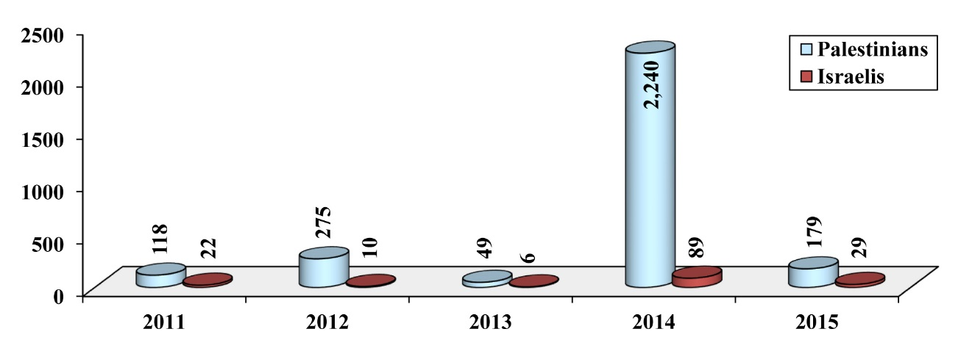

Palestinians and Israelis Wounded in the WB and GS 2011–2015
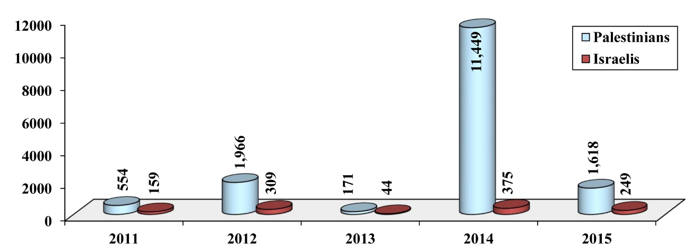

The Suffering of Prisoners
In 2014 and 2015, the suffering of Palestinian prisoners held by Israel continued. The number of Palestinian prisoners in Israeli jails at the end of 2015 was around 6,900, including 55 women and 450 children. The total number of prisoners from the WB was 6,482, including 500 from Jerusalem, in addition to 328 from GS, and 90 Arab citizens of Israel, as well as dozens of Arab detainees of various nationalities. The Palestinian Prisoners Center for Studies noted that Israel detained 6,830 Palestinians in 2015.
The number of administrative detainees held by Israel without charge or trial increased to 650 by the end of 2015, compared to 450 at the end of 2014, and 155 at the end of 2013.

Land and Holy Sites
Israeli assaults on Muslim and Christian holy sites in Jerusalem and historic Palestine continued in 2014 and 2015. Activities of both Israeli government and Jewish religious groups increased towards permanently dividing al-Aqsa Mosque between Muslims and Jews, similar to the arrangement at the Ibrahimi Mosque, reaching a peak in September 2015. This was a direct cause for the eruption of the Jerusalem Intifadah.
The Knesset elections in March 2015 and the ensuing government formed in May 2015, granted the “Temple Mount groups” (which plan to seize al-Aqsa Mosque) greater political influence. These groups obtained eight ministerial portfolios, including the Ministry of Construction and Housing and the Ministry of Jerusalem Affairs. They also obtained a seat in the Israeli micro-cabinet, the greatest political influence they have won in Israel’s history.
The number of excavations in the al-Aqsa Mosque since 2012 remained stabled at 47. In 2014, the Aqsa Foundation for Waqf and Heritage counted 357 assaults carried out by settlers on mosques, churches and monasteries, in addition to counting total or partial damage affecting more than 270 mosques during the war on GS that year (dubbed Operation Protective Edge by Israel and Operation Eaten Straw by Hamas). In 2015, the Project for Monitoring Colonial Activities in Palestine counted 265 assaults on holy sites.
Israeli forces stepped up their restrictions on worshipers at al-Aqsa Mosque, imposing tough measures around it and the old town. For the first time ever, this allowed Israel to limit the number of worshipers at the mosque to levels not seen since the start of the Israeli occupation. Israel also initiated restrictions on women’s entry beginning in September 2015, with a list of one hundred Palestinian women banned from the mosque. In 2014 and 2015, the Mamilla cemetery continued to be gradually appropriated, leaving less than ten percent of its original area intact. Al-Rahma cemetery was closed to burials in September 2015.
In 2014 and 2015 the steady pace of settlement expansion in the occupied WB continued, with 13,537 housing units built in 2014 alone, and 7,262 dunums seized by Israel. In 2015, the Israel issued tenders, approved plans, and issued permits for the construction of 17,376 housing units, seizing a total of 3,670 dunums. Statistics indicate the number of Israeli settlers rose from 240 thousand in 1990 to around 750 thousand in 2015, living in 196 settlements and 232 outposts scattered across the WB and East Jerusalem.
The Israeli occupation authorities also continued demolishing Palestinian homes and expelling residents from homes and public buildings in Area C in the WB (which is under full Israeli military and civilian control) and in East Jerusalem. In 2014, Israel demolished 333 homes, compared to 247 homes in 2015.
Israel continued building the 790-km separation barrier in the WB. More than 60% was completed (474 km), with 10% currently under construction. It continued expanding the “bypass roads,” whose length stood at 770 km at the start of 2015. Also, it continued to hinder the movement of people in the WB through checkpoints, which numbered 514 in early 2015 and 607 by the end of that year.
Meanwhile, the GS remains under a crippling siege, being denied its most basic needs. Development of infrastructure and normal building is blocked, its people are prevented from travelling, fishing is restricted, and all other economic activities are obstructed. Since July 2013 to the end of 2015, the Egyptian regime destroyed nearly two thousand tunnels along the border with GS.

The Peace Process
Israel continued to “manage” rather than “press ahead with” the peace process, preferring temporary solutions and avoiding the discussion of final status issues. At the same time, Israel continued to impose facts on the ground through settlement building, Judaization, and dismemberment of the WB, to prevent the future emergence of a viable Palestinian state.
When the negotiations resumed in the summer of 2013, they lost their momentum a few months later as the Israeli side insisted on continuing with its settlement building, providing no serious visions regarding final status issues, and refusing to release the fourth batch of Palestinian prisoners. For its part, the US administration, regardless of how furious it was by the conduct of Netanyahu and the Israeli government, suspended its efforts on the peace track and continued to provide support and cover for the Israeli side. Since the Israel lobby is very influential in the US, the US administration refused to put any pressure on Israel, and that was also in light of the overall Palestinian, Arab, and Muslim weakness, and US preoccupation with other regional hot issues. In an attempt to fill the vacuum, France made some movements seeking a breakthrough in the peace process through an international conference, but these efforts stalled with Israel, Europe, and the US not responding enthusiastically.
Mahmud ‘Abbas and the PLO leadership insisted on adhering to the peace process, despite the impasse it has reached. Amid the frustration felt by the Palestinian side, Mahmud ‘Abbas threatened to resign, reconsider the relationship with the occupation, suspend security coordination, abolish the Paris economic protocol, withdraw recognition of Israel and go to international organizations to prosecute the occupation. The Israeli side, however, dismissed these as manoeuvers lacking the real will to follow them through.

Third: The Israeli Situation
The Internal Situation
In 2014 and 2015, Israel veered further towards the extremist religious right. Right-wing forces continued to dominate the political landscape, pushing for even more racist laws. Despite its economic growth and military edge; the weakness, disintegration, and preoccupation of the Arab region with conflicts; and a favourable official international climate for the Zionist project, this project continued to carry the seeds of its own crisis within it. Indeed, the Palestinian people have grown in historic Palestine to nearly become half the total population. The Palestinians are more in favour of resistance and uprising. The Arab and Islamic popular climate is hostile to Israel and normalization with it. And the international sentiment continues to be increasingly frustrated with Israel, as a state that conducts itself as if it is above the law.
The political situation in Israel followed the same usual trends, with alliances emerging and others breaking apart, and new parties formed and others fading. With the collapse of the alliance between Likud and Yisrael Beiteinu (Israel Our Home) parties, the Zionist Camp alliance was established between the Labor Party and The Movement (Hatnuah). And with the collapse of the Kadima Party, the Likud-splinter Kulanu (All of Us) party emerged.
Zionist parties in the Knesset raised the threshold for membership from 2% to 3.25% of the vote, with a view to get rid of the Palestinian Arab representation in the Israeli parliament prompting the Arab parties to run for the first time ever on a unified list. The 20th Knesset elections were held on 20/3/2015, after the Israeli coalition government collapsed when Netanyahu sacked Lapid and Livni, leaders of the Yesh Atid (There is a Future) and Hatnuah parties respectively.

Comparing the Outcome of the 20th Knesset Elections with that of the
19th Knesset Elections
List Name | 20th Knesset  2015 | 19th Knesset  2013
Likud | 30 | 31
Yisrael Beitenu | 6
Zionist Camp | 24 | -
Labor | - | 15
The Movement (Hatnuah) | - | 6
Yesh Atid | 11 | 19
Kulanu | 10 | -
The Jewish Home (HaBayit HaYehudi) | 8 | 12
Kadima | - | 2
Shas | 7 | 11
United Torah Judaism (Yahadut Hatorah) | 6 | 7
Meretz | 5 | 6
Joint Arab List | 13 | -
United Arab List | - | 4
Democratic Front for Peace and Equality (Hadash) | - | 4
National Democratic  Assembly | - | 3

The Outcome of the 20th Knesset Elections 2015
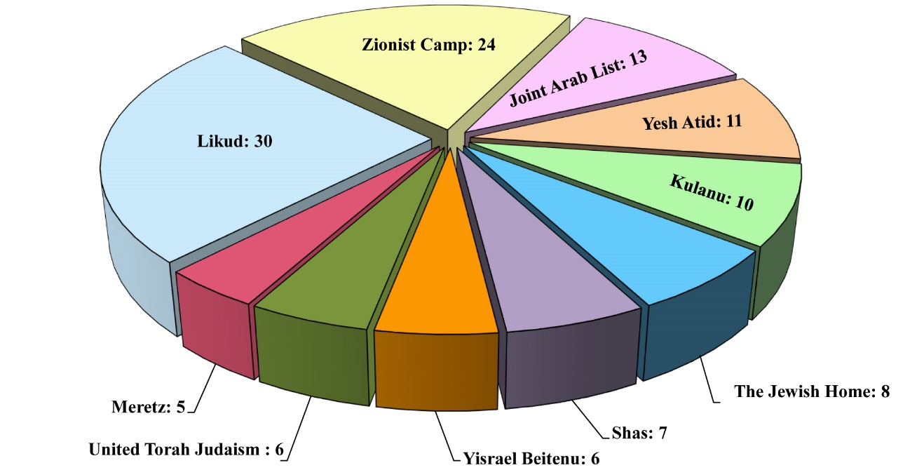

Right-wing parties led by Likud won the elections after which Netanyahu formed Israel’s 34th government, consisting of Likud, Jewish Home, Kulanu, Shas, and United Torah Judaism, winning the support of 61 members in the Knesset.
On the other hand, several racist laws were advanced and passed in the Knesset, all reinforcing the “Jewishness of Israel.” Persecution and harassment of Palestinians living in the 1948 occupied territories increased considerably, most notably the decision to outlaw the Islamic Movement led by Sheikh Ra’id Salah.
In corruption cases, Tel Aviv District Court convicted former Prime Minister Ehud Olmert on counts of bribery and breach of trust. A scandal was exposed involving tax evasion and money laundering, implicating former minister Binyamin Ben-Eliezer. There were also Israeli media reports and news on the scandals of sexual harassment involving politicians, policemen and military officials as well as Jewish clerics—most notably Deputy Prime Minister Silvan Shalom at the end of 2015, which forced him to step down from political life.

Demographic Indicators
In demographic indicators, at the end of 2015, the Central Bureau of Statistics (CBS) estimated the Israeli population to be 8.464 million people, including 6.336 million Jews, 74.9% of the population. As for the Arab population, including residents of East Jerusalem and the Golan Heights, CBS estimated them in 2015 to be 1.757 million, 20.8% of the population. If we remove the number of East Jerusalem residents (approximately 324 thousand) and the Golan Heights (almost 25 thousand), then the number of those who are known as the 1948 Palestinians (i.e., who are living in the Palestinian territories occupied in 1948) becomes 1.41 million in 2015, or about 16.6% of the population.
Population of Israel for Selected Years
Year | Total population | Jews | Arabs (including the population of East Jerusalem and in the Golan Heights) | Others
2009 | 7,552,000 | 5,701,900 | 1,535,800 | 314,300
2012 | 7,984,500 | 5,999,600 | 1,647,200 | 337,700
2014 | 8,296,900 | 6,219,200 | 1,720,300 | 357,400
2015 | 8,463,500 | 6,336,000 | 1,757,400 | 370,100

Population of Israel 2009 & 2014–2015
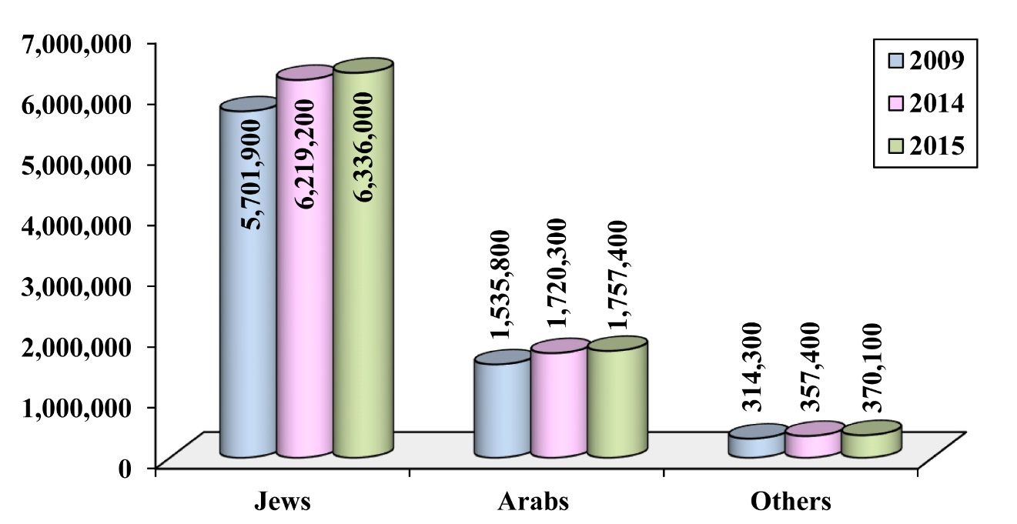

In 2014 and 2015, the population growth rate in Israel was 2%, which is almost the same rate since 2003. During 2015, 27,850 immigrants came to Israel, compared to 16,929 and 24,112 in 2013 and 2014, respectively. These figures show a relative increase in the rate of immigration in the years 2014 and 2015, compared to the ten years that preceded it, but the figure remains low compared to the last decade of the twentieth century. This happened after Israel exhausted Jewish human reservoirs willing to undertake extensive migration, with the remaining Jews abroad living in developed countries in North America and Europe , meaning they have no incentive to migrate on a large scale.
As for the world Jewish population, it was estimated to be 14.213 million at the end of 2013, of whom 83% percent live in the United States (US) and Israel. At the same time, the number of Jews around the world stopped increasing significantly, with the exception of Jews in Israel, as a result of low natural growth rate, opting out of the Jewish religion, and the spread of mixed marriages.
Numbers of Jewish Immigrants to Israel 1990–2015
Year | 1990–1994 | 1995–1999 | 2000-2004 | 2005-2009
No. of immigrants | 609,322 | 346,997 | 182,208 | 86,859

Year | 2010 | 2011 | 2012 | 2013 | 2014 | 2015 | Total
No. of immigrants | 16,635 | 16,893 | 16,560 | 16,929 | 24,112 | 27,850 | 1,344,365

Numbers of Jewish Immigrants to Israel 1991–2015
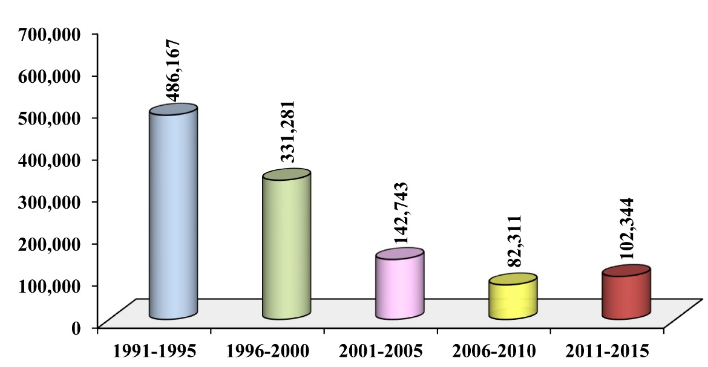
The table shows how the number of Jewish immigrants to Israel evolved over 5-year periods between 1991 and 2015, bearing in mind that 199,516 Jewish immigrants came to Israel in 1990.

Economic Indicators
At the economic level, the Israeli GDP was estimated in 2015 to stand at about 1,150 billion shekels ($296.1 billion), compared to 1,093.7 billion shekels ($305.7 billion) in 2014 and 1,055.8 billion shekels ($292.4 billion) in 2013. According to these estimates, in the local currency, GDP registered 3.6% and 5.2% growth, in 2014 and 2015 respectively, but calculated in US dollars, and because of the Shekel’s value fluctuation against the dollar, we get a different growth rate. The figures come from official Israeli sources.
According to statistics, the Israeli GDP per capita in 2015 amounted to 137,376 shekels ($35,343), compared to 133,178 shekels ($37,222) in 2014.
The total public expenditure of the Israeli government in 2014 was around 446.416 billion shekels ($124.77 billion), while its total public revenues in 2014 were about 416.051 billion shekels ($116.284 billion).
Israeli exports decreased in value in the dollar, by 7.3% in 2015, and Israeli imports fell by 14.2% in 2015, this decline is partly due to a decline in the value of the shekel against the dollar.

Total Israeli Exports and Imports 2012–2015 at Current Prices
($ million)
Year | 2012 | 2013 | 2014 | 2015
Exports | 63,145.3 | 66,788.4 | 68,967.9 | 63,955.4
Imports | 73,121.4 | 72,000.3 | 72,341 | 62,036

The US remained the primary trade partner for Israel. In 2015, US imports of Israeli goods were worth around $18.127 billion (28.3% of total Israeli exports). Israeli imports from the US were worth around $8.8081 billion (13% of total Israeli imports). In the same year, China became Israel’s second largest trading partner, followed by Hong Kong and Britain.
Israeli Exports and Imports to/from Selected Countries 2015 at Current Prices
($ million)
Country | US | China | Hong Kong | UK | Switzerland | Belgium | Germany
Israeli  exports to: | 18,126.8 | 3,245.7 | 5,310.1 | 4,008.5 | 1,496.4 | 2,481.5 | 1,435
Israeli imports from: | 8,080.6 | 5,768 | 2,049.5 | 2,272.4 | 4,425.9 | 3,275 | 3,809.9
Trade | 26,207.4 | 9,013.7 | 7,359.6 | 6,280.9 | 5,922.3 | 5,756.5 | 5,244.9

Country | Netherlands | Turkey | India | Italy | France | Malaysia | Other countries | Total
Israeli exports to: | 2,145 | 1,713.6 | 2,264 | 877.3 | 1,681 | 1,419.5 | 17,751 | 63,955.4
Israeli imports from: | 2,422.3 | 2,446 | 1,881.2 | 2,490.7 | 1,605.2 | 15.3 | 21,494 | 62,036
Trade | 4,567.3 | 4,159.6 | 4,145.2 | 3,368 | 3,286.2 | 1,434.8 | 39,245 | 125,991.4

Israeli Exports to Selected Countries 2015 ($ million)

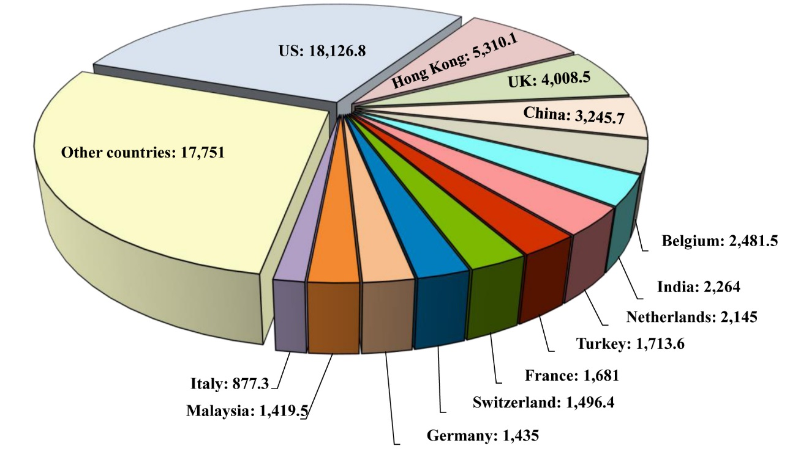

Israeli Imports from Selected Countries 2015 ($ million)
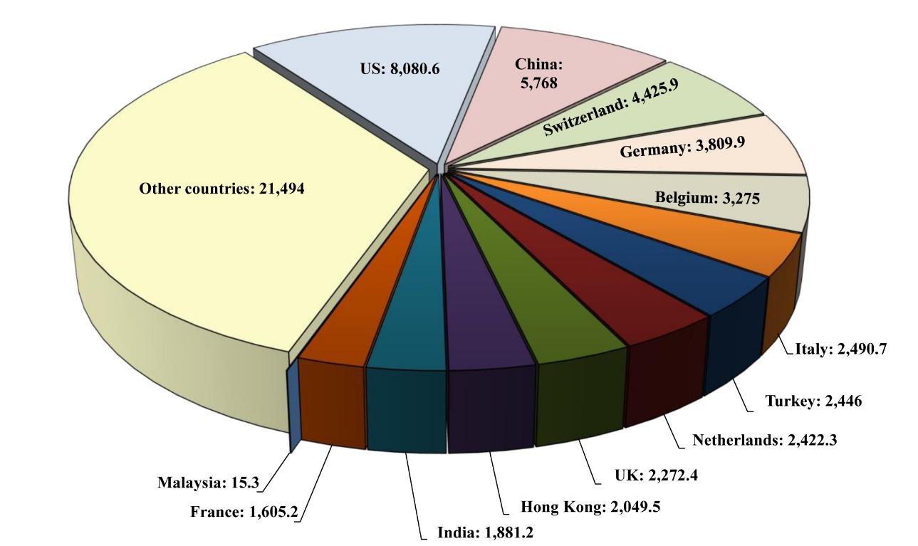

Although Israel is considered a rich and developed country, it still receives annual US aid that in 2015 reached $3.11 billion, including $3.1 billion as a military grant. Between 1949 and 2015, Israel received a total of $124.469 billion.
Military Indicators
A state of anticipation reigned over the Israeli military establishment in 2014 and 2015, on account of the events across the northern border in Syria. As for the southern border, which witnessed the assault on GS in the summer of 2014, Israeli deterrence was still elusive. This coincided with the increasing threat from so-called “global jihadist organizations” and cyberwarfare. The nuclear deal between Tehran and the major powers on 14/7/2015 caused disappointment in Tel Aviv, which strongly criticized it. The Jerusalem Intifadah, in the last quarter of 2015, meanwhile, caused a lot of confusion among Israeli decision-makers, and brought a new challenge to the Israeli army that it had not seen since al-Aqsa Intifadah.
The failures of the Israeli war on GS in the summer of 2014 had a profound effect in the transfers and appointments of the Israeli army staff, affecting the commanders of the key brigades that took part in the ground operations during the assault on GS, such as Paratroopers, Givati, Nahal, Kfir and other Brigades. Israel also continued to develop its anti-missile systems, especially SkyShield, a laser defence system, Arrow missile defence system, Iron Dome air defence system, and Magic Wand weapon system. The official Israeli budget was $15.47 billion in 2015, compared to $16.08 billion in 2014. However, the real value of the military budget is usually much higher than the official figure ($20.32 billion in 2014, for example). The actual 2015 military budget is not known until now. Israeli arms exports, meanwhile, exceeded $5 billion in 2014 and 2015.

Fourth: The Palestinian Issue and the Arab World
The changes and developments in the Arab world during 2014 and 2015, whether the internal situation in Arab countries or their interactions with the Palestinian issue, led to profound changes in the strategic climate surrounding Palestine. Mostly, this climate reinforced Israel’s position in the conflict at the expense of the Palestinians’ and the Arabs’, particularly resistance forces’.
The developments in surrounding countries, especially Syria and Egypt, and the effects of the crises there on Lebanon and GS respectively, are of particular importance. For Israel, the main threats in the south and the north decreased, given the continuation of the war in Syria and the preoccupation of Hizbullah there. On the other hand, Israel restored its strategic ties with the government of Egypt, the Arab world’s strongest military power, securing its southern border and weakening the resistance in GS, which was also hurt by the crisis in Syria.
At the same time, the intensification of the internal conflict between the forces of change and counter-revolution in several Arab countries, which resulted during 2014 and 2015 in a setback the “Arab Spring,” and exacerbated internal crises and regional wars, led to the weakening of Arab strength, which otherwise constituted, or could constitute, a supportive factor for the Palestinian issue. The human, political and economic toll caused by conflicts in the Arab countries, in addition to the social rift, mean that the region will be preoccupied for many years with recovery from the effects of these conflicts.
In addition, these conflicts occupied a high position in the list of priorities at the expense of the Palestinian issue, as they practically are re-forming the geopolitical map of the region and re-distributing influence among the key regional and international powers in the region, as is clear in the Syrian crisis.
This turning point is the biggest threat to the Palestinian issue at present. The forces hostile to Palestine and the nation are trying to rearrange alliances based on a new definition of priorities and threats, in a way that suggests the Arab-Israeli conflict is no longer the central cause in the region, replaced by the Arab-Iranian or Sunni-Shia conflict.
The Egyptian changes in 2014 and 2015 led to a return to Egypt’s traditional policy prior to the January 25 revolution, which sees that the peace process with Israel is the key pillar of its strategy in the region. This led to the return of stable and improved Egyptian-Israeli relations, and of the support to the PA in Ramallah against its internal rival Hamas, amid worsening relations between Egypt’s regime and the Muslim Brothers (MB) movement, and amid accusations that Hamas is supporting MB movement in the internal Egyptian crisis.
At the same time, security deterioration in the Sinai led to the return of a security-based approach to GS as a perceived threat to Egyptian national security. The Egyptian army thus escalated its campaign against tunnels to GS, as accusations grew against Hamas and GS of destabilising the peninsula. The Rafah crossing was opened for 21 days only in 2015.
The most stable country among Israel’s surrounding ones, Jordan, was a key battleground against Israeli efforts to alter the religious and cultural identity of Jerusalem, especially al-Aqsa Mosque, in 2014 and 2015. This applies to both the official and popular levels in Jordan, whose public opinion was the most responsive in condemning Israeli attacks on GS in 2014 and in supporting the Jerusalem Intifadah to refuse the attempts to divide al-Aqsa Mosque.
As for Syria, the continuation of the crisis was a major drain for the Palestinian issue due to many considerations, most notably the preoccupation of Arab and Islamic forces in other battles. Priorities of the region thus changed and resources are drained, with the exception of those of Israel, which benefited from the collapse of all prospects for the emergence of a strong political entity representing the aspirations of people and capable of confronting Israel on the northern front.
Concerning the normalization with Israel, the latter did not make any new breakthroughs in establishing new relations with the Arab countries. Israel maintained stable relations with Jordan and Egypt in particular. Trade between Israel and its leading three Arab economic partners (Jordan, Egypt, and Morocco) grew by 20% in 2014 and 2015 compared to 2013 (see table below).
However, it should be noted here that Israel’s accession to the club of energy-exporting countries would increase the strategic importance of its relations with Egypt and Jordan, given the two countries’ growing need for stable energy sources. Agreements to purchase Israeli gas signed with Jordanian and Egyptian companies in 2014 and 2015 are particularly relevant in this context.
Israeli Exports and Imports to/from Some Arab Countries 2014–2015
($ million)
 | Country | Israeli exports to: |  |  | Israeli imports from:
 |  | 2015 | 2014 |  | 2015 | 2014
Egypt |  | 113.1 | 147.9 | 54.6 |  | 58.3
Jordan |  | 99.5 | 107.8 | 410.5 |  | 378.1
Morocco |  | 23 | 10.6 | 15.6 |  | 6.6

Israeli Exports to Some Arab Countries 2014–2015 ($ million)
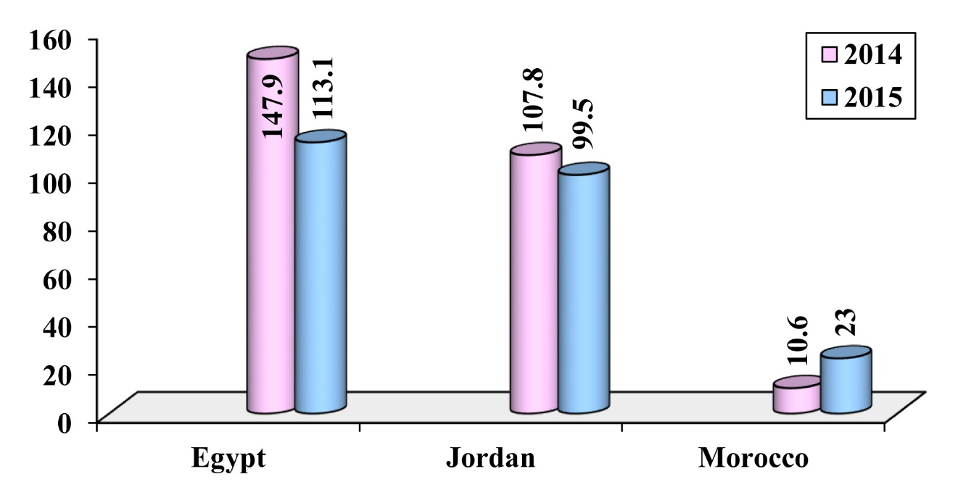

Israeli Imports from Some Arab Countries 2014–2015 ($ million)
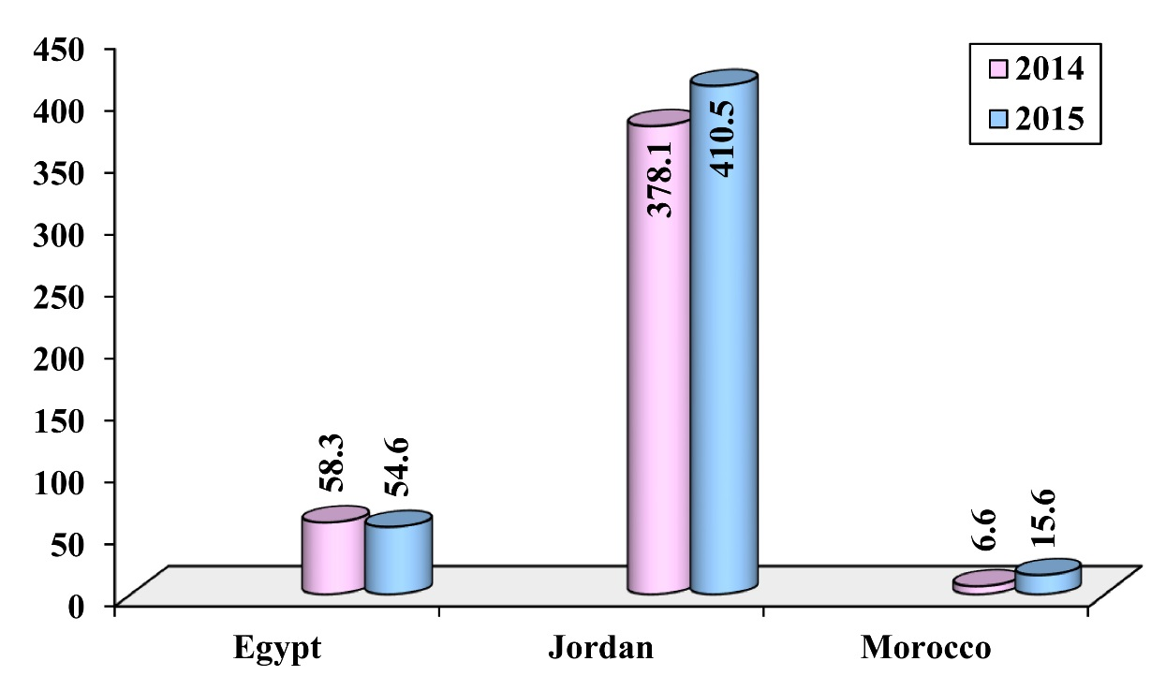

Fifth: The Palestinian Issue and the Muslim World
The repercussions of the Arab revolutions and counter-revolutions in the region, and the state of flux and unrest, also affected the attention afforded by the Muslim nations to the Palestinian issue in 2014 and 2015. Muslim countries like Iran and Turkey were preoccupied heavily with the geopolitical transformations taking place in the region.
The Organization of Islamic Cooperation (OIC) continued its traditional positions and statements during 2014–2015, which did not seem to have left a significant impact on the Palestinian issue. Nor does it appear that the OIC, as an official institution, is able to bypass the policies of the sponsoring states, which reveals the organization's inability to influence the traditional approach to the major Islamic issues.
Turkey was preoccupied with regional files, especially the Syrian file, and with internal issues such as elections, and a wave of military and security escalation with the Kurdistan Workers’ Party (PKK). However, it has been keen to maintain solid relations with the PLO leadership and the PA on the one hand, and the Islamic resistance movement Hamas, on the other. Official Palestinian-Turkish relations grew during 2014–2015 and there was cooperation in the international arena, built on the advanced Turkish role in the acceptance of Palestine to the United Nations (UN) as a non-member observer state. Also, Turkey maintained its relationship with Hamas, with some scaling back in the protocol and media framework. Hamas politburo chief Khalid Mish‘al made several visits to Turkey, where he met with senior officials.
At the level of Turkish–Israeli relations, the official diplomatic estrangement continued during the years 2014 and 2015. Political and media rhetoric between the two sides saw some contradictory phases, first of all with extreme tension, mudslinging, and incitement, continuing until mid-2015. Then calm followed with talk of possible reconciliation between the two sides. However, Turkey continues to insist on lifting the blockade on GS as a condition to normalize relations.
Iran continued its emphasis on fixed positions in refusing to recognize Israel, calling for the liberation of all of Palestine, and support for the Palestinian resistance. Iran supported the accession of Palestine to the UN, and also stressed that the signing of the nuclear deal will not weaken its stance on supporting the issue of Palestine. There was a joint effort to restore the warm relationship between Iran and Hamas with two Hamas delegations visiting Iran. The statements made by the two sides showed their keenness to maintain these relationships and to develop them, though disagreement over the position vis-à-vis the revolution and the crisis in Syria, and over the approach pursued by Iran to regional issues, still cast a negative shadow on the relationship.
The trade between most Muslim countries and Israel continued, whereas there was a fluctuation of trade volume between Turkey and Israel between 2014 and 2015. For in 2014 it rose by 11% compared to 2013, before it dropped by 23.5% in 2015 relative to 2014.
Israeli Exports and Imports to/from a Number of Non-Arab Muslim
Countries 2014–2015 ($ million)
Country | Israeli exports to: |  | Israeli imports from:
 | 2015 | 2014 | 2015 | 2014
Turkey | 1,713.6 | 2,755.6 | 2,446 | 2,683.6
Malaysia | 1.419.5 | 1,375.7 | 15.3 | 52
Nigeria | 113.2 | 96.9 | 2.9 | 1.4
Azerbaijan | 129.7 | 185 | 2.4 | 1.1
Kazakhstan | 59.7 | 114.3 | 1.6 | 3.9
Indonesia | 95.5 | 27.1 | 52.2 | 68.7

Israeli Exports to a Number of Non-Arab Muslim Countries 2014–2015
($ million)
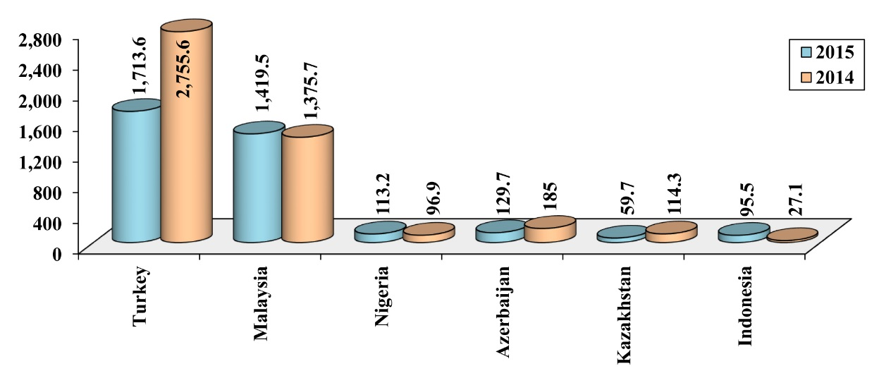

Israeli Imports from a Number of Non-Arab Muslim Countries 2014–2015
($ million)
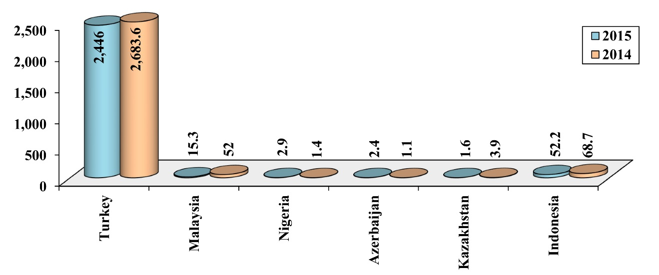

Sixth: The Palestinian Issue and the International Situation
During the years 2014 – 2015, the world was occupied with major events in the region; revolutions, changes, conflicts, and attempts to draw new maps. This caused a declining interest in the Palestinian issue, and to dealing with it in a limited way and in accordance with emerging developments and events.
The influence of the Quartet on the Middle East (UN, European Union, US and Russia) declined on the peace process during 2014 and 2015. Its effective activities completely stopped in 2014, and it only issued four statements in 2015.
The fact that the US turned its attention to other international issues, which it regarded as more urgent caused a major decline in the diplomatic efforts towards the Palestinian issue. Although the US generally abides by its traditional policies in this regard, but it is interesting to note that its public official pledges increasingly lacked credibility. It seemed that the US administration backed off of the political process between Israel and the Palestinians, especially in light of its inability (or unwillingness) to pressure the extreme right-wing Israeli government. That is, the American vision was based on dragging the Palestinians to surrender and to let the Israelis set the realities on ground. That is why Foreign Minister John Kerry’s rounds were not fruitful in regards to the reconciliation process, despite the fact that he met with President ‘Abbas 42 times, in addition to hundreds of phone calls.
The US administration continued to provide a cover for the aggressive Israeli activities, including the war on GS in summer of 2014, supporting it in confronting the Jerusalem Intifadah, condemning attacks against settlers, and pushing the PA in Ramallah to help stop these attacks. Regarding al-Aqsa Mosque, the US state department was committed to using a dual phrase: “al-Haram al-Sharif/The Temple Mount,” and that is a dangerous indicator, signifying that the location is now being officially considered a “joined property.”
In general, the core of the European stand did not differ from the American one during 2014 and 2015, but with a larger margin for criticizing Israeli practices while supporting the establishment of a Palestinian state, but without bypassing the US, because that is related to political channels. In 2015, the European Commission took a decision to label goods produced in Israeli settlements in the WB, East Jerusalem, and the occupied Golan Heights. Regarding the GS aggression in summer of 2014, the European Commission called for halting the fighting and condemning the shooting of rockets from GS into Israeli settlements, acknowledging Israel’s right to defend itself, and the necessity to consider the economic and social needs of GS residents. Regarding the Jerusalem Intifadah, the EU called both parties to contain the violence harming civilians and in relating the surge of violence to the lack of any possible political solution. As for the executive aspect of the European action regarding progress in the reconciliation process, symbolic acknowledgements in the parliaments began in 2014, lastly in the Greek parliament in late 2015. The parliaments of nine European countries acknowledged Palestine.
During the two summits of July 2014 and July 2015, the BRICS countries, which include China, Russia, India, Brazil, and South Africa, confirmed the commonalities regarding the Palestinian issue, such as confirming the importance of resolving the Arab-Israeli conflict based on international references and the Arab Peace Initiative. The group called for resuming the negotiations, based on two-state solution and the creation of a viable and connected Palestinian state, living peacefully side by side with Israel, with mutually acknowledged borders (based on the 1967 borders), and East Jerusalem as its capital. The group opposed Jewish settlement in the occupied territories of 1967. It called upon donor countries that participated in the Cairo Conference on Reconstructing GS to fulfil its pledges of offering support for this sake.
When following the UN activities, its known positions in most matters regarding the Palestinian issue continued during 2014 and 2015. However, the “relative” change was obvious in the resolution of the UN General Assembly on 11/9/2015 for agreeing to raise the Palestine flag in its New York HQ. The General Assembly renewed its resolutions for supporting the refugees’ right to return, and the Palestinian people’s right to decide their own fate and to have sovereignty on their natural resources. It also confirmed the illegitimacy of Jewish settlement in the occupied territories of 1967.
The UN resolutions (the General Assembly) supporting the Palestinian rights increased in 2014, reaching 145 countries, compared to 142 in 2013. Meanwhile, those opposing Palestinian rights were 6 to 7 countries, most of which are small states such as the Marshall Islands, Micronesia, Palau, and Nauru Islands. The US was a stable supporter, and Canada voted in favour of Israel again.

Seventh: Possible Paths for the Palestinian Issue 2016–2017
When studying the overall paths of the Palestinian issue and its future directions, it does not seem that there will be any major detours in the coming two years. That is, it seems that most of the crises will continue in the near future.
There is no genuine solution for the internal Palestinian schism problem and for ending the PA’s crises. This applies to the problem of reunifying the PA institutionally or geographically, reforming its security forces, its functional role or its economic crises. Further to that, it does not seem that there is clear PLO readiness to reconstruct the organization or to reactivate its institutions, especially regarding the acceptance of actual strong partners, such as Hamas. The fundamental difference between the resistance path and the reconciliation path, the disagreement regarding the priorities, and the lack of trust, will make the schism continue. It will to be “managed” rather than “resolved,” pending the occurrence of better circumstances that will be in favour of one side, which will eventually force all or most of its conditions on the other side.
It is expected that the Israeli society will become more extreme and will push for the formation of extreme right governments and for the adoption of more racist policies and the expansion of the settlements and the Judaization programs. Therefore, it seems that the peace process will blocked in the near future.
It seems that the Arab region surrounding Palestine will continue with the “liquidity” condition, and the formation and reformation processes. The conflict will most likely not stop any time soon; between people who want to get their freedom and revival, corrupt and authoritarian regimes, and external interventions that seek their own interests. Meanwhile, there are attempts to exhaust and weaken the nation with additional sectarian and ethnic fragmentations. Therefore, it will be difficult for the region to recover anytime soon in order to be able to stand up for Palestine, while the world will continue to be occupied with priorities and pressing local issues.
As for the Muslim countries, especially Turkey and Iran, they are not expected to be less involved in regional matters. Therefore, its declining action regarding the Palestinian issue, which is not considered now a top priority, will continue in the same path in the near future. This greatly applies to the international scene, where the US will continue to dominate with its pro-Israel policies. It will continue in attempting to weaken the Arab and Muslim communities surrounding occupied Palestine, despite the increasing negative sentiments opposing Israel in the international scene, and the increasing disapproval of Israel’s status as a state above the law.
On the other hand, the strong GS steadfastness during the Israeli aggression and siege, and the 2015 Jerusalem Intifadah, have confirmed the Palestinians’ ability to be resilient, to invent new means of resistance, and to redirect the campus towards Palestine. In addition to this, regional conditions indicate that unification and resurrection are near. These require time to rise to the scene and will be pushed by the decay and turmoil of the corrupt and authoritarian regimes. However, pioneers of this project must learn from the experiences of previous years and must resolve the dysfunction that caused the stalling of the uprisings and movements in the region. This will help create positive and expansive horizons for the Palestinian issue.

