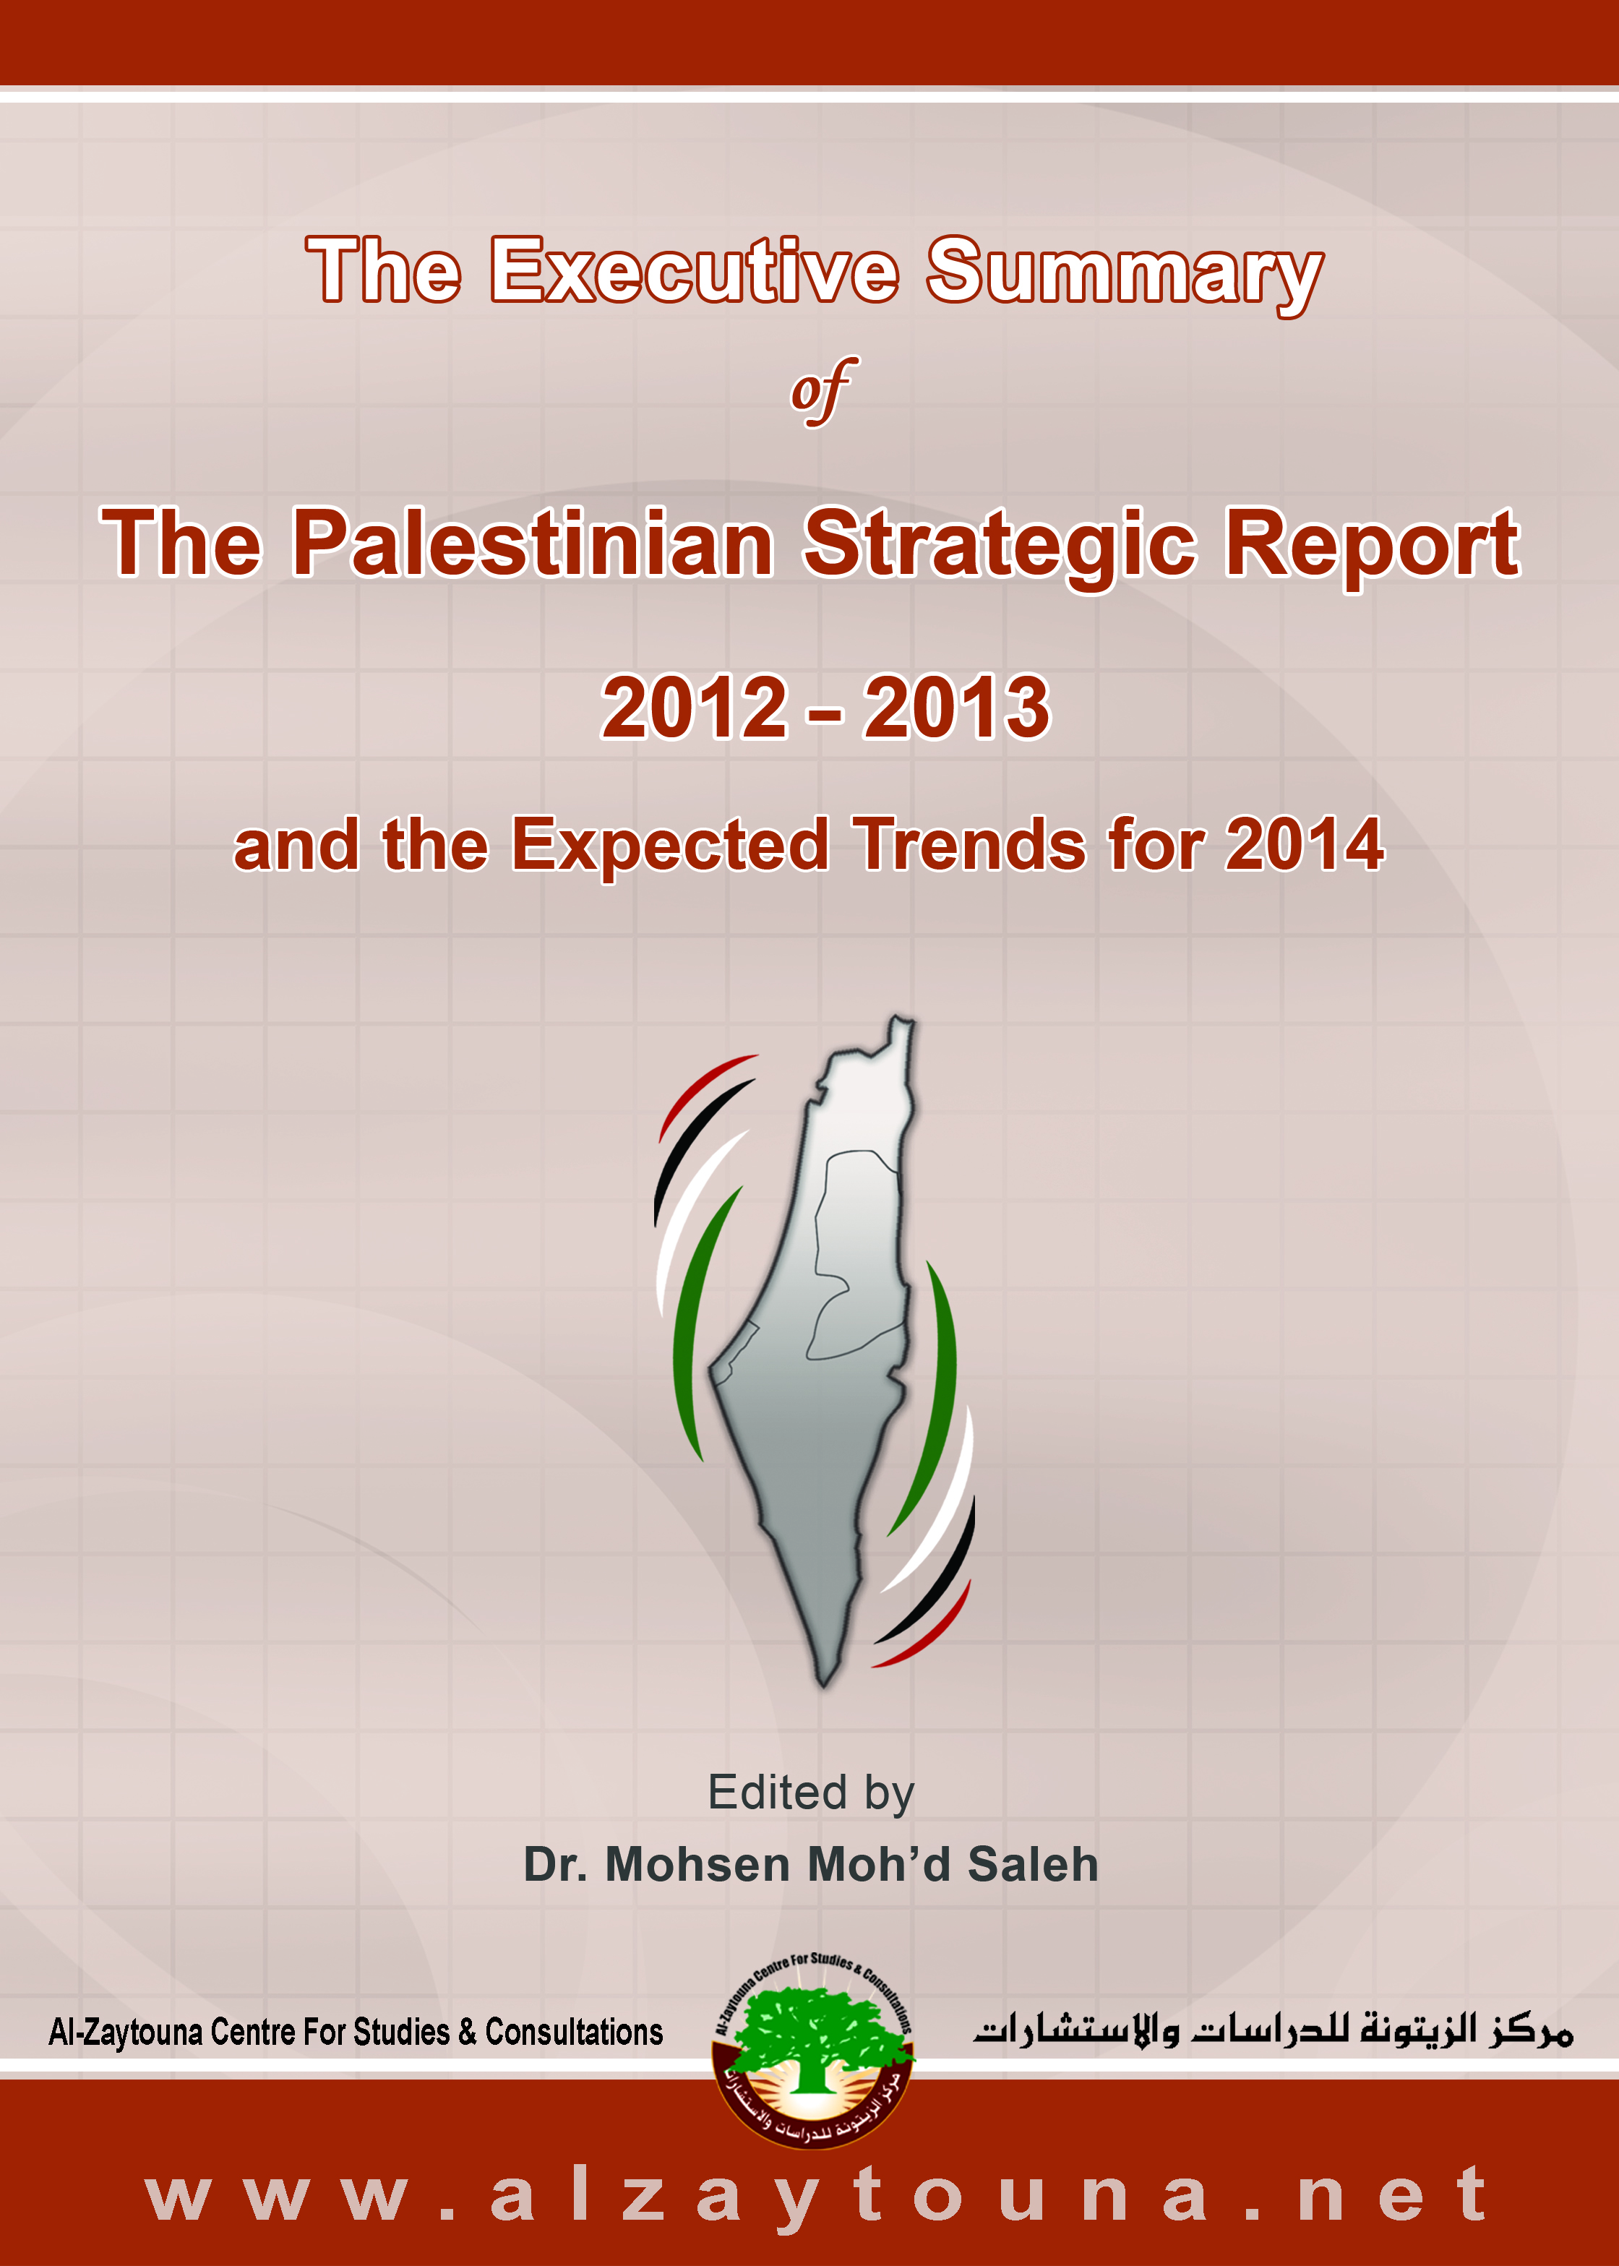

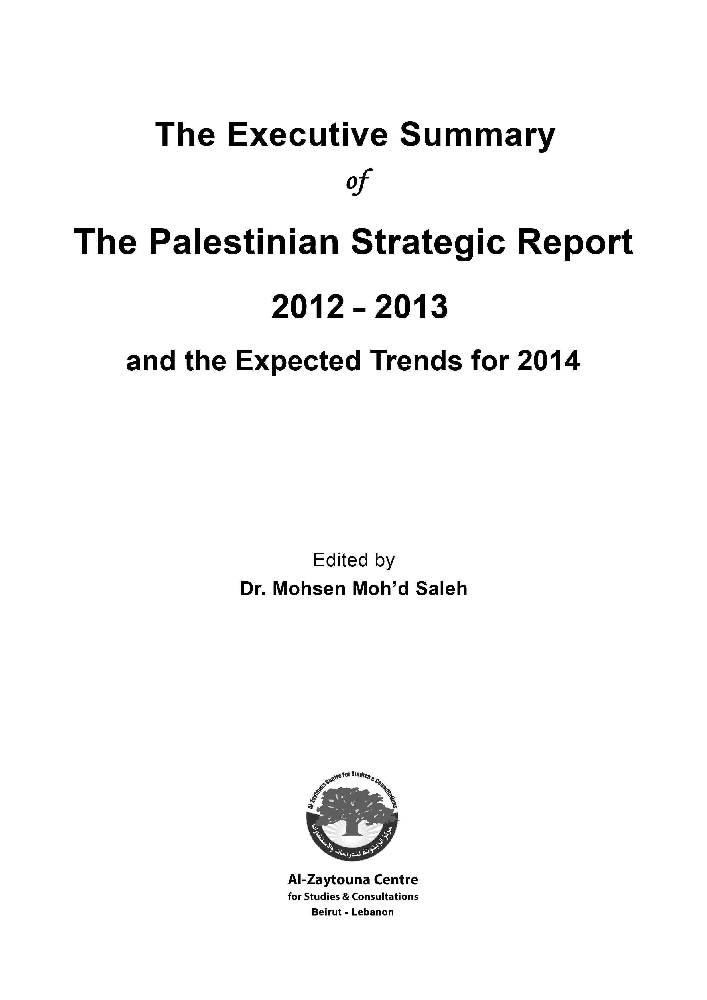

The Executive Summary
of
The Palestinian Strategic Report
2012–2013
and the Expected Trends for 2014

Publication Information
Title: Al-Taqrir al-Istratiji al-Filastini 2012–2013 (The Palestinian Strategic Report 2012–2013)
Edited by: Dr. Mohsen Moh’d Saleh
Published in: 2014 (1st edition)
Hardcover: 360 pp, 18.5*26 cm
Price: $22

Introduction
The Palestinian Strategic Report (PSR) is published by al-Zaytouna Centre for Studies and Consultations in Beirut. Al-Zaytouna is an independent studies center, which conducts strategic studies that attempt to anticipate future trends, with a particular focus on the Palestinian issue. The Centre has a board of consultants consisting of eminent researchers and experts.
The PSR, edited by Dr. Mohsen Moh’d Saleh (Associate Professor and the General Manager of the Centre), monitors and analyzes the Palestinian issue and its developments during 2012 and 2013. It sheds light on the internal Palestinian scene, Palestinian demographic and economic indicators, as well as looking at the land and holy sites. The Report discusses Palestinian relations at the Arab, Islamic and international levels, and provides an overview of the Israeli situation, resistance operations, and the peace process. The Report is rich with scientifically documented content and includes dozens of supporting tables, statistics, and illustrations.
The PSR was authored by a group of specialists, including: Dr. ‘Abdul-Hameed al-Kayyali, Mr. ‘Abdullah ‘Abd al-‘Aziz Najjar, Mr. Hani al-Masri, Mr. Hasan Ibhais, Prof. Dr. Ibrahim Hassan Abu Jabir, Dr. Johnny Mansour, Prof. Dr. Moein Muhammad ‘Atta Ragab, Mr. Mu’min Bsiso, Mr. Muhammad Zahid Gül, Prof. Dr. Talal ‘Atrissi, Mr. Wael Sa‘ad, and Prof. Dr. Walid ‘Abd al-Hay, Mr. Ziad Bhies.

First: The Internal Palestinian Scene
The internal Palestinian scene in 2012 and 2013 was characteristically complex and rife with many overlapping issues. The fundamental crisis arising from the Palestinian division dominated the Palestinian scene, with continued failure to implement the reconciliation program and to reform Palestinian institutions. The crisis over the inability to decide on specific directions and ambitions for national action continued, with continuing with the peace process or reverting to armed resistance being the two primary options.
The Israeli occupation in the West Bank (WB) and the blockade of the Gaza Strip (GS), in addition to the presence of two diametrically opposed administrations in Ramallah and Gaza City, continued to adversely affect national action in the Palestinian territories occupied in 1967. Furthermore, the failure of the Palestine Liberation Organization (PLO) to accommodate all the components and forces of the Palestinian people, and its inability to revive its institutions and the role of the Palestinians inside and outside Palestine, meant that the decline of the PLO was such that it effectively became a department of the Palestinian Authority (PA), which was in turn subordinate to the occupation and its conditions. This squandered the energy of the Palestinian people, while Israel pressed ahead with its Judaization plans and settlement building, altering the facts on the ground.
On 6/2/2012, Khalid Mish‘al, head of Hamas’s political bureau, signed the Doha Agreement with President ‘Abbas under the personal sponsorship of the Emir of Qatar. The agreement required the formation of a national consensus government headed by President ‘Abbas, and the reactivation of the leadership framework of the PLO. However, ‘Abbas did not form, or was not able to form, a national consensus government over the next two years. Bilateral dialogues that took place under the auspices of Egypt until the middle of 2013 did not lead to the implementation of the agreement either, amid mutual accusations between the two parties over the failure to reconcile.
The revolutions and changes that swept the Arab world had an impact on the internal situation in Palestine. Between 2012 and 2013 (especially the first 18 months), the pro-resistance forces, especially Islamists, wagered on the success of these uprisings and the rise of “political Islam.” However, the military coup and subsequent ban on Hamas in Egypt, and the crippling blockade on GS, cast a negative shadow (even if a short-term one) on the Palestinian Islamist movement. This reality was further entrenched with the expansion in the scope of attacks against Islamist movements in the countries that saw uprisings or regime change, and even in those countries that anticipated such events. Some were prompted by the desire not to rush the process of Palestinian reconciliation, except in line with conditions that would see Hamas contained as the weaker party. However, the peace process, which hit a dead end, and the structural, political, and economic crises of the PA, compelled the Palestinians to ultimately return to the path of reconciliation.
In 2012 and 2013, the emergency government in the WB continued its work under Salam Fayyad. However, the sharp objections and criticisms made by Fatah’s leadership against Fayyad, and Fayyad’s attempt to exploit his post, relationships, and financial and administrative influence, to create a clique of supporters, prompted ‘Abbas to accept his resignation on 14/4/2013, and appoint Rami Hamadallah as his replacement. In GS, the government of Isma‘il Haniyyah continued to face a large number of challenges, most notably the economic challenge as a result of the blockade imposed on the GS, along with Israeli military aggression. There were also accusations exchanged with the Ramallah government of increasing the suffering of the Strip, and of smearing Hamas. In the second half of 2013, Haniyyah’s government took a number of initiatives towards Palestinian reconciliation, which received a response from the Fatah leadership; an agreement was thus reached to reactivate reconciliation plans on 23/4/2014.
In 2012, local elections were held in the WB. The Central Elections Commission in the WB endorsed the election results where the turnout was 55%. Due to the boycott by resistance factions led by Hamas, the local elections were lackluster and half-hearted, given that there was no serious competition. Despite Fatah winning in most municipalities, the election ended up highlighting the internal splits within Fatah, as figures and lists dismissed from Fatah won, for example in the city of Nablus.
The internal situation within Fatah was marked by disputes, especially between the faction loyal to President ‘Abbas and the faction loyal to Muhammad Dahlan, who was dismissed from Fatah. Dahlan, backed by the United Arab Emirates and the new Egyptian regime that followed the ouster of President Morsi, and helped by his continued influence within Fatah, supported his sustained his attacks on ‘Abbas. However, ‘Abbas responded with a fierce campaign in the media. ‘Abbas and Dahlan also exchanged accusations over responsibility for Yasir ‘Arafat’s death, as investigations by Swiss experts suggested he might have been poisoned with radioactive polonium.
In 2012 and 2013, Hamas proceeded to rearrange its internal affairs, and held internal elections. In early 2012, Mish‘al said he did not intend to run for another term as head of Hamas’s political bureau, but under internal pressure, he backed down. On 2/4/2013, Hamas announced in an official statement that the Shura Council had renewed its vote of confidence in Mish‘al for another term.
The PA remained committed to security coordination with Israel throughout 2012 and 2013. This not only hurt the resistance forces, and relations among Palestinians, but also created deep cracks in the psychological and social fabric of the Palestinians. Hamas published a statement accusing the PA’s security forces of carrying out 1,262 assaults on its supporters in the WB in 2012 and 1,613 assaults in 2013.
Meanwhile, the Independent Commission for Human Rights noted that the number of complaints lodged with it, involving violations of the right to fair legal procedure, specifically in relation to arbitrary arrest and detention on political grounds, totaled 789 in 2012 in the WB and the GS; 563 complaints in the former and 226 complaints in the latter.
Overcoming the internal Palestinian crisis requires a serious stand to determine the course and priorities of national action, agree on the Palestinian fundamentals, and settle questions related to the paths of the peace process and resistance, as well as the role and future direction of the PA, confidence-building programs, and including all factions in the national project; otherwise, reconciliation programs will continue to carry the seeds of crisis and failure within them.

Second: The Israeli-Palestinian Scene
In 2012, Israeli society had plenty reasons to worry, as a result of the rapid changes and revolutions in the Arab world, the resistance’s success in repelling Israeli aggression in GS, and the setbacks in the peace process. But in 2013, Israeli society had an equal number of reasons to be reassured, as a result of the frustration that followed the Arab revolutions, the successful coup in Egypt, the resumption of the peace process according to Israeli conditions, and stalled Palestinian reconciliation.
The results of the 19th Knesset elections in early 2013 showed Israel lurching further to the right in favor of extremist pro-settlement policies. The alliance between Likud and Yisrael Beiteinu (Israel Our Home) won only 31 seats out of 120, but still came out on top. The alliance was able to form a government, though its share of seats declined compared to the previous election, when the two parties had won a total of 42 seats separately. The rightwing pro-settlement faction within Likud led by Moshe Feiglin received a boost in the election, while the extremist settler party Jewish Home won 12 seats. A new party affiliated to the center right, Yesh Atid, led by Yair Lapid, won 19 seats. For its part, the Kadima Party suffered a major defeat, with its share of the seats declining from 28 to 2 seats, while Arab parties retained their seats. Netanyahu went on to form a rightwing pro-settler government, but without the participation of the Haredi parties (ultraorthodox religious parties). The new government acted in a way that further thwarted plans for peaceful settlement, and also passed a new law for military and civil service, something that the Haredi parties strongly rejected.
At the end of October 2013, local and municipal elections were held amid indifference among the Israeli public, of whom only 35% showed up, while 75% of Palestinians took part in the vote, as these elections are important for the status of Arab family and clans. The elections showed a decline in the influence of Arab political parties in favor of clans and families in local municipal affairs. The members of local authorities affiliated to political parties was under 9%. Meanwhile the Democratic Front for Peace and Equality suffered a dramatic setback in most municipalities that participated in the elections, particularly in the city of Nazareth.
On 11/3/2014, the Knesset passed a law raising the electoral threshold from 2% to 3.25% of the total votes cast, to get rid of small parties and political lists. This adversely affects the Arab parties represented in the Knesset, most of which will therefore be eliminated from the Israeli parliamentary process, rendering the Knesset a purely “Jewish parliament.” On the other hand, Arab Palestinians at the end of 2013 were able to thwart the Praver Plan to relocate the Negev Bedouins and seize their lands.
The next two years, 2014–2015, are expected to witness conflicts within the government between Likud, Israel Our Home, and Yesh Atid in particular, with regard to the socio-economic situation. The social fracture may also widen after compulsory military service was extended to the Haredim.
Comparing the Outcome of the 19th Knesset Elections with that of the 18th Knesset Elections
List Name | 19th Knesset  2013 | 18th Knesset  2009
Likud | 31 | 27
Yisrael Beitenu | 31 | 15
Yesh Atid | 19 | –
Labor | 15 | 13
The Jewish Home (HaBayit HaYehudi) | 12 | 3
Kadima | 2 | 28
Shas | 11 | 11
United Torah Judaism (Yahadut Hatorah) | 7 | 5
The Movement (Hatnua) | 6 | –
Meretz | 6 | 3
United Arab List | 4 | 4
Democratic Front for Peace and Equality (Hadash) | 4 | 4
National Democratic Assembly | 3 | 3
National Union (HaIhud HaLeumi) | – | 4

The Outcome of the 19th Knesset Elections 2013
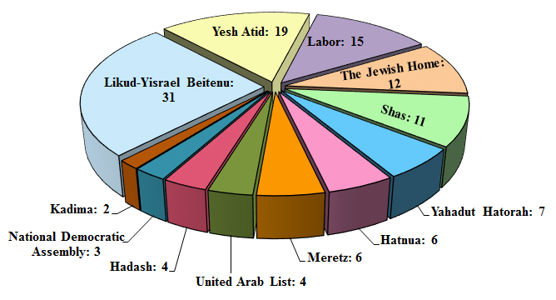
In demographic indicators, the Israeli Central Bureau of Statistics estimated the Israeli population at the end of 2013 at 8.134 million, of whom 6.102 million were Jewish, representing 75% of the population. The Arab population, including residents of East Jerusalem and the Golan Heights, was estimated in 2013 at 1.683 million, representing 20.7% of the population. If we took out the number of residents of East Jerusalem (308 thousand) and the Golan Heights (25 thousand), the number of the 1948 Palestinians (i.e., the Palestinian regions occupied in 1948) changes to 1.35 million in 2013, or about 16.6% of the population.
Population of Israel for Selected Years
Year | Total population | Jews | Arabs (including the population of East Jerusalem and in the Golan Heights) | Others
2007 | 7,243,600 | 5,478,200 | 1,450,000 | 315,400
2010 | 7,695,100 | 5,802,400 | 1,573,100 | 319,600
2012 | 7,984,500 | 5,999,600 | 1,647,200 | 337,700
2013 | 8,134,300 | 6,102,100 | 1,683,200 | 349,000

Population of Israel 2007 & 2012–2013
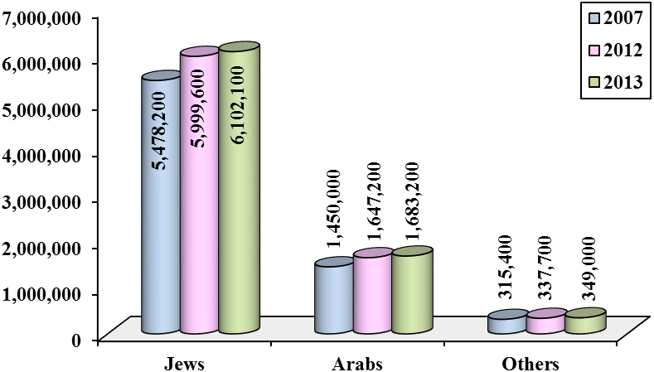
In 2012 and 2013, the rate of population growth in Israel was 1.9%, more or less the same rate that has existed since 2003. In 2013, 16,882 immigrants came to Israel, compared to 16,558 and 16,893 in 2012 and 2011 respectively. The figures for these years are consistent with the declining curve of Jewish immigration since 2000, with the exhaustion of large pools of Jewish communities willing to immigrate en masse, and the concentration of the remainder of world Jewry in North America and Europe, where Jews do not have strong incentives to immigrate to Israel to start new lives. The number of Israelis who had permanent residence outside Israel was 500–750 thousand.
The population of Jews in the world reached 13.885 million in 2012, 82.6% of whom lived in the United States (US) and Israel. The growth of the world Jewish population continued to flat line with the exception of the Jewish population in Israel, as a result of the low rate of natural growth, people leaving the Jewish faith, and the spread of mixed marriages.
Numbers of Jewish Immigrants to Israel 1990–2013
Year | 1990–1994 | 1995–1999 | 2000-2004 | 2005-2009
No. of immigrants | 609,322 | 346,997 | 182,208 | 86,858

Year | 2010 | 2011 | 2012 | 2013 | Total
No. of immigrants | 16,634 | 16,893 | 16,558 | 16,882 | 1,292,352

Numbers of Jewish Immigrants to Israel 1990–2013
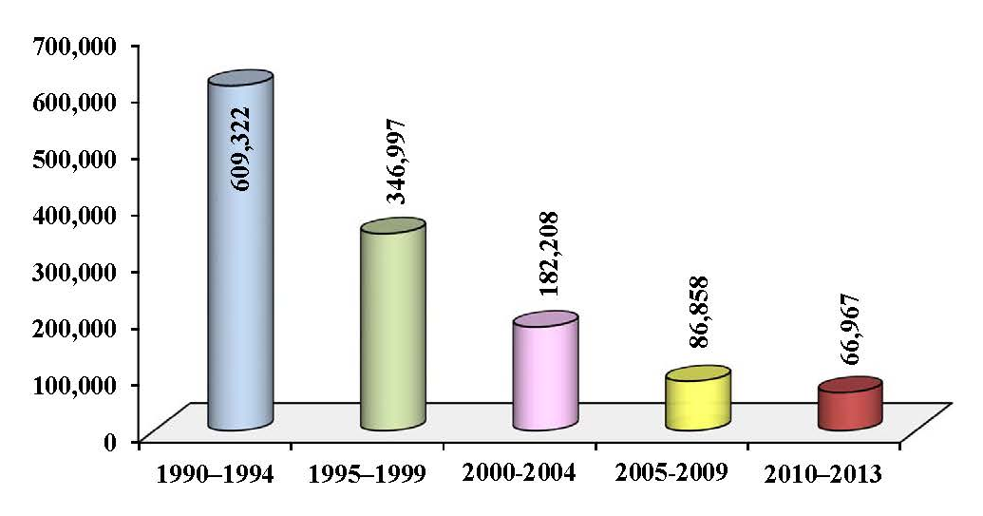
At the economic level, Israel’s Gross Domestic Product (GDP) in 2013 was estimated at 1,053.3 billion shekels ($291.8 billion) (The symbol $ used throughout this summary is the US$), compared to 993.4 billion shekels ($257.5 billion) in 2012 and 923.9 billion shekels ($258.1 billion) in 2011. According to these estimates, the GDP growth in local currency amounted to 6% and 7.5% for the years 2013 and 2012, respectively. But when calculating the growth rate in dollars, and because of the fluctuation of the value of the shekel against the dollar, we find that the growth rate was different, and therefore we should not rush to inaccurate conclusions. Note that the statistics that we present are derived from official Israeli sources.
According to statistics, the GDP per capita Israeli income in 2013 amounted to 130,756 shekels ($36,227), compared to 125,652 shekels ($32,569) in 2012.
The total public expenditure of the Israeli government in 2013 was 309.544 billion shekels ($85.761 billion), while total revenues for the public treasury in 2013 were 268.36 billion shekels ($74.35 billion). Israeli exports rose for the year 2013 by 5.4%, while imports declined by 1.7%.

Total Israeli Exports and Imports 2010–2013 at Current Prices
($ million)
Year | 2010 | 2011 | 2012 | 2013
Exports | 58,415.9 | 67,802.2 | 63,145.3 | 66,583.8
Imports | 59,199.4 | 73,536.2 | 73,121.4 | 71,898.9

The US remained Israel’s top trading partner. In 2013, Israeli exports to the US reached $17.637 billion (26.5% of total exports), while Israeli imports from the US were $8.153 billion (11.3% of total imports). In the same year, China became Israel’s second largest trading partner, with Hong Kong advancing to the third spot, and Belgium falling to fourth.
Israeli Exports and Imports to/ from Selected Countries 2013 at Current Prices ($ million)
Country | US | China | Hong Kong | Belgium | Germany | UK | Switzerland
Israeli exports to: | 17,636.9 | 2,863.6 | 5,376.3 | 3,116.7 | 1,779.5 | 3,895.9 | 1,383.1
Israeli imports from: | 8,153.2 | 5,610.9 | 1,668.4 | 3,823.4 | 4,667.7 | 2,420.9 | 4,397.4
Trade | 25,790.1 | 8,474.5 | 7,044.7 | 6,940.1 | 6,447.2 | 6,316.8 | 5,780.5

Country | Turkey | Netherlands | India | France | Malaysia | Other countries | Total
Israeli exports to: | 2,503.5 | 2,092.5 | 2,271.8 | 1,565.9 | 1,457.2 | 20,640.9 | 66,583.8
Israeli imports from: | 2,354.1 | 2,719.3 | 2,121.9 | 1,544 | 72.9 | 32,344.8 | 71,898.9
Trade | 4,857.6 | 4,811.8 | 4,393.7 | 3,109.9 | 1,530.1 | 52,985.7 | 138,482.7

Israeli Exports to Selected Countries 2013 ($ million)
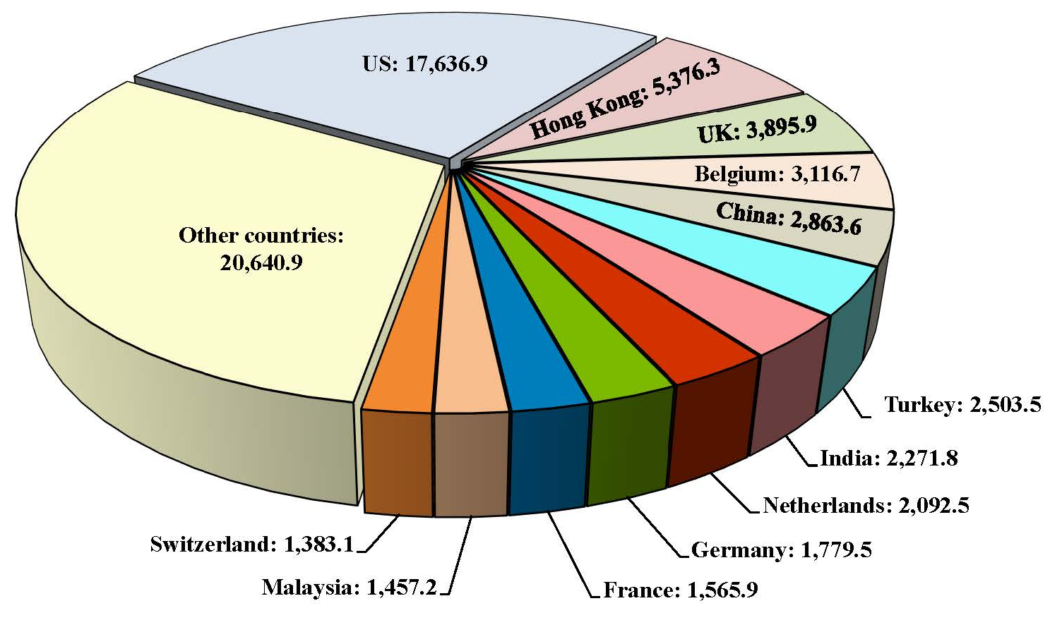

Israeli Imports from Selected Countries 2013 ($ million)
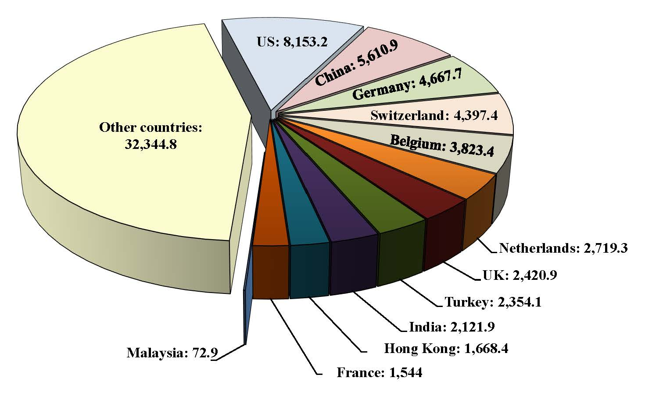
Although Israel is considered a rich and developed country, it continues to receive annual US aid, to the tune of $3.115 billion in 2013, including $3.1 billion in military aid. Between 1949 and 2013, Israel received $118.244 billion in US aid.
On the military side, Israeli concerns regarding future scenarios increased in 2012 and 2013 as a result of the developments of the “Arab Spring,” in parallel with the increased threat of resistance groups, which acquired improved military capabilities. This was in addition to the threat of electronic warfare, classified by the military as the fifth battle arena, after land, sea, air, and space. However, stripping Syria of its chemical weapons, and the possibility of a political solution to the nuclear crisis with Iran, were two positive developments in the eyes of the Israeli military.
Israel also agreed a motion to reduce the duration of compulsory military service by four months, from 36 to 32 months. Colonel Ghassan Alian was also appointed commander of the Golani Brigade, and becoming the first Arab Druze officer to hold this position in the history of the Israeli army. Israel continued to develop its anti-missile systems, notably Arrow, Iron Dome, and Magic Wand. The Israeli military budget was $16.284 billion in 2013. Israeli military exports in 2012 were $7 billion.
In 2012 and 2013, Israel continued its assaults on the Palestinian people. In 2013, 49 Palestinians were killed by Israel in the WB and GS, and in 2012, 275 Palestinians were killed in total. In 2013, around 171 Palestinians were injured, while the number of wounded in 2012 was 1,966. The high number of those killed in 2012 can be attributed to the Israeli assault on GS, dubbed Pillar of Defense, and the counter-operation by the Palestinian side dubbed Stones of Baked Clay between 14–21/11/2012. In this conflict 191 people were killed and 1,526 injured, mostly women, children, and elderly people. This was followed by a truce that lasted for the duration of 2013, a year in which only 55 rockets and shells were fired from GS in response to Israeli attacks, compared to 1,130 in 2012.
In 2012 and 2013, Israel continued to close border crossings with GS and tightened the blockade. The WB, meanwhile, was calm, in light of growing security coordination between the PA and the Israeli occupation army. The Israel Security Agency—ISA (Shabak) recorded 1,271 resistance operations in 2013 compared to 578 in 2012 in the WB, including East Jerusalem. Most of the operations involved throwing stones and Molotov cocktails. Israeli security recorded the killing of 6 Israelis in 2013, as a result of operations carried out by Palestinians, and 10 in 2012, while 44 Israelis were wounded in 2013, compared to 309 in 2012.
The Killed and Wounded Among Palestinians and Israelis in the WB and GS 2009–2013
Year | Killed |  | Wounded
Year | Palestinians | Israelis | Palestinians | Israelis
2009 | 1,181 | 15 | 4,203 | 234
2010 | 98 | 11 | 967* | 29
2011 | 118 | 22 | 554* | 159
2012 | 275 | 10 | 1,966 | 309
2013 | 49 | 6 | 171 | 44
*Including international supporters.

Palestinians and Israelis Killed in the WB and GS 2009–2013
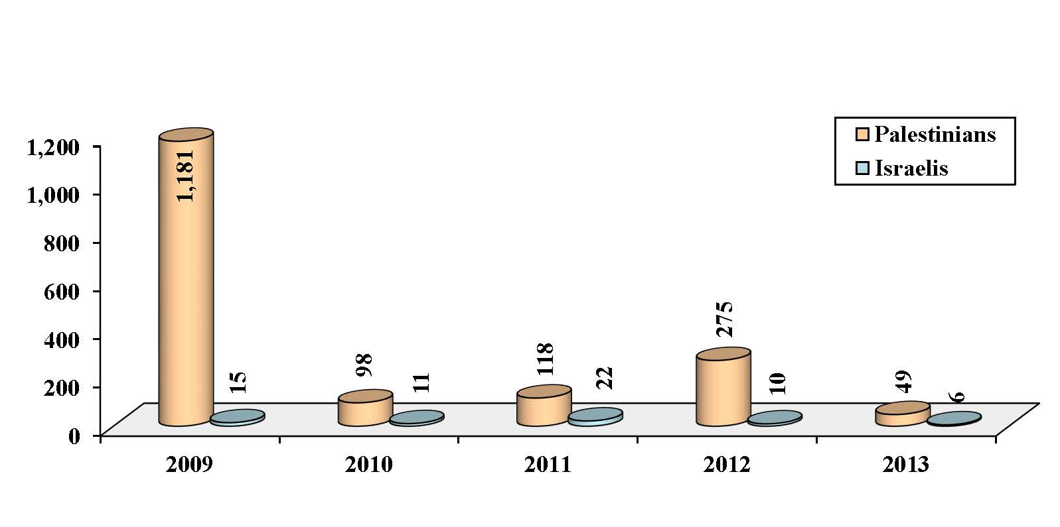
Palestinians and Israelis Wounded in the WB and GS 2009–2013
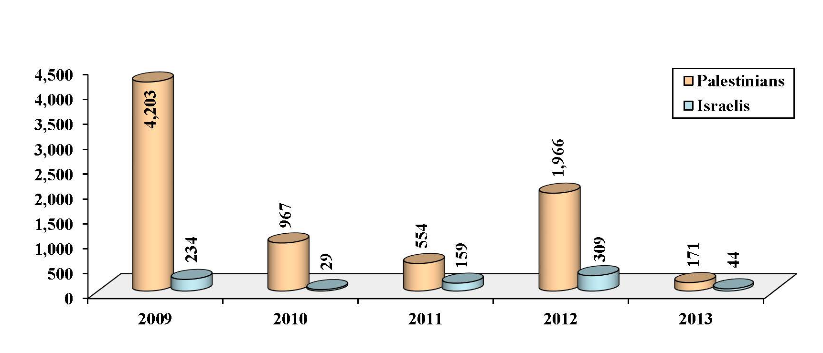
The years 2012 and 2013 continued the trend of the previous yeas in terms of the continued suffering of Palestinian detainees. The number of Palestinian prisoners in Israeli jails at the end of 2013 was 5,023, including 17 women and 154 children. The total number of prisoners from the WB was 4,408, including 163 from Jerusalem, in addition to 389 from GS, and 226 Palestinians from Israel, as well as dozens of Arab detainees of various nationalities. The Bureau of Statistics at the Ministry of Detainees & Ex-Detainees Affairs noted that Israeli forces had detained 3,874 Palestinians in 2013.
Israel dealt with the Palestinian internal issue in 2012–2013 with the same strategy it had used before; seeking to entrench the Palestinian schism and prevent reconciliation. Israel chose to continue to drag on the peace process, without any serious intention to resolve final status issues, at a time when it continued to impose facts on the ground through Judaization and settlement programs. Palestinian-Israel negotiations were resumed in Washington at the end of July 2013, in accordance with Israeli conditions, without a formal decision by a clear majority of the members of the Executive Committee of the PLO, and without meeting any of the conditions highlighted by the PLO leadership over three years. This demonstrated yet again that the option of bilateral negotiations remains the only option taken seriously by the PLO leadership, and that all its claims to the contrary have most likely been made to put pressure on Israel and improve its negotiating position.
Negotiations were resumed without an agreement on a settlement freeze, a referential framework that provides for the establishment of a Palestinian state on the 1967 borders, or any reference to international law, UN resolutions or even American guarantees.
Furthermore, GS was completely ignored and the Egyptian role was sidelined in the negotiations. The Israeli side imposed its agenda by focusing on security issues. The only achievement made by the Palestinian negotiators was securing the release of 78 prisoners, who had been incarcerated since before the Oslo Accords.
The US side showed bias to the Israeli side, refraining from putting any pressure on the latter. Efforts that spanned the better part of nine months of negotiations did not produce any results, and the peace process reached an impasse once again.

Third: The Palestinian Issue and the Arab World
At the Arab level, internal political changes were the most important factor influencing the Palestinian issue in 2012 and 2013. These changes profoundly affected some of the most important countries that serve as the strategic depth of the Palestinian issue, especially Egypt and Syria. The transitional political process in 2012 in several countries, including Egypt, helped show how relevant the Palestinian issue remained for the Arab Street, and therefore, how much it influenced the foreign policy agenda for candidates contending to take power during that phase. However, the snags that hit the transitional process and the escalation of political crises in 2013 dampened Arab interest in Palestine at both the popular and official levels, making way for internal concerns to dominate the agenda.
It is also possible to say that the outcome of these crises weakened the masses’ ability to influence political decision-making again, putting the calculations of gains and losses back in the forefront, along with the influence of powerful external actors, which had appeared on the decline even if temporarily as a result of the “Arab Spring” in 2011. This raised doubts about the possibility of a real change towards building a nurturing Arab environment that supports Palestinian steadfastness, resistance and confrontation of Israeli violations.
In Egypt, throughout 2012, there were positive signs concerning the Palestinian issue, and these signs first appeared after the January 25 revolution. They suggest that Egypt may provide leverage and a positive influence on the Palestinian issue. Egypt, under the leadership of President Morsi, had a strong role in supporting the GS politically against the Israeli assault in November 2012. However, Egypt’s preoccupation with its internal concerns did not allow its leadership to play a more effective role at the Palestinian level.
This role suffered a setback when the democratic transition was disrupted, and the army took over power in July 2013. This coincided with the closure of the Rafah crossing, and a cynical media and political campaign not only against Hamas in GS or political Islam, but also against Palestinians as a people, resistance movements, and attitudes that favored resistance.
Otherwise, Egypt in 2012 and 2013 did not actively support Palestinian-Israeli negotiations, although it was officially one of the most important issues for Egypt as it was a signatory to the Camp David Accords.
Jordan sought in 2012 to restore its role in Palestinian-Israeli negotiations. In early 2012, King ‘Abdullah II sponsored a round of direct “exploratory” talks between the two parties in order to bring their views closer together. As for its relation with Hamas, it was temporarily improved in 2012 after a Qatari mediation and due to the Arab protest movement. However, the relationship declined following the military coup in Egypt, in conjunction with a number of Arab countries taking political and security measures against Islamic movements in the region.
On the other hand, the continuation and exacerbation of the Syrian crisis in 2012 and 2013 had tough implications on the Palestinian issue, whether with Syria now weakened relative to Israel, politically, militarily, and strategically; or whether in terms of the Palestinian casualties of the fighting and the bombardment and besiegement of Palestinian camps; and the souring relationship between the Syrian regime and Palestinian resistance, especially Hamas.
The repercussions of the Syrian crisis also affected Lebanon on more than one level. Hizbullah has lost a large part of its popular support, which it had enjoyed as a resistance movement against Israel, because of its participation in the fighting in Syria alongside the regime, as some saw this to be involvement in the suppression of the revolution of the Syrian people. Among the other implications related to the Lebanese-Palestinian relationship, involves the displacement of Palestinian refugees from Syria to Lebanon. This drew some negative attitudes toward them, with claims about involvement by Palestinians in some security incidents in Lebanon, after the country became a secondary arena for the warring parties in Syria. Some parties exploited this to incite hatred against Palestinians in the refugee camps.
In 2012 and 2013, Arab Gulf countries became preoccupied with issues other than the Palestinian issue. The Syrian crisis, the political crisis in Egypt, and the agreement over the Iranian nuclear program took precedence in their priorities, especially as far as Saudi Arabia was concerned—though Qatar tried to balance the Palestinian issue with its other preoccupations.
As for normalization with Israel, the popular attitudes expressed by the Arab revolutions, in 2012 and the first half of 2013, opposed Arab regimes’ normalization with Israel. This was while trade between Israel and its top three Arab partners (Egypt, Jordan, and Morocco) recorded a consistent decline in 2012 and 2013. But after the military coup in Egypt, and with the growing campaign against the Muslim Brothers movement and Hamas in a number of Arab countries, there have been several indications that the regimes’ relative hostility towards Israel had started to retreat.
Despite the decline in the manifestations of normalization with Israel in 2011, economic ties between Israel and Jordan, and Israel and Egypt, continued. The following table shows the size of trade relations between Israel and some Arab countries in 2012 and 2013.
Israeli Exports and Imports to/ from Some Arab Countries 2012–2013
($ million)
Country | Israeli exports to: |  |  | Israeli imports from:
Country | 2013 | 2012 |  | 2013 | 2012
Egypt | 119.4 | 206.7 |  | 49.8 | 59.8
Jordan | 99.3 | 154 |  | 266.5 | 205.5
Morocco | 53.7 | 23 |  | 6.2 | 6

Israeli Exports to Some Arab Countries 2012–2013($ million)
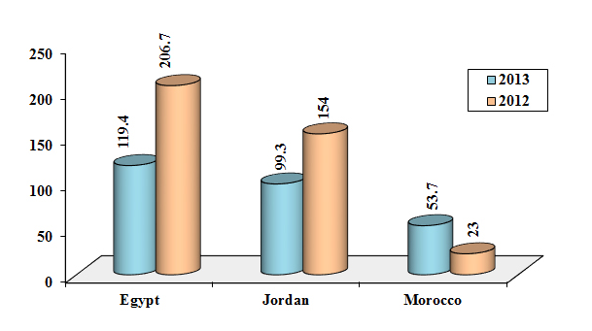
Israeli Imports from Some Arab Countries 2012–2013($ million)
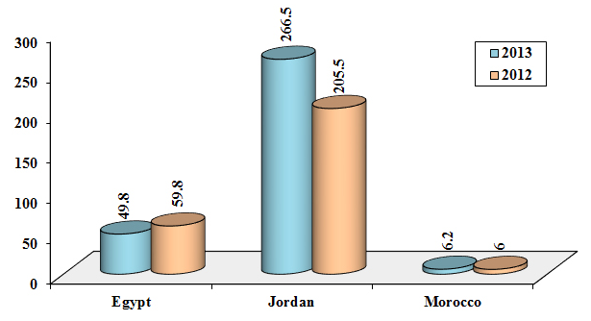

Fourth: The Palestinian Issue and the Muslim World
In 2012 and 2013, the Palestinian issue maintained its position high among the interests of the Muslim world. The developments brought by the Arab Spring in the region prompted Turkey and Iran to play a more vital role and to contribute to building regional maps with direct impact on the Palestinian issue.
The Organization of Islamic Cooperation (OIC) continued its support for the Palestinian issue through official statements and diplomatic support in international forums. The OIC supported the efforts of the PA to recognize Palestine as a non-member state of the United Nations (UN). However, this official bureaucratic and non-influential conduct was still not commensurate with the weight of this international organization.
As for Turkey, it redefined its regional role in light of the revolutions and changes in the Arab world, abandoning its previous policy of “zero-problems with neighbors,” as it was particularly concerned by the continuation of the Syrian revolution and its implications. Thus, in the years 2012–2013, Palestinian-Turkish relations made ​​remarkable progress, especially with the Hamas movement, of which some leaders moved to Turkey after leaving Syria. Erdogan's government continued to deal officially with the caretaker government led by Hamas in the GS. Turkey continued to defend Hamas as a political movement and refused to designate it a “terrorist group.” Turkish policy also continued to be positive with the Palestinian government in Ramallah during the years 2012–2013, through mutual official visits and diplomatic support for the PA in international forums.
In terms of Turkish-Israeli relations, Israel was forced to apologize to Turkey on 22/3/2013 for its raid on the Turkish ship Mavi Marmara. Although they accepted Israel’s apology, Turkey continued to believe that full normalization with Israel was contingent on Israel lifting the blockade on GS.
Concerning Turkish-Israeli economic relations, it is clear that the Turkish government managed its trade relations with Israel, to a large extent, in isolation from political positions and actions. Here it should be noted that the year 2013 saw remarkable growth in the volume of bilateral trade, by as much as 25% compared to 2012, when it had seen a decline of about 9% relative to 2011.
As for Iran, it continued its support for the Palestinians and the resistance forces, and it continued to voice its hostility towards Israel. Iran supported international recognition of Palestine as a non-member state of the UN. At the same time, with the election of Hassan Rouhani as president in the summer of 2013, Iran tried to take a more reconciliatory tone with the West, and signed with the Western powers an agreement over its nuclear program.
It is noted that the difference in attitudes between Iran and Hamas about what was happening in Syria continued to cast a shadow over the relationship between the two parties. In spite of statements and positions expressed by the two parties, which emphasized the continuity of contact between them, 2013 passed without a return to their previously warm relations. Consequently, their political ties were weak and there was a significant decline in Iranian financial and logistical support for Hamas. However, both parties made sure they avoided a full rupture, and there were continued attempts to restore relations, albeit slowly and gradually.
As regards Malaysia, in 2012–2013 the country maintained its support for the Palestinian people’s rights in accordance with international legitimacy, continued to reject the Israeli blockade of the GS, and supported the efforts for Palestinian internal reconciliation. Malaysia also supported the efforts of the PLO leadership to upgrade the status of Palestine at the UN. In 2012–2013, there was a clear increase in official and popular support for the Palestinian people in Malaysia, especially for the GS.

As for trade between the Islamic world and Israel, trade continued during the years 2012–2013 at the pace of the previous years, with a significant increase in the trade between Turkey/Malaysia and Israel.
Israeli Exports and Imports to/ from a Number of Non-Arab Muslim Countries 2012–2013 ($ million)
Country | Israeli exports to: |  |  | Israeli imports from:
Country | 2013 | 2012 |  | 2013 | 2012
Turkey | 2,503.5 | 1,421.4 |  | 2,354.1 | 2,082.7
Malaysia | 1,457.2 | 763.3 |  | 72.9 | 74
Nigeria | 155.5 | 367 |  | 2.1 | 2.8
Azerbaijan | 138.8 | 139.4 |  | 0.4 | 1.1
Kazakhstan | 89.1 | 77.2 |  | 1.5 | 1.7
Senegal | 61.7 | 25.3 |  | 5 | 4.8

Israeli Exports to a Number of Non-Arab Muslim Countries 2012–2013
($ million)
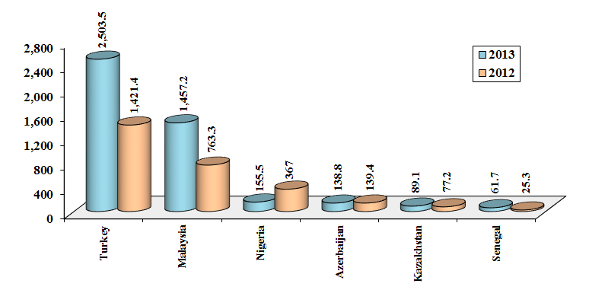
Israeli Imports from a Number of Non-Arab Muslim Countries 2012–2013
($ million)
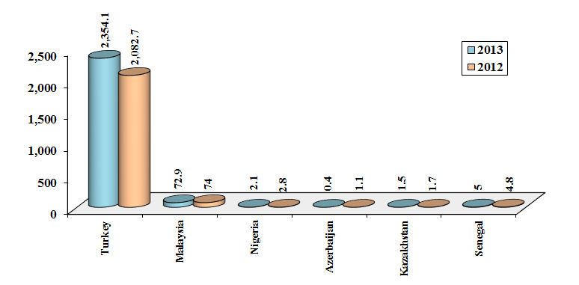

Fifth: The Palestinian Issue and the International Situation
If we exclude Palestine’s success in achieving non-member status at the UN, and the continued decline in international public support for Israel, the two years of 2012 and 2013 were characterized by the decline of the Palestinian issue in regional and international developments. These developments include the Arab Spring, the US pivot to the Asia-Pacific region, and the Russian-Chinese quest to create a multipolar international order or at least weaken US unipolarity. Hence, the Palestinian issue may enter a new phase of international changes that will have a huge impact on it in the coming years; Palestinian decision-makers should take this into account.
Concerning the diplomatic activity of the Middle East Quartet (UN, European Union (EU), US, and Russia), it is considered powerless in expressing international will that may impose a solution on the parties of the conflict in Palestine. It appears that Israel continues to enjoy a high degree of confidence in its ability to continue its occupation and act as a state above the law and international conventions.
US efforts regarding the Palestinian issue did not break their usual pattern until mid–2013, when the US secured approval from the Israelis and the Palestinians to resume negotiations. It tried to give the talks a momentum by encouraging hopes for a new framework agreement or a new Oslo agreement, and by hyping economic plans and financial inducements. However, the US did not propose a specific project as a solution, and did not officially make any commitments to the PLO. While US diplomatic efforts eventually hit a wall, the official US sentiment was that events in the Middle East should not dominate US foreign policy. The main problem for the US was that it did not want to reach a solution based on concessions by its Israeli allies, whom the US did not want to pressure.
US officials tried to advance the claim that there was no link between the “Arab Spring” and the Arab-Israeli conflict, because linking the two would lead to more pressure on the Israeli side. At the same time, the US and its Western allies pressed ahead with their agreement with Iran over the nuclear program without regard to Israeli discomfort. On the other hand, the US did not pay much attention to a UN resolution calling on Israel to place its nuclear program under International Atomic Energy Agency (IAEA) supervision, which was endorsed by 176 countries. It is worth mentioning that hundreds of anti-Israel groups are increasingly operating in the US, which has become a source of concern for Israel. These groups grew significantly during the al-Aqsa Intifadah and then again following the Israeli assault on GS in 2008/2009.
The European attitude remained consistent with the US position in 2012 and 2013, except when it came to Israeli settlement activity. The Europeans stressed their rejection of settlement building and moved towards a boycott of goods produced in Israeli settlements. There were differences between European parties over endorsing Palestine as a non-member state of the UN; 17 European countries voted ‘yes,’ including Austria, France, Italy, Norway, and Spain. Other countries like Britain and Germany abstained, and only the Czech Republic voted ‘no.’
As for the BRICS countries, Brazil, Russia, India, China and South Africa, which represent an emerging global force (accounting for around 23% of global output, comprising 42% of the world's population, responsible for 33% of growth in global output, and controlling 42% of the global monetary reserve), they confirmed their support for resolving the conflict on the basis of UN resolutions, the Madrid principles, and the Arab initiative. The BRICS group encouraged “the Quartet to intensify its efforts and call for greater involvement of the UN Security Council in search for a resolution of the Israeli-Palestinian conflict.” Its position on Jerusalem is also clearer, and its statements are devoid of the idea of land swaps or the phrase “as agreed upon by the parties,” which the Americans and Europeans often attach to some issues, such as the refugees, borders, and Jerusalem. BRICS’ statements also appear more averse to condemning Hamas.
As for the UN, it continued in its traditional stances towards the Palestinian issue during 2012 and 2013. However, the “relative” change was in the UN resolution issued on 29/11/2012, which accepted Palestine as a non-member state in the UN. This was a groundbreaking legal development that conferred greater legitimacy on the Palestinian entity, though it did not alter the overall direction of the political behavior of any of the parties to the conflict, be they direct or indirect parties. The General Assembly of the UN passed resolutions confirming the right of the Palestinian people to self-determination and sovereignty over its resources, and rejecting Jewish settlement in the territories occupied in 1967.
The average support of UN General Assembly resolutions for Palestinian rights in 2012 was 155 countries, compared to 142 in 2013, meaning that the figure had declined (though this probably has to do with the nature of resolutions). The average opposition to Palestinian rights was seven countries, mostly small states like Micronesia, the Marshall Islands, Nauru, and Palau. The US always supports Israel, while Canada, Australia, the Czech Republic, and Panama voted repeatedly in favor of Israel.
When comparing international public opinion trends in 2012 with 2013, it appears that negative views of Israel’s influence in the world increased by 2%, while positive views declined by 1%, giving Israel worrying signs in the long run.

Sixth: The Land and the Holy Sites
Israeli assaults on Islamic and Christian holy sites in Jerusalem particularly, and in historic Palestine in general, continued. Developments confirmed again that the Judaization of Jerusalem is one of the key priorities for Israel. Israeli activities to create permanent partitions in al-Aqsa Mosque for Jews and Muslims, whether by the government or by Jewish organizations, have increased considerably, and thus it is possible to say that there is an Israeli plan to divide the mosque “chronologically.” This division would allow small groups of Jews to enter daily and routinely outside of Muslim prayer times.
The elections for the Israeli Knesset on 22/1/2013 gave the “Temple” groups (i.e., those planning to seize al-Aqsa) greater political influence. With the formation of a government following those elections, these groups now even had ministers and deputy ministers. These groups created a coalition for the Temple, which began operating on 21/3/2013, with the participation of 19 officially registered groups. There was also a consensus among the different spectra of the Israeli community to implement the “Old City of Jerusalem” plan, known as Kedem Yerushalaim, with construction in the vicinity of al-Aqsa Mosque, and in particular in the area around the Western Wall. On 13/2/2012, Israel approved the construction of the most important project in the plan, known as the Kedem Compound.
The number of excavations and tunnels under the al-Aqsa Mosque and its surroundings increased from 41 excavations on 21/8/2011 to 47 by 1/8/2013. It appears that the works carried out in 2013 focused on linking these excavations together and preparing them for visitors, to form an underground tourist city.
In 2012, the Solidarity Foundation for Human Rights counted 18 attacks on holy sites, most of which were carried out by the Tag Mehir movement of extremist settlers, in addition to the destruction of 34 mosques in part or in full during Operation Pillar of Defense/Operation Stones of Baked Clay in GS. The Foundation also counted 13 attacks in 2013. Occupation forces ratcheted up the restrictions imposed on worshippers at al-Aqsa Mosque, often preventing Endowment workers from entering the premises. The Mamilla Cemetery west of the Old City of Jerusalem continued to be violated, with excavations taking place there as part of the construction of the Museum of Tolerance. On 19/3/2013, the al-Aqsa Foundation uncovered 10 schemes to alter the features of the cemetery, swallowing up the entire remaining 25 donums.
The years 2012 and 2013 also witnessed steady settlement building activity. In 2012, 12,244 new housing units were approved, and in 2013, 11,066 new units were approved in various parts of the WB. According to the Applied Research Institute Jerusalem (ARIJ), in the first eight months of 2012, Israel carried out expansion works in 151 settlements (out of 199 Israeli settlements in the WB). In 2013, Israel confiscated ​​10,800 donums of Palestinian land in the occupied WB for military and settlement purposes, including 196 donums in East Jerusalem.
According to figures published by ARIJ, the number of Israeli settlers living in settlements rose from 240 thousand in 1990 to more than 656 thousand in 2012, living in 196 settlements and 232 outposts throughout the WB, including East Jerusalem. According to ARIJ, the number of settlers in the WB amounted to 693 thousand in 2013, while Israeli data puts the figure at around 570 thousand.

The Israelis carried out scores of attacks on Palestinian farmers and their crops. In 2013, the Israeli forces and settlers uprooted more than 13,057 fruit trees, including 880 trees in East Jerusalem. The Israeli authorities also systematically siphoned underground water from basins in the WB, and consumed more than 80% of the water resources there, while denying Palestinians access to their basic water needs, and even resells to them the water it seizes from their land.
The Israeli authorities continued demolishing Palestinian homes and expelling Palestinians from homes and public buildings in Area C in the WB (an area under full Israeli military and civilian control), and in East Jerusalem. In 2012, Israel demolished around 540 buildings, and in 2013, 267 houses. Israeli authorities only approved 5% of total Palestinian requests for building permits in Area C. As for the Separation Wall in the WB, the authorities finished building 495 km or 64% of its total length; 55 km (7%) is under construction, and 224 km (29%) is still at the planning stage.
Until July 2012, the UN Register of Damage received more than 26 thousand complaints regarding physical damage caused by the construction of the Wall in the northern WB. The livelihoods of around 150 Palestinian farming communities were severely hurt because of the permits and gates system, which restricts the ability of Palestinian farmers to reach their lands beyond the Wall.
Simultaneously, Israel continued to strengthen its authority and ease the lives of settlers in the WB by expanding the “bypass roads,” which have a length of approx. 900 km. Israel also has plans to build new roads with a total length of 600 km. Israel also continued to restrict the movement of Palestinians in the WB, with the 542 checkpoints it maintains there.
Meanwhile, the GS remained under a crippling blockade, denied access to its most basic needs. Development of infrastructure was disrupted, the movement of its residents severely constrained, fishing restricted, and all aspects of economic life suffered.

Seventh: Palestinian Demographic Indicators
Estimates indicate that the number of Palestinians in the world was, at the end of 2013, about 11.807 million. Half, i.e., 5.891 million people (49.9%) live in the Diaspora. The other half, i.e., 5.916 million people (50.1%) reside in historic Palestine, and are distributed as follows: 1.43 million people in the territories occupied in 1948; and 4.485 million people in the territories occupied in 1967: 2.755 million in the WB (61.4%), and 1.731 million in the GS (38.6%).
In Jordan, the number of Palestinians at the end of 2013 was estimated at 3.535 million, representing 29.9% of Palestinians in the world (and 60% of Palestinians in the Diaspora), the majority of whom hold Jordanian citizenship. The number of Palestinians in the rest of the Arab countries was estimated at 1.691 million, or 14.3% of total Palestinians in the world, mostly concentrated in neighboring Arab countries, i.e., Lebanon, Syria, and Egypt, as well as in the Gulf states. The number of Palestinians in the rest of the world was estimated at 665 thousand or 5.6% of total Palestinians in the world, concentrated in the US, Latin America, Canada, Britain and the rest of the EU.
Palestinian Population Worldwide Estimate According to Place of Residence at the End of 2012 & 2013 (thousands)
Place of residence |  | 2012 |  | 2013
 |  | Population estimate | Percentage (%) | Population estimate | Percentage (%)
Palestinian territories occupied in 1967 | WB | 2,684.1 | 23.2 | 2,754.7 | 23.3
Palestinian territories occupied in 1967 | GS | 1,672.9 | 14.5 | 1,730.7 | 14.7
Palestinian territories occupied in 1948 (Israel) |  | 1,398.3 | 12.1 | 1,430.2 | 12.1
Jordan |  | 3,459.1 | 29.9 | 3,535.2 | 30
Other Arab countries |  | 1,682.9 | 14.6 | 1,690.6 | 14.3
Foreign countries |  | 655.5 | 5.7 | 665.3 | 5.6
Total |  | 11,552.8 | 100 | 11,806.7 | 100

Palestinian Population Worldwide Estimate According to Place of Residence at the End of 2013 (%)
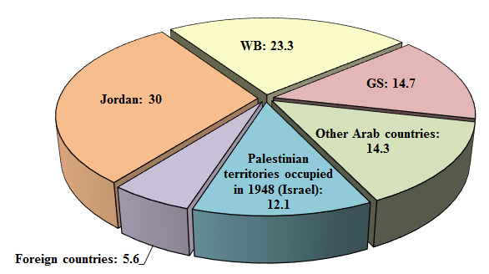

Refugees still make up more than two-thirds of Palestinians in the world. In addition to 5.891 million Palestinians in the Diaspora, there are 1.924 million refugees living in the WB and GS, and 150 thousand refugees who were expelled from their land, but who remain on land occupied in 1948. Therefore, the total number of Palestinian refugees is 7.872 million, or 68.1% of Palestinians worldwide, according to 2012 estimates.
The number of refugees registered with the UN Relief and Works Agency for Palestine Refugees (UNRWA) was 5.351 million by 1/7/2013. It is important to note that there are a lot of refugees who did not register themselves with UNRWA because they do not need its services, or are not present where UNRWA operates, such as the Arab Gulf, Europe, and the Americas.

Palestinian Refugees Worldwide; Population Estimates in 2012
Country | WB | GS | Israel* | Jordan | Lebanon | Syria | Other Arab countries | Foreign countries | Total
Population estimate | 797,495 | 1,126,886 | 150,000 | 3,459,100 | 474,053 | 528,711 | 680,136 | 655,500 | 7,871,881
* Approximate number.

Palestinian Refugees Worldwide; Population Estimates in 2012
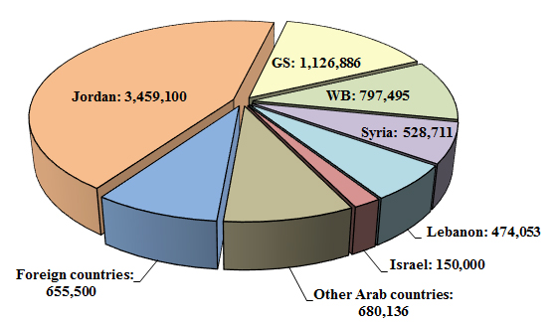

A closer look at the demographic data of the Palestinians in the WB and GS at the end of 2013 shows that the percentage of persons aged under 15 years was 39.9%, with a clear difference between the WB and GS; 37.7% in the WB compared to 43.3% in GS. The percentage of the elderly, aged 65 years and older, was estimated at 2.9% of the population in the occupied territories; 3.2% in the WB and 2.4% in GS.
Population growth in the WB and GS in 2013 maintained its previous pace, reaching 2.9% (2.6% in the WB and 3.4% in GS), and 2.5% among the Palestinians of 1948. If growth continues at these levels over the coming years compared to population growth among Jews (1.7%), the number of Palestinians and Jews in historic Palestine could equalize in 2016, at around 6.42 million people. The proportion of Jews will decline to 48.9% in 2020, with 6.87 million Jews compared to 7.18 million Palestinians.

Estimated Population Count of Palestinians and Jews in Historic Palestine 2011–2020 (thousands)
Year | Palestinians |  |  | Jews
Year | WB & GS | Palestinian territories occupied in 1948 (Israel) | Historic Palestine | Jews
2011 | 4,231 | 1,367 | 5,598 | 5,898
2012 | 4,357 | 1,398 | 5,755 | 6,000
2013 | 4,485 | 1,430 | 5,915 | 6,103
2014 | 4,615 | 1,466 | 6,081 | 6,207
2015 | 4,749 | 1,503 | 6,252 | 6,313
2016 | 4,887 | 1,541 | 6,428 | 6,420
2017 | 5,029 | 1,580 | 6,609 | 6,529
2018 | 5,175 | 1,620 | 6,795 | 6,640
2019 | 5,325 | 1,661 | 6,986 | 6,753
2020 | 5,479 | 1,703 | 7,182 | 6,868

Estimated Population Count of Palestinians and Jews in Historic Palestine 2011–2020 (thousands)
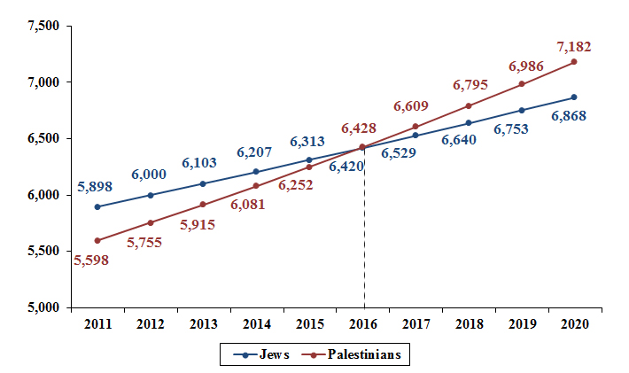

Eighth: Economic Indicators in the WB and GS
The years 2012 and 2013 did not bring anything new in terms of the economic status quo in the WB and GS. The direct dependency on the Israeli economy, and isolation from the outside Arab and international worlds continued. This was mainly due to the Israel’s control of all Palestinian international ports and border crossings, and a high proportion of Palestinian foreign trade that was conducted with Israel. The size of trade with Israel in 2012 was approx. $3,990 million, i.e., 72.8 % of total PA foreign trade ($5,480 million), consisting mostly of imports ($3,351 million). Exports were extremely limited ($639 million), which severely damaged the Palestinian economy, and made the trade balance dramatically skewed in favor of Israel.
The Palestinian economy continued to suffer as a result of the blockade and the closure of crossings imposed on GS since 2007. Three out of four commercial crossings are permanently closed down, and only the Karam Abu Salem crossing remains operational.
Moving on to Palestinian economic indicators in the WB and GS, total GDP rose from $6,797.3 million in 2012 to $6,896.7 million in 2013, an annual growth rate of 5.9%, 1.5% for the two years in question in a row, with an average of 3.7%. It is important to note that the base year is 2004. If the GDP were to be calculated based on current prices, the figure would be close to $11,297 million in 2013. This figure remains very low compared to the Israeli GDP, which is almost 26 times more, highlighting the damage of the occupation and its practices against Palestine and its people.
GDP of the PA and Israel 2008–2013 at Current Prices ($ million)
Year | PA | Israel
2008 | 6,247 | 213,227
2009 | 6,720 | 206,289
2010 | 8,331 | 232,115
2011 | 9,775 | 258,138
2012 | 10,255* | 257,482
2013 | 11,297** | 291,819
* Preliminary estimates.
** The 2013 data are calculated according to the actual value of the first three quarters of the same year.
GDP of the PA and Israel 2008–2013 at Current Prices ($ million)
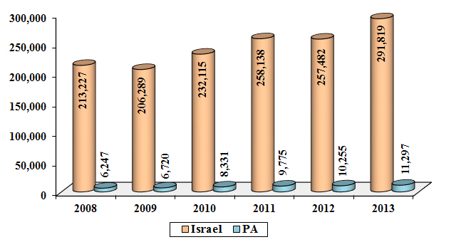
The average GDP per capita (at constant prices) was $1,679.3 and $1,660 in 2012 and 2013 respectively, with 2012 seeing a growth of 2.7% and 2013 a negative growth of 1.1%, an annual average of 0.8%. But the disparity between the WB and GS was evident in this data as well: in 2013 the average GDP per capita in the WB was about $2,035.6, compared to $1,114.4 in GS. When calculating the GDP per capita at current prices, the figures are found to be $2,534 and $2,719 in 2012 and 2013 respectively.
GDP per Capita of the PA and Israel 2008–2013 at Current Prices ($)
Year | PA | Israel
2008 | 1,737 | 29,006
2009 | 1,815 | 27,571
2010 | 2,186 | 30,458
2011 | 2,489 | 33,252
2012 | 2,534* | 32,569
2013 | 2,719** | 36,227
* Preliminary estimates.
** The 2013 data are calculated according to the actual value of the first three quarters of the same year.

GDP per Capita of the PA and Israel 2008–2013 at Current Prices ($)
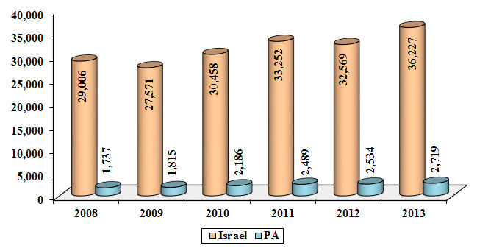
Although this is positive growth, the fact that it is linked to the continuation of foreign aid, and persistent high unemployment, means that this may not be real growth. The unemployment rate in the WB and GS was 23.4% in 2013, compared to 23% in 2012. This is while bearing in mind that unemployment rates vary between the WB and GS; in 2013, unemployment was 32.6% in the latter, compared to 18.6% in the former. In 2012, the figures were 31% and 19% respectively.
Net revenues collected by the PA rose in 2013 by 3.6% compared to 2012: The revenues were $2,320 million in 2013 compared to $2,240 million in 2012. Total expenditures of the PA also rose, including development expenditures, to about $3,419 million in 2013, compared to $3,258 million in 2012, an increase of 4.9%. The budget deficit amounted to $1,099 million in 2013, compared to $1,018 million in 2012. Foreign aid, meanwhile, including development funding, rose to $1,358 million in 2013 compared to $932 million in 2012.
The potential for real economic growth or a substantial correction—under the Oslo Accords, Paris Protocol, and Israeli practices seeking to curtail the Palestinian economy and entrench its dependency on Israel—looks unlikely to be fulfilled.

Ninth: Educational Indicators in the WB and GS
Palestinians in the WB and GS are remarkably advanced relative to the Arab world in terms of literacy and education, which reached 95.9% and 96.3% in the years 2012 and 2013, respectively. Only Qatar comes close to these figures in the Arab world.
The total number of Palestinian schools that cover basic education (elementary and intermediate) as well as secondary education was 2,784; 2,094 schools in the WB, and 690 schools in the GS, in the academic year 2013/2014. The number of students enrolled in basic and secondary education in the academic year 2013/2014 was 1.152 million: 571,908 male students and 579,794 female. The number of teachers in these schools was 63,017 in the academic year 2013/2014.
The total number of university students in the academic year 2012/2013 was 123,484 in the WB and GS; 68,548 students in the WB and 54,936 students in GS, 58.2% female students and 41.8% were male. The An-Najah National University in Nablus is the largest of these universities with 21,327 students enrolled in 2012/2013. It is followed by the Islamic University of Gaza with 19,938 students, and then Al-Aqsa University in GS with 17,094 students.
Number of Students in Traditional Universities in the PA 2012/2013
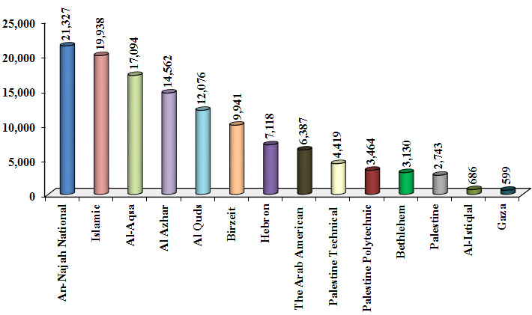

The Al-Quds Open University provided university education for 61,592 students in 2012/2013, including 21,811 males and 39,781 females. According to figures available from the Ministry of Education and Higher Education, there were 34 university and community colleges providing education for 28,505 students in 2012/2013, including 15 college universities attended by 16,232 students which award bachelor's degrees, and 19 community colleges attended by 12,273 students which award diplomas.

