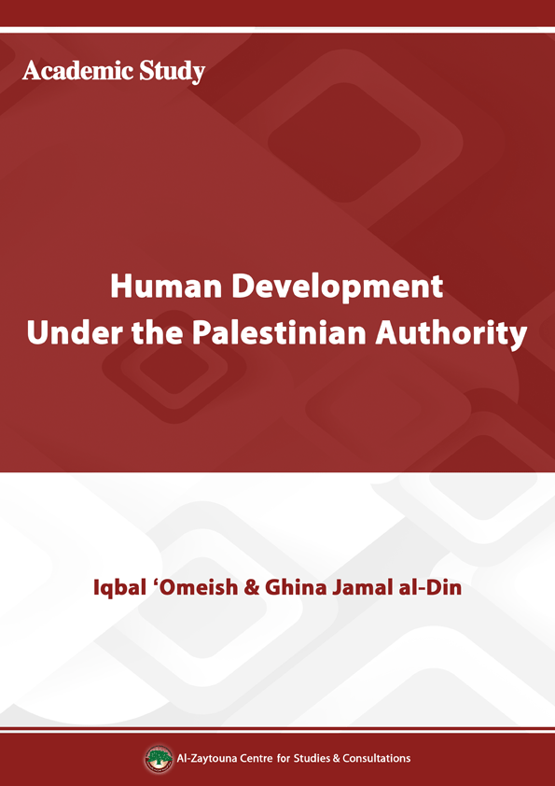
Human Development Under the Palestinian Authority
Iqbal ‘Omeish & Ghina Jamal al-Din
Introduction
Studying the social, demographic, educational, and health-related indices of the Palestinian people reveals their current state and probable trends that could shape their future. It must be noted that the Palestinian case is quite singular and faces exceptional circumstances. Indeed, half of the Palestinian people live under Israeli occupation, exploitation, obstruction, and siege, while the other half lives in exile and in the Diaspora, where they suffer from bitter dispossession, asylum conditions, and deprivation. In other words, the figures we review in this chapter are approximate numbers, and the best available under such exceptional circumstances.
This chapter attempts to present a statistical comparative study on the various indicators of the life of the Palestinian people during the period 1993–2013, in the West Bank (WB) and Gaza Strip (GS). The chapter reviews the different demographic characteristics of Palestinians at home and abroad. The chapter then reviews the state of education and culture among Palestinians, in addition to primary, secondary, and tertiary education during the same period. Since the overall picture cannot be examined without studying the health situation of the Palestinian people, the chapter also overviews general health indicators, in terms of services, hospitals, and health insurance, in addition to the impact of the occupation on the health sector.

First: Social and Demographic Indicators
The Palestinian population is dominated by young people. Half of the Palestinian people in the WB and GS are under the age of 19. Between 1993 and the end of 2013, the Palestinian population grew by 87.7%. Although Palestinians live under the occupation and are subjected to various obstacles, they have been able to adapt to their complex situation and stood in the face of the occupation. The Palestinian refugee question, and the tearing of the social fabric of the Palestinian people due to Israeli occupation, is the biggest demographic challenge facing the Palestinian population.
1. The Palestinian Population Worldwide
Based on estimates from the Palestinian Central Bureau of Statistics (PCBS), Palestinians worldwide at the end of 2013 were estimated at 11.81 million, compared to 6.29 million at the end of 1993. When examining the numbers of Palestinians during the period 1993–2013, we find that the annual growth is 3.2%; meaning that the population grew by 87.7% from 1993 until the end of 2013. However, Palestinians’ worldwide distribution did not vary significantly during the 20 years under study. The following table presents the estimated worldwide Palestinian population according to place of residence, for selected years.
Palestinians are divided according to place of residence to: Palestinians living in historic Palestine, which includes lands occupied in 1948, and 1967, and whose number was estimated in 2013 at 5.92 million, 50.1%, of the total Palestinian population, including 4.49 million in WB and GS, 38% of the total Palestinian population. In 1993, the number of Palestinians in historic Palestine was 2.8 million, 44.3% of the total Palestinian population, including approximately two million in WB and GS, representing 31.7%.
The number of Palestinians living in the Palestinian territories occupied in 1948 (Israel), in 2013, reached 1.43 million, 12.1% of Palestinians worldwide, while in 1993 they were around 800 thousand, 12.6% of Palestinians worldwide.

Table (1): Palestinian Population Worldwide Estimate According to Place of Residence–Selected Years (thousands)
Total | Foreign countries | Other Arab countries | Jordan | Palestinian territories occupied in 1948  (Israel)⃰ | Palestinian territories occupied in 1967 |  | Place of residence
 |  |  |  |  | GS | WB
6,291.7 | 339.4 | 1,095.3 | 2,070.2 | 789.9 | 748.9 | 1,248 | Population estimate | 1993
100 | 5.4 | 17.4 | 32.9 | 12.6 | 11.9 | 19.8 | Percentage  (%) | 1993
9,305.3 | 526.8 | 1,464.5 | 2,716.2 | 1,037.8 | 1,299.4 | 2,260.6 | Population estimate | 2002
100 | 5.7 | 15.7 | 29.2 | 11.1 | 14 | 24.3 | Percentage  (%) | 2002
10,039.6 | 580 | 1,632 | 2,867 | 1,184.5 | 1,420.5 | 2,355.6 | Population estimate | 2007
100 | 5.8 | 16.2 | 28.6 | 11.8 | 14.1 | 23.5 | Percentage  (%) | 2007
11,552.8 | 655.5 | 1,682.9 | 3,459.1** | 1,398.3 | 1,672.9 | 2,684.1 | Population estimate | 2012
100 | 5.7 | 14.6 | 29.9 | 12.1 | 14.5 | 23.2 | Percentage  (%) | 2012
11,806.7 | 665.3 | 1,690.6 | 3,535.2** | 1,430.2 | 1,730.7 | 2,754.7 | Population estimate | 2013
100 | 5.6 | 14.3 | 30 | 12.1 | 14.7 | 23.3 | Percentage  (%) | 2013
* For the Palestinian population in the 1948 occupied territories; the number does not include either the Palestinians in the 1967 occupied territories, including Jerusalem, nor does it include Arab Syrians, Lebanese or non-Arab Christians or those classified as “Others.” In contrast, Israeli statistics have published figures different from those of the PCBS, as the Israeli Central Bureau of Statistics (CBS) estimated the number of Arab Palestinians in 1948 occupied territories at 1.683 million in 2013. If we deduct the number of citizens in East Jerusalem, that is 308 thousands (based on 2012 statistics) and the number of citizens in the Golan Heights which is about 25 thousands, then the number of 1948 Palestinians totals 1.35 million.
** The number of Palestinians in Jordan at the end of 2009 was estimated to be 3,240,473, based on the 2.2% annual growth rates issued by the Jordanian Department of Statistics (DoS) for the period 2010–2013.
Palestinian Population Worldwide Estimate According to Place of Residence at the End of 2013 (%)
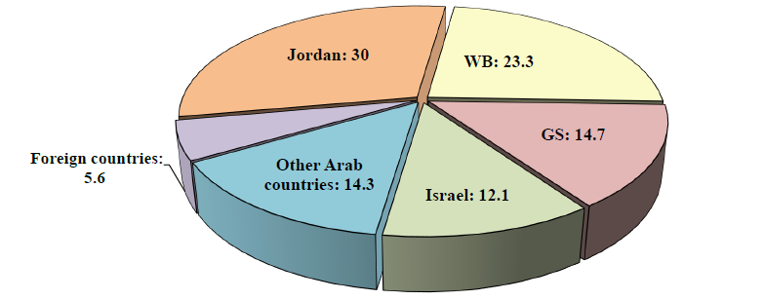

Palestinian Population Worldwide Estimate According to Place of Residence in
1993 and 2013 (%)
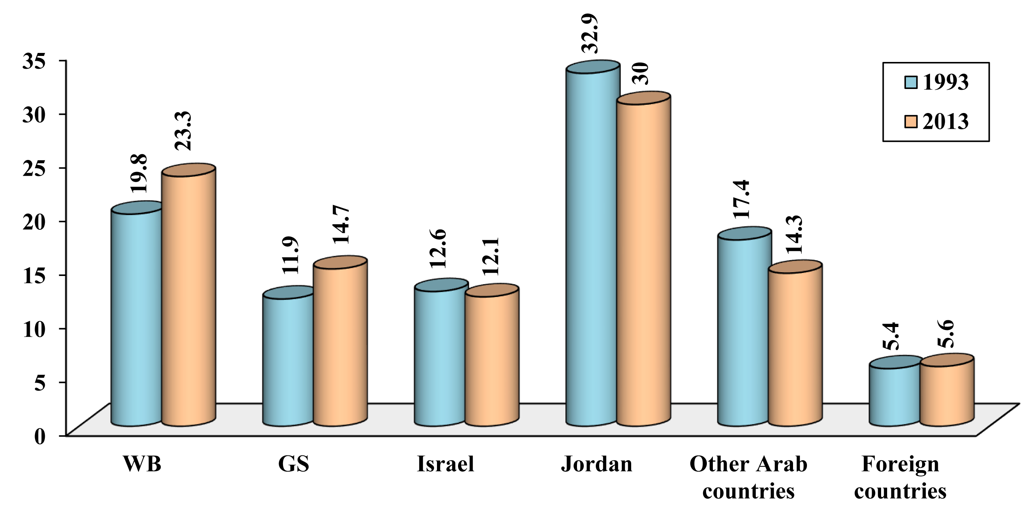

Palestinians living in the Diaspora at the end of 2013 totaled 5.89 million, accounting for nearly 49.9% of Palestinians worldwide, concentrated mostly in neighboring Arab countries, particularly Jordan, which was home to about 3.54 million Palestinians, 30% of Palestinians worldwide. Palestinians in other Arab countries are estimated to total 1.69 million, accounting for 14.3%, mostly present in neighboring Arab countries including Lebanon, Syria, Egypt, and the Gulf states. Palestinians in foreign countries total an estimated 665 thousand, 5.6% of Palestinians worldwide. When compared with the end of 1993, Palestinians in the Diaspora totaled 3.5 million, 55.7% of Palestinians worldwide, broken down into around 2.1 million in Jordan, 1.1 million in other Arab countries, and 339 thousand in foreign countries, or 32.9%, 17.4% and 5.4% of Palestinians worldwide respectively.
It should be noted that the Palestinian refugees are not only those living outside of Palestine. There are 1.984 million refugees residing in the Palestinian territory occupied in 1967, and there are about 150 thousand refugees expelled from their land, but still residing in the Palestinian territory occupied in 1948 (Israel). Thus, the total number of Palestinian refugees is 8.025 million refugees, 68% of the total Palestinian people, according to 2013 estimates. There may be some redundancy in the calculation of some numbers, because refugees could move from the place they registered as refugee or the country of which they are citizens, but that has limited impact on the overall volume of refugees.
It is worth mentioning that the number of Palestinian refugees in Syria comes from official numbers published by the United Nations Relief and Works Agency for Palestine Refugees in the Near East (UNRWA) on 1/1/2014. The suffering of refugees in Syria increased as a result of the conflict there. In early 2014, up to 440 thousand were in need of ongoing assistance. Around 270 thousand were displaced and forced to flee to safer areas inside Syria, while around 80 thousand were displaced outside Syria. Those refugees went into: Lebanon, which took in 53 thousand; Jordan, which took in 14 thousand; Egypt, which took 6 thousand; and Gaza, which took in 860. Other refugees went to Turkey, Libya, Malaysia, and other countries.

Table (2): Palestinian Refugees Worldwide; Population Estimates 2012–2013
Total | Foreign countries | Other Arab countries | Syria | Lebanon | Jordan | Israel* | GS | WB | Year
7,871,881 | 655,500 | 680,136 | 528,711 | 474,053 | 3,459,100 | 150,000 | 1,126,886 | 797,495 | 2012
8,025,459 | 665,300 | 637,580 | 569,645 | 483,375 | 3,535,200 | 150,000 | 1,165,870 | 818,489 | 2013
* Estimated number.
Palestinian Refugees Worldwide; Population Estimates in 2013
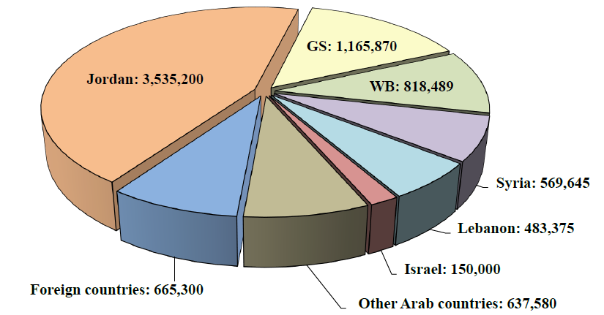
2. The Demographic Characteristics of Palestinians in WB and GS
The number of citizens in the WB and GS at the end of 2013 was estimated at 4.486 million people, of whom 2.755 million lived in WB (61.4%), and 1.731 million (38.6%) in GS.
Estimates for 2013 indicate that 44.2% of Palestinians in WB and GS are refugees, 1.984 million people. Their number in WB was 818 thousand, constituting 29.7% of total WB Palestinians, while in GS they reached 1.166 million, 67.4% of the total GS Palestinians.
Table (3): Palestinian Total and Refugee Population in the WB and GS 2012–2013
Refugee population |  | Total population |  | Place of residence | Year
Percentage (%) | Estimate | Percentage (%) | Estimate | Place of residence
29.7 | 797,495 | 61.6 | 2,684,066 | WB |  | 2012
67.4 | 1,126,886 | 38.4 | 1,672,865 | GS |  | 2012
44.2 | 1,924,381 | 100 | 4,356,931 | WB & GS |  | 2012
29.7 | 818,489 | 61.4 | 2,754,722 | WB |  | 2013
67.4 | 1,165,870 | 38.6 | 1,730,737 | GS |  | 2013
44.2 | 1,984,359 | 100 | 4,485,459 | WB & GS |  | 2013

Palestinian Total and Refugee Population in the WB and GS in 2013
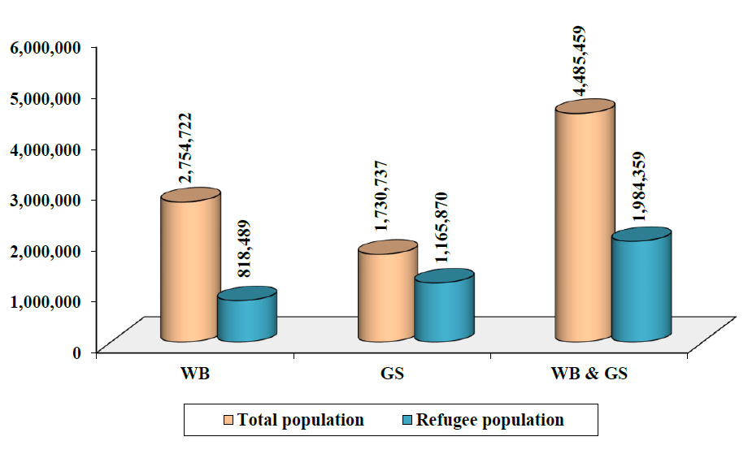
Although Palestinian society in the WB and GS is characterized by being a young society, the proportion of individuals who are younger than 15 decreased from 47.1% in 1997 to 39.9% in 2013, with a stark difference between the WB and GS. Indeed, the proportion of those aged under 15 was 37.7% in 2013 and 45.1% in 1997 in WB, compared to 43.3% in 2013 and 50.3% in 1997 in GS. Conversely, in 2013 the elderly (65 years and over), constituted just 2.9% of the total population (with 3.2% in WB and 2.4% in GS), compared to 3.5% of the total population (with 3.8% in WB and 2.9% in GS) in 1997.
The sex ratio of males to females in WB and GS increased from 101.9 in 1997 (with 102.1 in the WB and 101.5 in GS) to 103.2 in 2013 (with 103.3 in WB and 103.2 in GS). Whereas the dependency rate (number of dependent persons per 100 individuals of work age, 15–64 years) in the WB and GS decreased from 101.3 in 1997 to 74.8 in 2013. However, dependency rate in the WB is lower than that in the GS, since in the WB the ratio decreased from 94.7 in 1997 to 69.5 in 2013, whereas in GS, it decreased from 114.5 to 84.1 over the same period.
The available data shows that the Crude Birth Rate (CBR) decreased from 42.7 births per thousand population in 1997 to 32.6 in 2013, and it is expected that it will decrease to 31.9 by 2015. At the regional level, CBR in WB decreased from 41.2 births in 1997 to 29.7 in 2013, while in GS it decreased from 45.4 to 37.1 births over the same period.
Regarding the Crude Death Rate (CDR), it is relatively low compared to the predominant rates in other Arab countries. CDR decreased from 4.9 deaths per thousand population in 1997 to 3.8 deaths in 2013, and it is expected that it will decrease to 3.6 by 2015. Whereas at the regional level, CDR in WB decreased from 5.1 in 1997 to 4 in 2013, while in GS it decreased from 4.7 to 3.7 over the same period.
The natural population growth rate in 2013 reached 2.9% in WB and GS, with 2.6% in the WB, and 3.4% in GS. It is expected that the growth rates will remain as they are in the period 2014–2017, since the decrease in mortality rates along with high fertility rates will maintain the increased natural population growth rate. This is while bearing in mind that the natural population growth rate in 1997 in WB and GS reached 3.8%, with 3.6% in WB and 4.1% in GS.
Regarding household size, data shows a slow annual decrease of the average household size in WB and GS, from 6.4 persons in 1997 to 5.3 in 2012. At the regional level, household size decreased in WB from 6.1 persons in 1997 to 5.1 in 2012, and from 6.9 persons to 6 in GS over the same period.
The fertility rate in WB and GS is considered high compared to other countries. It is due to early marriages (especially among females) and the desire to have children, in addition to the customs and traditions prevailing in the Palestinian society. However, there has been a decrease in the total fertility rate in the WB and GS where there were 4.4 births per woman over 2008–2009 compared to 6 in 1997. Comparing WB with GS shows an increased fertility rate in the GS compared to the WB during 1997–2009; where in the WB there were 4 births per woman over 2008–2009 compared to 5.6 births in 1997, while in GS there were 5.2 births per woman over 2008–2009 compared to 6.9 in 1997.
Table (4): Selected Demographic Indicators of Palestinians by Residence, 1997 and 2013
WB and GS |  | GS |  | WB |  | Indicator
2013 | 1997 | 2013 | 1997 | 2013 | 1997 | Indicator
39.9 | 47.1 | 43.3 | 50.3 | 37.7 | 45.1 | % of individuals under15 years
2.9 | 3.5 | 2.4 | 2.9 | 3.2 | 3.8 | % of individuals 65 years and over
74.8 | 101.3 | 84.1 | 114.5 | 69.5 | 94.7 | Dependency rate (per 100 individuals 15–64 years)
103.2 | 101.9 | 103.2 | 101.5 | 103.3 | 102.1 | Sex ratio (males per 100 females)
32.6 | 42.7 | 37.1 | 45.4 | 29.7 | 41.2 | CBR (births per 1,000 population)
3.8 | 4.9 | 3.7 | 4.7 | 4 | 5.1 | CDR (deaths per 1,000 population)
4.1  (2010) | 6 | 4.9  (2010) | 6.9 | 3.8  (2010) | 5.6 | Total fertility rate (births per woman)
2.9 | 3.8 | 3.4 | 4.1 | 2.6 | 3.6 | Natural population growth rate
5.3  (2012) | 6.4 | 6  (2012) | 6.9 | 5.1  (2012) | 6.1 | Average household size (individuals per house)

Dependency Rate of Palestinians in WB and GS, 1997 and 2013
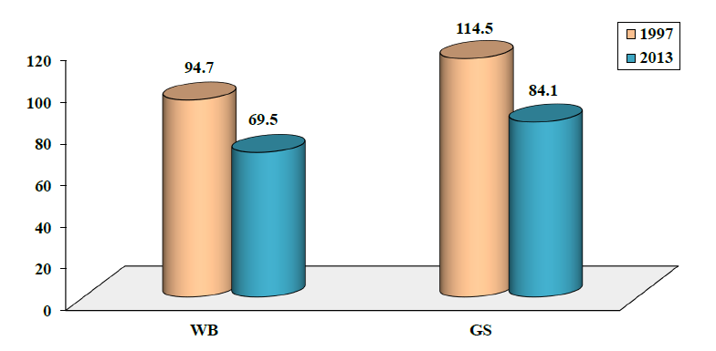

CBR of Palestinians in WB and GS, 1997 and 2013
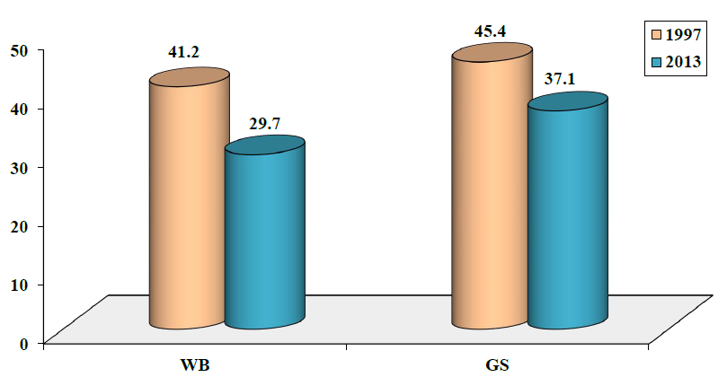
The illiteracy rate among adults in the WB and GS is one of the lowest in the world. The rate of illiteracy among individuals age 15 and above reached 4.1% in 2012 compared to 4.7% in 2011, whereas it was 13.9% in 1997. An illiterate person is defined as an individual who cannot read or write a simple sentence.
As for the 2013 Palestinian citizens’ distribution over the governorates, Hebron has 15% of the total population in the WB and GS, followed by Gaza governorate with 13.3%, while Jerusalem governorate reached 9.1%. The 2013 figures also show that Jericho and al-Aghwar was the least populated governorate constituting 1.1% of the total population of the WB and GS.
Below is the estimated population count in WB and GS governorates for the years 1997 and 2013, based on PCBS figures.
Table (5): Estimated Population Count by Governorate, 1997 and 2013
Governorates | 1997 | 2013 | 1997–2013 Annual Growth Rate
WB | 1,810,309 | 2,754,722 | 2.7
Jenin | 195,299 | 299,775 | 2.7
Tubas | 35,216 | 61,605 | 3.6
Tulkarem | 129,030 | 177,134 | 2
Nablus | 251,392 | 368,477 | 2.4
Qalqilya | 69,268 | 106,690 | 2.7
Salfit | 46,688 | 68,410 | 2.4
Ramallah and al-Bireh | 205,448 | 333,597 | 3.1
Jericho and al-Aghwar | 31,501 | 50,076 | 2.9
Jerusalem | 324,105 | 407,902 | 1.4
Bethlehem | 132,090 | 207,707 | 2.9
Hebron | 390,272 | 673,349 | 3.5
GS | 1,001,569 | 1,730,737 | 3.5
North Gaza | 179,690 | 342,030 | 4.1
Gaza | 359,941 | 597,391 | 3.2
Deir al-Balah | 144,890 | 251,428 | 3.5
Khan Yunis | 196,662 | 325,926 | 3.2
Rafah | 120,386 | 213,962 | 3.7
WB & GS | 2,811,878 | 4,485,459 | 3
Estimated Population Count in WB Governorates 2013
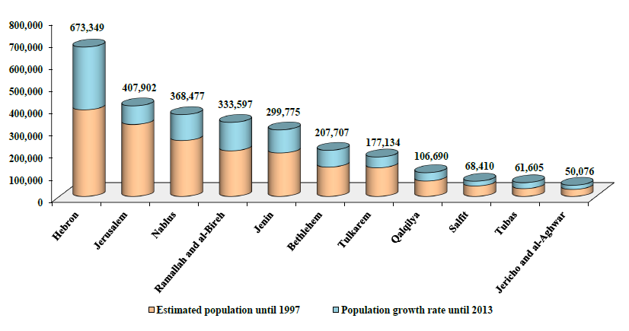

Estimated Population Count in GS Governorates 2013
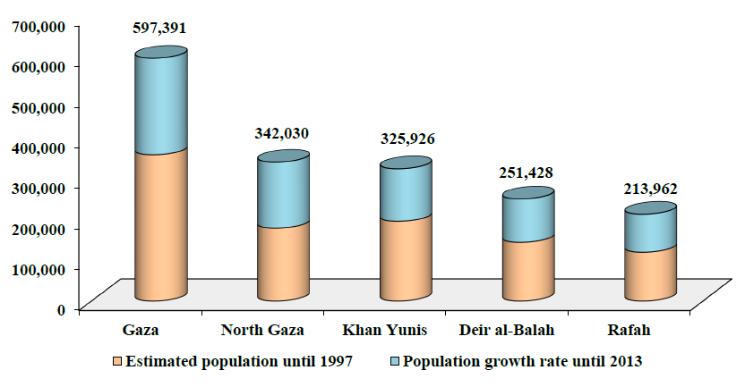

3. Demographic Growth Trends
Despite the relative decrease in the natural growth rate among the Palestinian population, this rate remains high as compared to other populations, including the Israelis. Based on PCBS estimates, Palestinians in historic Palestine reached 5.92 million at the end of 2013, while Jews numbered 6.1 million according to CBS estimates. Based on annual growth rates, reaching 2.9% for Palestinians in the WB, and GS, 2.5% for the Palestinians in the occupied lands in 1948 (Israel), and 1.7% for Jews, the number of Palestinians and Jews in historic Palestine will become equal during 2016, where, if the current growth rates hold, each group will reach 6.42 million. As a result, by the year 2020 Jews residing in Palestine will be only 48.9% of the population, 6.9 million compared to 7.2 million Palestinians.
Table (6): Estimated Population Count of Palestinians and Jews in Historic Palestine 2011–2020 (thousands)
Jews | Palestinians |  |  | Year
Jews | Historic Palestine | 1948 Occupied Palestine (Israel) | WB & GS | Year
5,898 | 5,598 | 1,367 | 4,231 | 2011
6,000 | 5,755 | 1,398 | 4,357 | 2012
6,103 | 5,915 | 1,430 | 4,485 | 2013
6,207 | 6,081 | 1,466 | 4,615 | 2014
6,313 | 6,252 | 1,503 | 4,749 | 2015
6,420 | 6,428 | 1,541 | 4,887 | 2016
6,529 | 6,609 | 1,580 | 5,029 | 2017
6,640 | 6,795 | 1,620 | 5,175 | 2018
6,753 | 6,986 | 1,661 | 5,325 | 2019
6,868 | 7,182 | 1,703 | 5,479 | 2020

Estimated Population Count of Palestinians and Jews in Historic Palestine
2011–2020 (thousands)
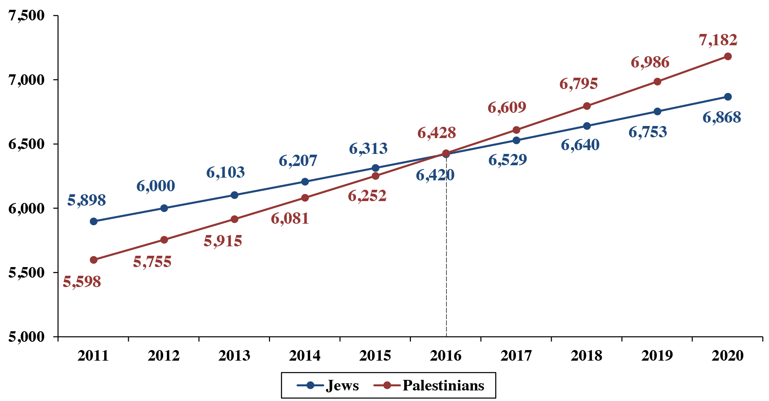

Second: Educational Indicators
Despite the suffering the Palestinian people undergo through the different forms of occupation, war and siege, they still lead the Arab world in literacy rates. Under the Israeli occupation and its cruel repressive measures, education remains one of the most important forms of Palestinian resistance and the real capital in which the Palestinian people invest to prove themselves and reach their goal of freedom, liberation and independence.
1. The General Educational and Cultural Situation
Palestinians in WB and GS represent one of the most advanced cases in the Arab World when it comes to literacy and illiteracy elimination rates. Illiteracy rates reached 3.7% in 2013, meaning that the literacy rates for those who can read, write and beyond was 96.3%, the only comparable rates are those of Qatar, while educational attendance of individuals in the age group 6–11 of both sexes reached 98.9% in 2013.
As for information and communication technology tools in the home, 2012 figures show that cell phones are available to 95.7% of families in the WB and GS; 40% of these families have a landline, 97.3% have televisions, 95% have satellite dishes, 51.4% have computers, and 32.1% of these families have access to the internet. In addition, 2012 figures show that there were 2,725 mosques in the WB and GS (1,864 in the WB, and 861 in GS), while according to 2013 figures there were 656 cultural centers in the WB and GS (574 in the WB and 82 in GS), 15 museums and 9 theaters.
For the circumstances of a nation under siege, occupation, and suffering from the destruction of its infrastructure and its inability to develop beyond the conditions set by the occupation authorities, this shows how determined the Palestinian people are to learn, engage in cultural and media communication, and succeed at least in the struggle of educational determination amid a depressing and devastating environment under occupation.
2. Basic and Secondary Education
There were 2,784 Palestinian schools covering basic (elementary and intermediate) and secondary education in the academic year 2013/2014 compared to 1,474 schools in the academic year 1994/1995, meaning an increase of 88.9% in 20 years. On a regional level, there were 2,094 schools in WB (75.2% of schools) in the academic year 2013/2014, compared to 1,136 (77.1% of schools) in the academic year 1994/1995, which indicates an increase in school numbers by 84.3%. As for GS, there were 690 schools (24.8% of schools) in the academic year 2013/2014, compared to 338 schools (22.9% of schools) in the academic year 1994/1995, which indicates a 104.1% increase.
As for public schools in WB and GS, numbers reached 2,063 in the academic year 2013/2014 compared to 1,080 in the academic year 1994/1995 (A 91% increase). It is notable that the majority of public schools are in WB: 1,668 schools (80.9% of public schools) in the academic year 2013/2014 compared to 909 schools (84.2% of public schools) in the academic year 1994/1995. Whereas, in GS the number of public schools reached 395 (19.1% of public schools) in the academic year 2013/2014 compared to 171 schools (15.8% of public schools) in the academic year 1994/1995. The shortage of schools in GS is to some extent compensated by the presence of UNRWA schools, which of which there were 245 in the academic year 2013/2014 and 159 schools in the academic year 1994/1995. As for WB, the number of UNRWA schools reached 97 in the academic year 2013/2014, and 100 schools in the academic year 1994/1995.
If we take into account that the population of WB is 2.755 million people compared to 1.731 million in GS (i.e., 61.4% in WB versus 38.6% in GS) in 2013, we will understand that the number of schools in WB compared to its population is higher than that of GS. This can partially be explained by the distribution of the WB population over wider lands areas, villages and cities, which requires more schools. As for the presence of higher rates of UNRWA schools in GS, it reflects the high level of poverty suffered by most of the population in GS (see table (1) and table (7)).
Table (7): Basic and Secondary Schools in the WB and GS According to Supervising Authority–Selected Years
 |  | 1994/1995 | 1999/2000 | 2005/2006 | 2011/2012 | 2012/2013 | 2013/2014
Public | WB | 909 | 1,069 | 1,379 | 1,609 | 1,639 | 1,668
Public | GS | 171 | 220 | 346 | 396 | 399 | 395
Public | WB & GS | 1,080 | 1,289 | 1,725 | 2,005 | 2,038 | 2,063
UNRWA | WB | 100 | 96 | 92 | 99 | 99 | 97
UNRWA | GS | 159 | 168 | 187 | 244 | 245 | 245
UNRWA | WB & GS | 259 | 264 | 279 | 343 | 344 | 342
Private | WB | 127 | 197 | 244 | 311 | 321 | 329
Private | GS | 8 | 17 | 28 | 48 | 50 | 50
Private | WB & GS | 135 | 214 | 272 | 359 | 371 | 379
Total | WB | 1,136 | 1,162 | 1,715 | 2,019 | 2,059 | 2,094
Total | GS | 338 | 405 | 561 | 688 | 694 | 690
Total | WB & GS | 1,474 | 2,767 | 2,276 | 2,707 | 2,753 | 2,784
Basic and Secondary Schools in the WB and GS 1994/1995 and 2013/2014
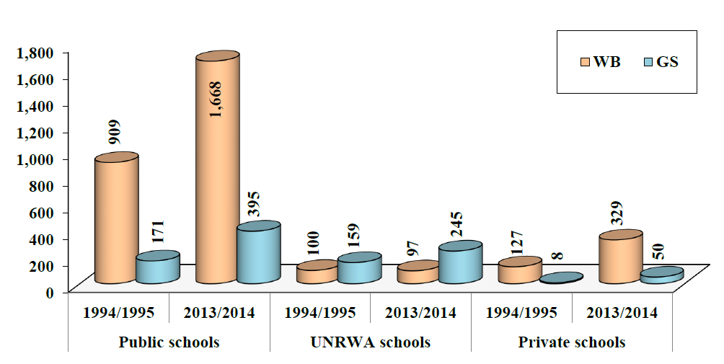

The number of students in primary and secondary schools in the academic year 2013/2014 amounted to 1.152 million, including 572 thousand males and 580 thousand females. If we compare the numbers of these students with those of 1994/1995, we find that they increased by 86.4%, a 3.3% increase annually. As for the number of teachers in these schools, it reached 63,017 in the academic year 2013/2014, of whom 25,756 were males and 23,261 were females, while in the academic year 1994/1995, the total number was 19,843, of whom 10,985 were males and 8,858 are females. It is worth mentioning that the number of female teachers increased by 321% compared to 134% increase for male teachers over the same period.
As for classrooms, the numbers seem very close between those for males and those for females with 15 thousand classrooms each in the academic year 2013/2014, while the number of mixed classrooms reached 7,756. Whereas in the academic year 1994/1995, there were 7,065 classrooms for males and 6,419 for females, and the number of mixed classrooms reached 3,454.

Table (8): Number of Schools, Students, Teachers and Classrooms in PA Territories by Sex 1994/1995 and 2013/2014
 | Schools |  | Students |  | Teachers⃰ |  | Classrooms
 | 1994/1995 | 2013/2014 | 1994/1995 | 2013/2014 | 1994/1995 | 2013/2014 | 1994/1995 | 2013/2014
Males | 503 | 992 | 318,743 | 571,908 | 10,985 | 25,756 | 7,065 | 15,053
Females | 480 | 933 | 299,125 | 579,794 | 8,858 | 37,261 | 6,419 | 15,355
Mixed ⃰ ⃰ | 491 | 859 |  |  |  |  | 3,454 | 7,756
Total | 1,474 | 2,784 | 617,868 | 1,151,702 | 19,843 | 63,017 | 16,938 | 38,164
* Teachers: All teaching and non-teaching staff in school except employees and janitors.
** The number of students and teachers in mixed schools is added to the males and females numbers.

Number of Students in PA Territories by Sex 1994/1995 and 2013/2014
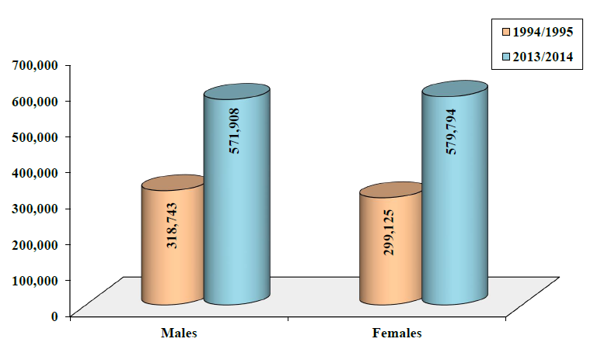

Number of Teachers in PA Territories by Sex 1994/1995 and 2013/2014
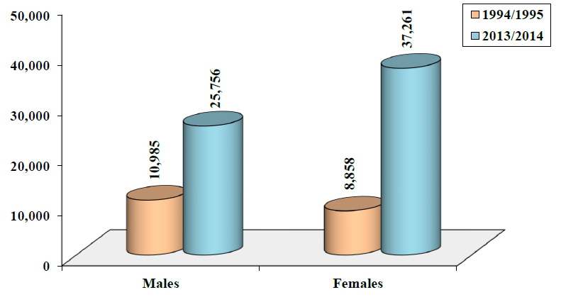

Number of Classrooms in PA Territories by Sex 1994/1995 and 2013/2014
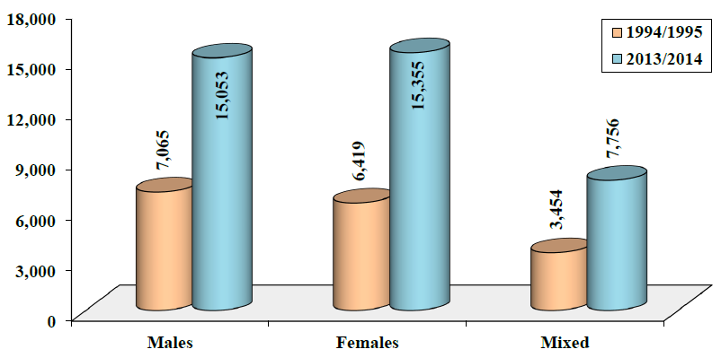
Reports for academic year 2013/2014 show that government schools, which total 2,063, represent 74.1% of total schools in the WB and GS. Students in government schools, who number 764,219, represent 66.4% of total students in the WB and GS. Government school teachers number 44,391, thus constituting 70.4% of WB and GS teachers. Classrooms in government schools numbered 25,933, representing 68% of total classrooms in the WB and GS. These indicators show that education by the government comprises over two thirds of the educational process in basic and secondary schools. If we take into account the UNRWA-run schools, we see that most students depend on low-costing education provided by these schools, with a limited number of students seeking private education (see table (8) and table (9)).
Table (9): Number of Schools, Students, Teachers and Classrooms in Government Schools in PA Territories–Chosen Years
 | Schools | Students | Teachers ⃰ | Classrooms
1994/1995 | 1,080 | 418,697 | 13,529** | 11,813
1999/2000 | 1,289 | 586,777 | 20,438 | –
2005/2006 | 1,725 | 757,615 | 35,013 | 22,082
2011/2012 | 2,005 | 761,691 | 42,961 | 25,323
2012/2013 | 2,038 | 762,499 | 43,814 | 25,679
2013/2014 | 2,063 | 764,219 | 44,391 | 25,933
Note: There was no available data regarding the number of classrooms in 1999/2000.
* Teachers: All teaching and non-teaching staff in school except services employees and janitors.
**The number was calculated after subtracting the number of kindergarten teachers (four teachers) from the total number of school instructors for all public schools equal to 13,533.

3. University Education
Many Palestinian universities in the WB and GS provide a traditional college education for their students. An-Najah University in Nablus is the biggest of these universities with an intake of 21,327 for the academic year 2012/2013, followed by Islamic university of Gaza with 19,938 students. While the Islamic university used to take the highest number of students for many years, there was a remarkable drop in numbers in the academic year 2012/2013 due to the official detachment of one of the faculties from the university. Al-Aqsa University in Gaza had the third highest intake with 17,094 students for the academic year 2012/2013. There was a total 123,484 university students in the same academic year in the WB and GS, including 68,548 students in the WB and 54,936 in the GS. This meant that students in GS represent around 44.5% of total students in the WB and GS, taking into account that Gazans represent 38.6% of total population in the WB and GS (see table (3) and table (10)).
If we compare the above statistics with those of academic year 1994/1995, we find that An-Najah University used to be the biggest university with 5,551 students, followed by Al-Azhar University in GS with 5,159 students, and the Islamic University of Gaza with 4,338 students. The number of students for the academic year 1994/1995 in the WB and GS reached 23,585 students as follows: 14,088 students in the WB, while in GS there were only two universities providing educations for 9,497 students. Meaning that the percentage of college students in GS was around 40.3% of the total students of WB and GS (see table (10)).
In addition, female students outnumber their male counterparts, reaching 71,909 attending universities that provide traditional education compared to 51,575 male students in the academic year 2012/2013, which means that female students comprised 58.2% compared to 41.8% male students. This phenomenon is no longer deemed strange in the Arab world and, while there is no room to analyze it in depth here, it represents the extent to which the Palestinian woman has succeeded in assuming her position side by side with her male peers. It also shows that Palestinian female students have better chances to finish their university education compared to male students, who generally have to leave school and join the job market to help their families with the struggle to afford the costs of living, or even leave home to pursue higher education abroad (see table (10)).
Table (10): Number of Students in Traditional Universities in PA Territories by Sex–Selected Years
University | 1994/1995 |  |  | 2003/2004 |  |  | 2012/2013
University | Males | Females | Total | Males | Females | Total | Males | Females | Total
An-Najah National | 2,942 | 2,609 | 5,551 | 5,113 | 5,943 | 11,056 | 9,116 | 12,211 | 21,327
Al-Quds | 895 | 1,256 | 2,151 | 3,214 | 2,934 | 6,148 | 5,972 | 6,104 | 12,076
Birzeit | 1,878 | 1,135 | 3,013 | 3,097 | 3,207 | 6,304 | 3,618 | 6,323 | 9,941
Hebron | 773 | 670 | 1,443 | 1,420 | 2,865 | 4,285 | 1,831 | 5,287 | 7,118
Arab American | – | – | – | 1,899 | 883 | 2,782 | 3,285 | 3,102 | 6,387
Palestine Technical-  Kadoorie ⃰ | – | – | – | – | – | – | 2,239 | 2,180 | 4,419
Palestine Polytechnic | – | – | – | 1,321 | 688 | 2,009 | 1,897 | 1,567 | 3,464
Bethlehem | 744 | 1,186 | 1,930 | 623 | 1,475 | 2,098 | 766 | 2,364 | 3,130
Al Istiqlal (The Palestine Academy for Security Sciences) | – | – | – | – | – | – | 546 | 140 | 686
Islamic/ Gaza | 2,840 | 1,498 | 4,338 | 5,834 | 7,723 | 13,557 | 7,774 | 12,164 | 19,938
Al-Aqsa/ Gaza | – | – | – | 3,257 | 5,859 | 9,116 | 4,966 | 12,128 | 17,094
Al-Azhar/ Gaza | 3,298 | 1,861 | 5,159 | 6,787 | 4,284 | 11,071 | 7,089 | 7,473 | 14,562
Palestine/ Gaza | – | – | – | – | – | – | 2,200 | 543 | 2,743
Gaza | – | – | – | – | – | – | 276 | 323 | 599
Total | 13,370 | 10,215 | 23,585 | 32,565 | 35,861 | 68,426 | 51,575 | 71,909 | 123,484
Notes: The sign (–) is used for universities that were not established in 1994/1995, 2003/2004 or were not classified as conventional university
* Established in 1930 as a school of agriculture then improved to become a faculty that offers diplomas in many specialties, then in 2007 it became a technical university. The number of its students for 2003/2004 was included in table (12) for university colleges.
Number of Students in Traditional Universities in PA Territories 2012/2013
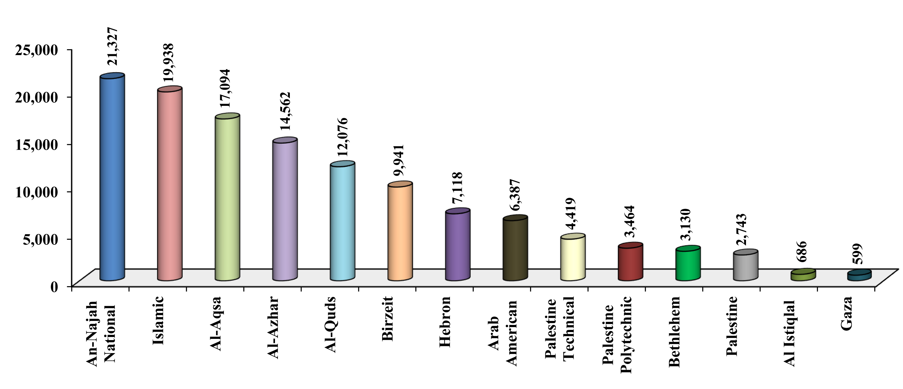

Number of Students in Traditional Universities in PA Territories by Sex 2012/2013
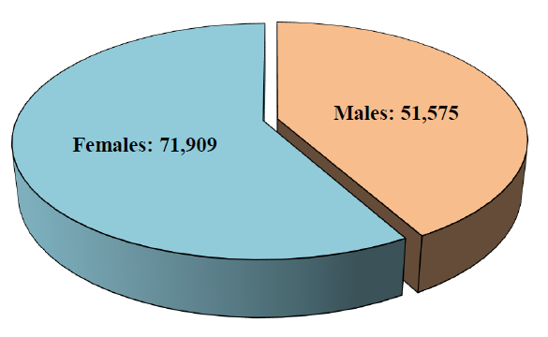

Number of Students in Traditional Universities in the WB and GS 2012/2013
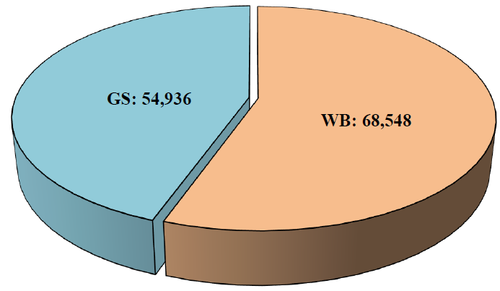
It should be noted here that male faculty members still outnumber their female counterparts, with 5,309 male teachers (79.9%) compared to 1,332 females (20.1%) in the academic year 2012/2013. This means that it is still too early for the high percentage of female students in universities to be reflected in faculties; the number of faculty members includes all teachers in universities and colleges other than community colleges.
Ultimately, quite a large proportion of female university graduates do not join the labor market and work instead as housewives, which explains the high percentage of males in labor market.
Al-Quds Open University provided open education for 61,592 students in the academic year 2012/2013 including 21,811 males and 39,781 females. The university’s campuses are distributed over 17 locations in the WB and 5 locations in GS. It provided education for 40,230 students in the academic year 2003/2004, compared to 3,869 students in the academic year 1994/1995.
Table (11): Number of Students Seeking Open Education in PA Territories
by Sex–Selected Years
Al-Quds Open university | Enrolled students
Al-Quds Open university | Males | Females | Total
1994/1995 | 2,035 | 1,834 | 3,869
2003/2004 | 22,484 | 17,746 | 40,230
2012/2013 | 21,811 | 39,781 | 61,592

Number of Students Seeking Open Education in PA Territories
by Sex 2012/2013
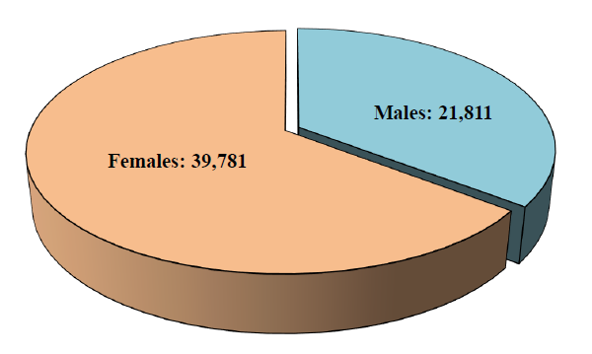

4. University and Community Colleges
There are 38 university and community colleges in the WB and GS (18 college universities and 20 community colleges). According to figures available from the Ministry of Education and Higher Education, there were 34 university and community colleges providing education for 28,505 students in the academic year 2012/2013, including 15 college universities attended by 16,232 students, which award bachelor’s degrees, and 19 community colleges attended by 12,273 students, which award intermediate diplomas. It is worth noting that the number of university colleges in the WB and GS in the academic year 2003/2004 did not exceed 9 colleges providing education for 3 thousand students only, whereas in the academic year 1994/1995, it did not exceed four colleges providing education for 1,926 students only.

Table (12): Number of Students in University and Community Colleges in PA Territories by Sex–Selected Years
Colleges |  |  | University | Community | Total
1994/1995 | Number of Colleges |  | 4 | 19 | 23
1994/1995 | Enrolled students | Males | 637 | 1,876 | 2,513
1994/1995 | Enrolled students | Females | 1,289 | 2,234 | 3,523
1994/1995 | Enrolled students | Total | 1,926 | 4,110 | 6,036
2003/2004 | Number of Colleges |  | 9 | 20 | 29
2003/2004 | Enrolled students | Males | 1,252 | 4,423 | 5,675
2003/2004 | Enrolled students | Females | 1,734 | 4,088 | 5,822
2003/2004 | Enrolled students | Total | 2,986 | 8,511 | 11,497
2012/2013 | Number of Colleges |  | 15 | 19 | 34
2012/2013 | Enrolled students | Males | 7,666 | 6,391 | 14,057
2012/2013 | Enrolled students | Females | 8,566 | 5,882 | 14,448
2012/2013 | Enrolled students | Total | 16,232 | 12,273 | 28,505
Number of Students in University and Community Colleges in PA Territories 2012/2013
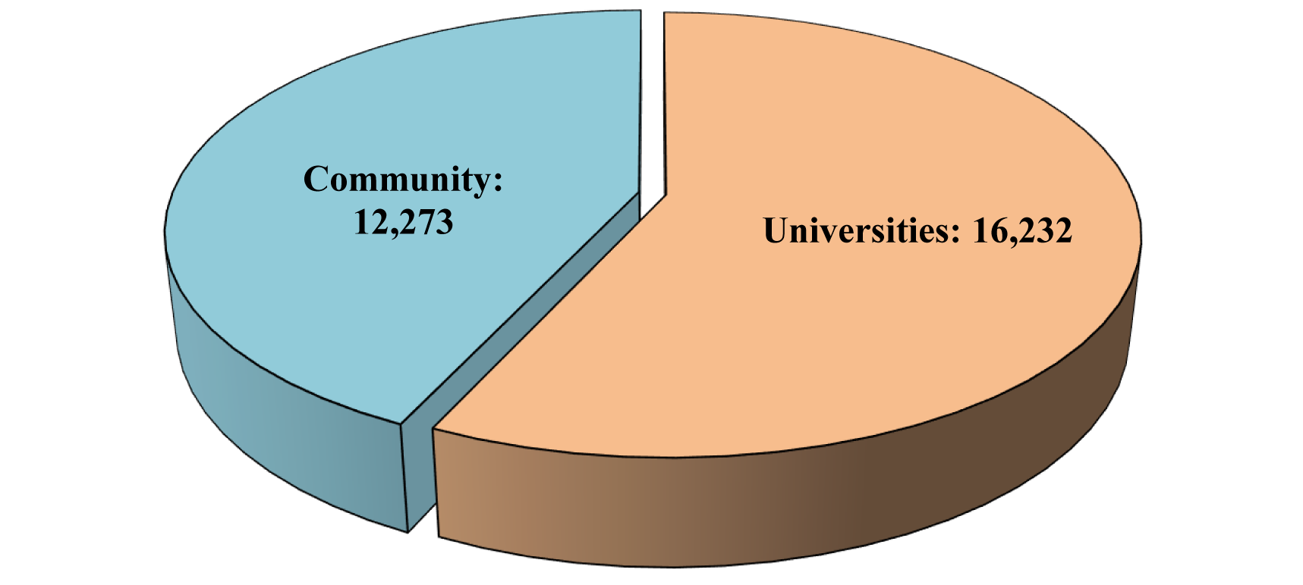
Third: Health Indicators
According to the Universal Declaration of Human Rights issued by the United Nations General Assembly (UNGA), “Everyone has the right to a standard of living adequate for the health and well-being of himself and of his family, including food, clothing, housing and medical care.” While the World Health Organization (WHO) defines “Health” as “a state of complete physical, mental and social well-being and not merely the absence of disease or infirmity.” However, a study of health indicators in the WB and GS shows a deterioration in this sector to the lowest levels due to Israeli practices. These practices include the ongoing siege against GS since 2007, the closure of the border crossing between the GS and Israel, in addition to the suffering in regional mobility caused by Israeli checkpoints and the Separation Wall preventing patients from receiving treatment.
1. Health Services
Several bodies offer health services for Palestinian in WB and GS such as the Ministry of Health (MOH), UNRWA, non-governmental health organizations, the military medical services and the private sector. In 1994, the Palestinian Authority (PA) inherited poor and difficult health service conditions. Despite the MOH efforts, health service conditions in WB and GS still face many obstacles and difficulties, which stand in the way of their development, thus limiting its capacities to fulfill Palestinian citizens’ needs.
As for UNRWA, its services are limited to primary health care provided by its centers distributed over the refugee camps in WB and GS, which by the beginning of 2013 numbered 64 centers, as follows: 42 centers in WB and 22 centers in GS. However, the agency faces financial problems due to its limited budget, especially as its health services are provided for free.
The remaining institutions play a complementary role to the main role of the Ministry of Health, where the number of hospitals in 2012 not affiliated to the ministry totaled 54 hospitals, with capacity for 2,508 inpatients, accounting for 46% of the total capacity in Palestinian hospitals. NGOs own and manage 33 hospitals, accounting for approximately 42% of total Palestinian hospitals, whereas the private sector owns and manages 17 hospitals, 21.5% of the total Palestinian hospitals; 3 hospitals are affiliated to military medical services, whereas UNRWA owns only one hospital.
In conclusion, health centers distributed over the different governorates of WB and GS increased from 454 centers in 1994 to 760 centers in 2013, with an increase rate of 67.4%.
Table (13): Number of Hospitals of Health Institutions in PA Territories 2012
Number of Hospitals | Health Institutions
25 | Ministry of Health
1 | UNRWA
33 | NGOs
3 | Military
17 | Private
79 | Total
Number of Hospitals of Health Institutions in PA Territories 2012
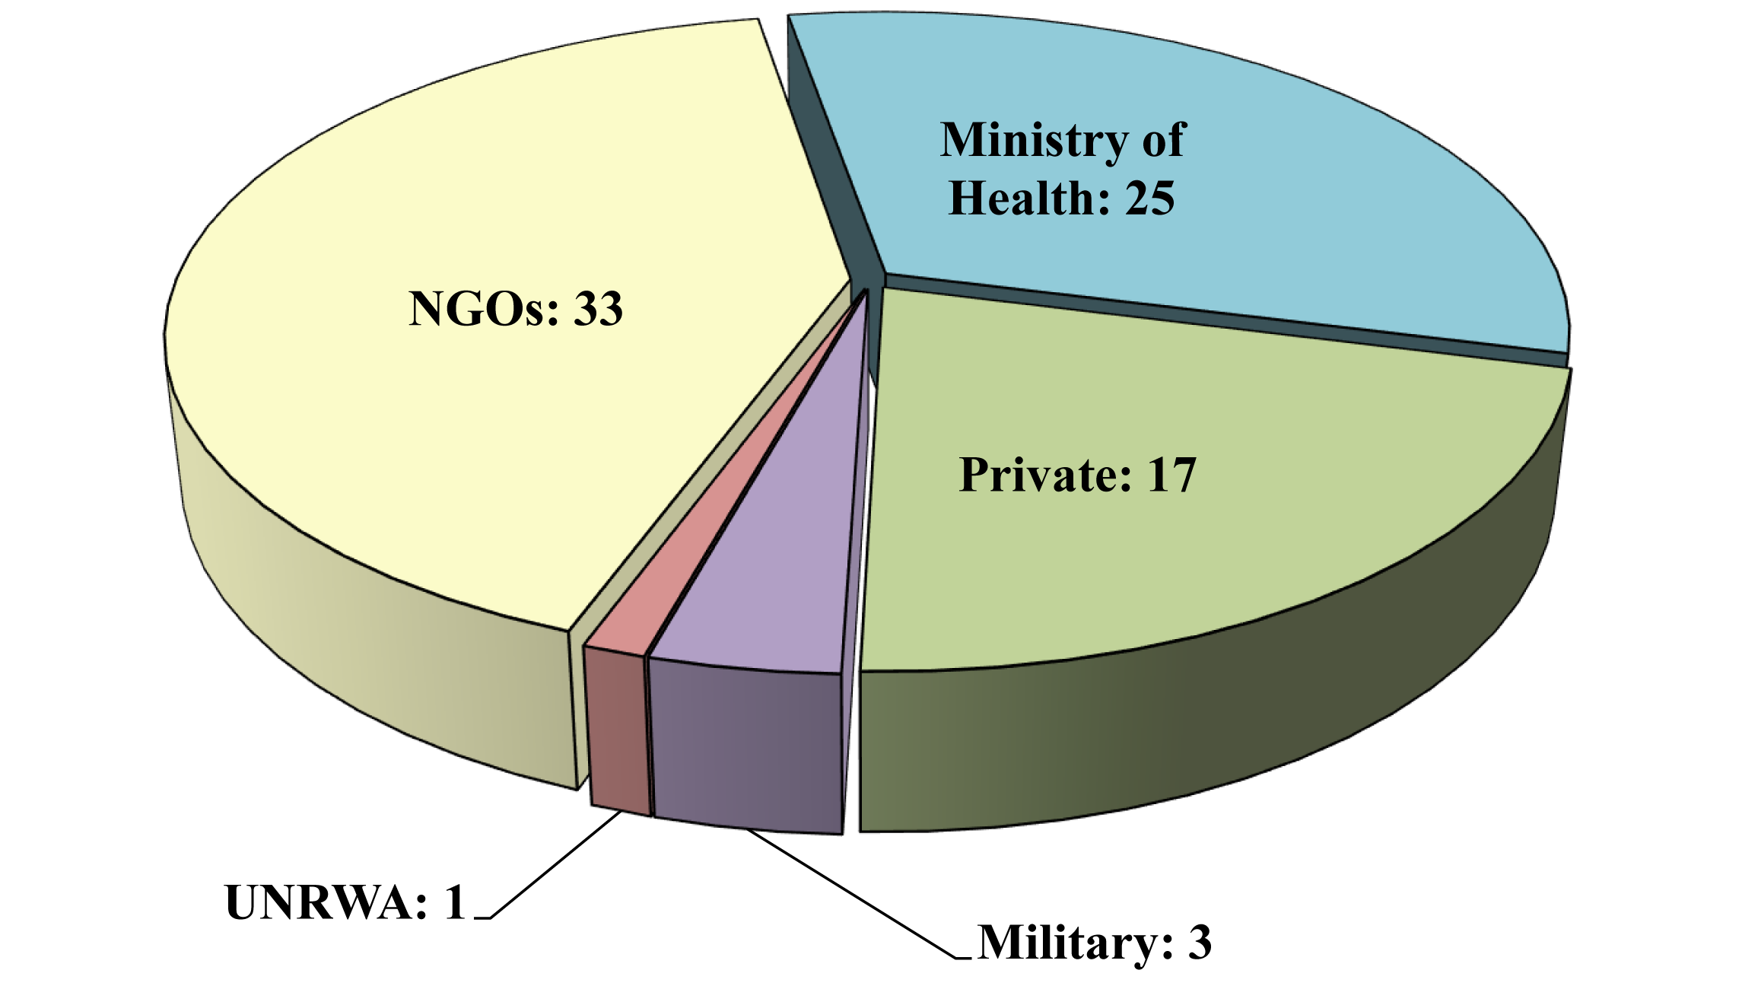
Despite the increase in hospitals in the WB and GS from 37 mid 1996 to 79 in 2012, hospital beds per thousand people did not increase by much; this has to do with the increase of population over the same period. However, it should be noted that the number of hospitals and beds in GS increased between 1996 and 2012. GS hospitals accounted for 16.2% in 1996 with 0.9 beds per thousand people, while in 2012, hospitals accounted for 38% with 1.4 beds per thousand people.

Comparing figures to Israel, CBS reported in 2012 there were 373 hospitals in Israel, 372.2% more than the provision for Palestinians. As for the number of beds, they reached 43,589 beds at an average of 5.5 hospital beds per thousand people, almost four times the Palestinian rate (393%).
The following table breaks down the number of hospitals and beds according to the PCBS.
Table (14): Number of Hospitals and Beds per Thousand People in the
WB and GS–Selected Years (Midyear)
 |  | Hospitals | Beds | Beds per thousand people
1996 | WB | 31 | 2,021 | 1.2
1996 | GS | 6 | 865 | 0.9
1996 | WB & GS | 37 | 2,886 | 1.1
2000 | WB | 48 | 2,659 | 1.2
2000 | GS | 17 | 1,896 | 1.6
2000 | WB & GS | 65 | 4,555 | 1.4
2005 | WB | 54 | 3,007 | 1.3
2005 | GS | 22 | 2,000 | 1.4
2005 | WB & GS | 76 | 5,007 | 1.3
2012 | WB | 49 | 3,143 | 1.2
2012 | GS | 30 | 2,344 | 1.4
2012 | WB & GS | 79 | 5,487 | 1.3
Number of Hospitals in the WB and GS–Selected Years (Midyear)
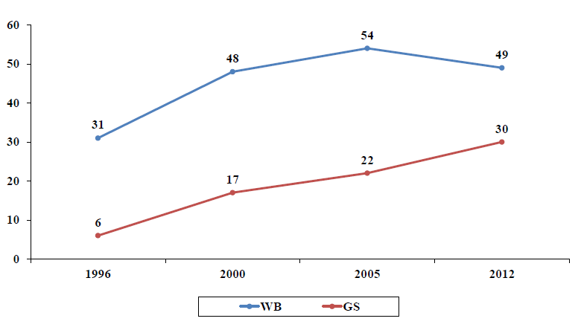
Number of Beds in the WB and GS–Selected Years (Midyear)
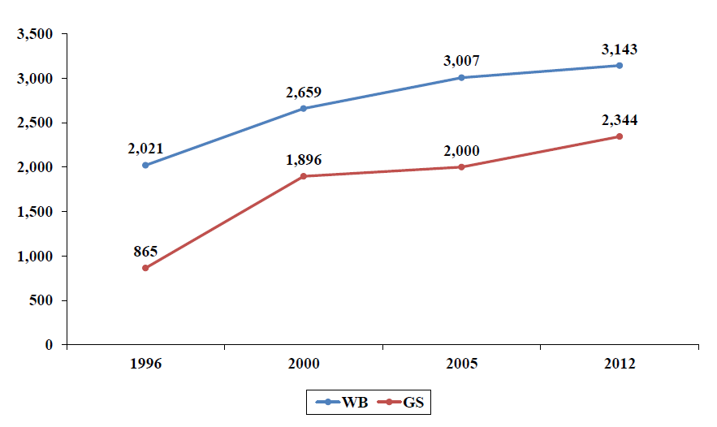
2. Health Insurance
Data indicates that in 2011, 82.2% of WB and GS citizens had at least a one-year health insurance, while the percentage of insured did not surpass 61.5% in 1996. Most of the citizens rely on governmental health insurance, as well as the presence of other types of insurance such as: military, private, Israeli, and UNRWA’s insurance or social security. As for individuals with more than one health insurance policy, they reached 27.2% in 2011, as follows: 26.5% benefiting from governmental and UNRWA’s insurance, 0.2% from governmental and private insurance, and 0.5% from UNRWA and a private insurance.
It is worth mentioning that the percentage of insured individuals in GS is higher than that of WB, reaching 96.7% in GS compared to 73.2% in WB in 2011. The following table tracks the different type of insurance over different years; note that the early years have no separate data for each of the WB and GS.
Table (15): Insured Individuals in WB and GS According to Insurance
Type–Selected Years (%)
 |  | 1996 | 2000 | 2011
 |  | WB & GS | WB & GS | WB | GS | WB & GS
Insured Individuals  (%) |  | 61.5 | 60.4 | 73.2 | 96.7 | 82.2
Insurance Type | Public | 38.9 | 27.9 | 44.7 | 26.8 | 37.9
Insurance Type | Military | – | 3.4 | – | – | –
Insurance Type | UNRWA | 18.4 | 14.8 | 9 | 12.7 | 10.4
Insurance Type | Social security | 1.2 | 3.3 | – | – | –
Insurance Type | Private | 3 | 11 | 2.2 | 0.2 | 1.4
Insurance Type | Israeli | – | – | 8.2 | 0 | 5.1
Insurance Type | Other | – | – | 9.1 | 57 | 27.4

Insured Individuals in WB and GS–Selected Years (%)
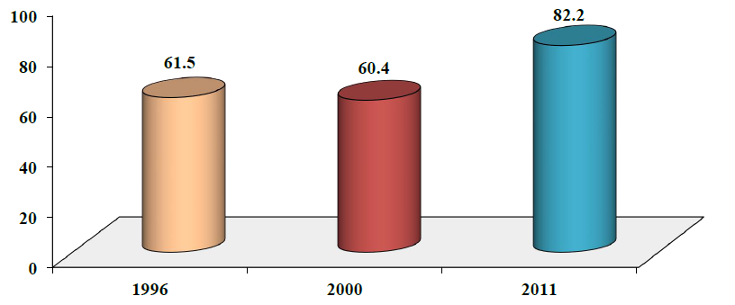
3. Workforce
The staff in the Ministry of Health witnessed an ongoing evolution after the PA came to power and took responsibility for the health sector in WB and GS in 1995. It increased from 4,758 persons in 1995 to 14,339 in 2013. As for physicians, dentists, and pharmacists’ rate, it increased from 20.2% of the overall workforce in the Ministry of Health in 1995 to 23.3% in 2003, reaching 24% in 2013.
Table (16): Workforce in the PA Ministry of Health 1995–2003
Year | Physicians, dentists and pharmacists | Nurses | Paramedical | Administration and services | Total
1995 | 963 | 1,634 | 804 | 1,357 | 4,758
1996 | 1,102 | 2,092 | 770 | 1,874 | 5,838
1997 | 1,201 | 2,147 | 761 | 2,381 | 6,490
1998 | 1,403 | 2,448 | 804 | 2,110 | 6,765
1999 | 1,367 | 2,371 | 967 | 2,405 | 7,110
2000 | 1,631 | 2,457 | 843 | 2,527 | 7,458
2001 | 1,864 | 2,675 | 842 | 2,904 | 8,285
2002 | 1,923 | 2,966 | 909 | 2,775 | 8,573
2003 | 2,110 | 2,985 | 910 | 3,064 | 9,069

Table (17): Workforce in the Ministry of Health in WB and GS – Selected Years
Year |  |  | 2005 | 2007 | 2010 | 2012 | 2013
WB |  |  | 4,751 | 4,952 | 6,226 | 6,438 | 6,700
Physician |  | General | 500 | 527 | 653 | 567 | 589
 |  | Specialist | 206 | 233 | 310 | 342 | 342
Dentist |  |  | 46 | 45 | 47 | 58 | 62
Pharmacist |  |  | 148 | 148 | 172 | 160 | 181
Nurse |  |  | 1,455 | 1,592 | 1,975 | 2,070 | 2,154
Midwife |  |  | 155 | 157 | 200 | 229 | 252
Paramedical |  |  | 490 | 530 | 752 | 1,066 | 964
Administration and services |  |  | 1,751* | 1,720 | 2,117 | 1,946 | 2,156
GS |  |  | 7,693 | 7,825 | 8,393 | 8,393 | 7,639
Physician | General |  | 920 | 928 | 1,567 | 1,567 | 1,291
Physician | Specialist |  | 541 | 733 | 594 | 594 | 510
Dentist |  |  | 150 | 176 | 238 | 238 | 238
Pharmacist |  |  | 229 | 243 | 240 | 240 | 227
Nurse |  |  | 1,550 | 1,794 | 1,597 | 1,597 | 1,425
Midwife |  |  | 71 | 104 | 84 | 84 | 78
Paramedical |  |  | 892 | 814 | 759 | 759 | 556
Administration and services |  |  | 3,340** | 3,033 | 3,314 | 3,314 | 3,314
WB & GS |  |  | 12,444 | 12,777 | 14,619 | 14,831 | 14,339
*Including 103 health workers.
** Including 83 health workers.

Workforce in the Ministry of Health in WB and GS–Selected Years
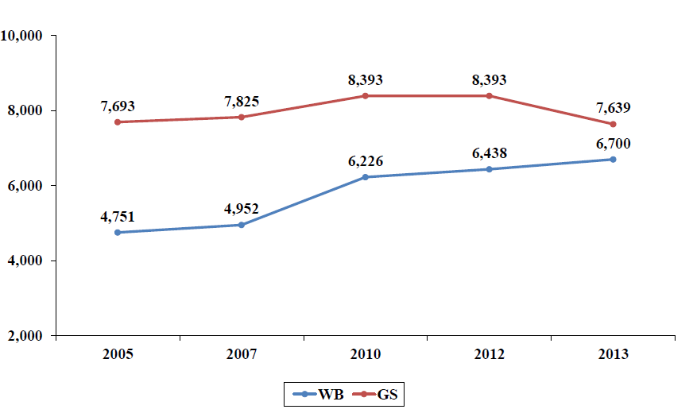

Data of the Palestinian Ministry of Health indicates that the workforce in GS is higher than that in WB, where it reached 6,700 employees in 2013 in WB and 7,639 in GS. If we study these two numbers based on profession, we see that the number of physicians and dentists in WB was 993, while it was 2,039 in GS, a 105.3% difference. In 2005, the WB numbers increased, but in GS there were still 114.2% more.
Despite the fact that the GS population is smaller than that of WB, 2013 statistics show that there are 11.8 physicians per 10 thousand population in GS, whereas in WB it was 3.6 physicians per 10 thousand population. This means that the physician’s rate in GS is three-times the WB rate. Table (17) shows the evolution of the workforce in the Ministry of Health based on profession and region over the same period.
4. Disease and Disability
Despite the spread of the Acquired Immunodeficiency Syndrome disease (AIDS) and Human Immunodeficiency Virus (HIV) (patients with AIDS who did not develop the disease’s symptoms) in the majority of world’s countries, the WB and GS record low rates of infections, where 64 AIDS and 13 HIV cases were recorded cumulatively since 1988 and till 2012. It is noted that the majority of AIDS cases were recorded among males (61 cases), that is a rate of 79.2% of total AIDS and HIV cases. Whereas in Israel, CBS recorded 900 AIDS cases cumulatively up to 2012, and 6 thousand HIV cases.
As for non-communicable diseases, the total new cancer cases reported in the WB reached 2,189 cases in 2013, a 21.5% increase from the 1,802 cases reported in 2012. The Palestinian Ministry of Health did not provide any data for GS. It is notable that the total new cases of cancer reported in WB and GS reached 1,623 cases in 2005 as follows: 1,168 cases in WB and 455 cases in GS.
If we study the reported cases of cancer in WB for 2013 by cancer type, we find that breast cancer accounted for 18.3% of the total cases for women. Colon cancers were second with 10.8%, and pulmonary cancer third with 10.1%. Pulmonary cancer came first in cancers recorded among men in 2013.
It is notable that there was a remarkable increase in reported cancer-related deaths in WB in 2013, where it increased from 10.3% in 2007 to 10.8% in 2010, reaching 13.3% in 2013.
Reported cases of diabetes mellitus reported by the public diabetes center in WB reached 4,816 cases in 2013 with a decrease of 19.3% in total reported cases in 2012. Records in GS were not available; the highest rate of diabetes mellitus was in the age group 55–64. In 2003, there were 3,818 new cases of diabetes mellitus reported in WB.
As for the diabetes mellitus deaths, WB recorded 421 cases in 2013, and there was no available data on GS, compared with 291 cases in 2003 in WB.

When studying disability cases over the Palestinian territories, we find 113 thousand cases in 2011, of whom 75 thousand were in WB, accounting for 2.9% of the total WB population, and around 38 thousand cases in GS, that is 2.4% of the total GS population. In return, the final result of the Population, Housing and Establishment Census in 2007 indicated that 108 thousand people in WB had at least one disability, accounting for 5.3% of the overall WB population. In 2006, PCBS indicated that 2.7% of individuals have at least one disability in the WB and GS as follows: 2.9% in the WB and 2.3% in GS.
Disabilities had a great impact on Palestinian society, where more than a third (37.6%) of all disabled individuals aged 15 years and above had never been enrolled at school, (35.5% in the WB and 42.2% in GS) and the majority of them do not work according to 2011 statistics.
5. Ministry of Health’s Actual Expenditures
The actual expenditure of the Ministry of Health in WB and GS reached $411 million in 2012, and around $360 million in 2013; a decrease of 12.4%, while in 1997 it did not exceed $93 million. These expenditures accounted for 12.6% of the PA’s total public expenditure ($3,258 million) in 2012, and 10.5% in 2013 ($3,419 million). It is notable that in 2013, salaries made up half (51.9%) of the expenditures of the Ministry of Health, while in 2012 they made up 38.3%, and 44.5% in 1997 (see table (18)).

Table (18): Distribution of Actual Expenditure for the PA Ministry of Health–Selected Years ($ million)
 | 1997 | 2000 | 2005 | 2012 | 2013
Salaries | 41.102 | 45.5 | 73.15 | 157.277 | 186.768
Other Expenditures | 51.282 | 54.836 | 66.45 | 253.227 | 173.157
Total | 92.384 | 100.336 | 139.6 | 410.504 | 359.925

Distribution of Actual Expenditure for the PA Ministry of Health–Selected Years
($ million)
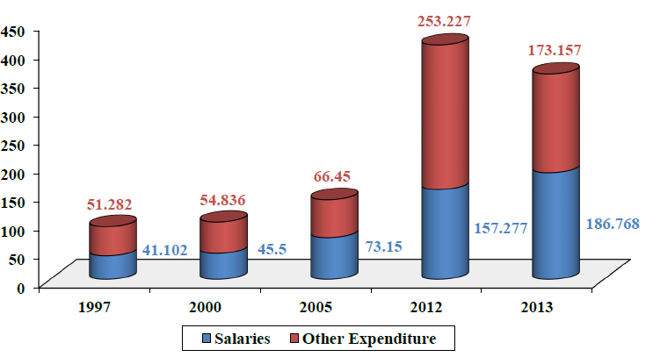

In its 2013 annual financial report the Palestinian Ministry of Health in GS published that its operating expenses had reached $169.5 million that year, while wages and salaries took the biggest share 39.3% (around $66.6 million). As for the average Israeli health expenditure rate, it reached 7.4% of 2012 Gross Domestics Product (GDP), and according to the CBS the Israeli average spending per capita reached $2,183 in 2011.
6. Occupation’s Impact on the Health Sector
Since its establishment, Israel has been working on limiting all development of Palestinian facilities, and even destroying them in the aim of destroying the life of the Palestinian individual and eliminating him from his land and home. Health services were among the facilities affected by Israeli policies. In Ramallah, for example, the number of hospital beds decreased from 209 beds for an estimated population of 115 thousand in 1967, to 116 beds for an estimated 140 thousand in 1987.
The occupation’s impact was not confined to basic supplies for hospitals and health centers, or the development of hospitals and their services, but also impacted Palestinian patients to the point of extortion, and even stealing their organs, in addition to unlicensed medical tests.
In 2005, the eardrums of a number of children were intentionally perforated in the aim of performing a drug test, despite the fact that this drug was not approved for medical use in any country around the world. This is according to a report by Eliezer Goldberg, the Israeli state comptroller, who said also that it took researchers more than a week to pass on the information in 21 out of 37 deaths. Some took more than a month, even though any fatality during such clinical tests should be reported to the ministry within 48 hours.

The Palestinian patients’ suffering did not end with their death; An investigation published by the Swedish newspaper Aftonbladet on 17/8/2009 showed the Israeli army had stolen organs from the bodies of Palestinians killed by the Israeli army or in accidents. The investigation added that the Israeli Medical Corps, in cooperation with the Abu Kabir Forensic Institute, had stolen the organs and implanted them in the bodies of Israeli soldiers injured in clashes with Palestinians. The investigation also noted that the Israeli army removed the skin of the dead, later to be implanted in the bodies of Israeli soldiers suffering skin burns.
Palestinian prisoners suffered the largest share of these practices, in addition to the medical negligence they already suffer from. The former prisoner and researcher specialized in prisoners’ affairs, ‘Abdul Nasser Farwana, in a research paper titled: “Palestinian Prisoners, Guinea Pigs for Israeli Pharmaceutical Companies,” confirmed that Israel is still using prisoners as “guinea pigs,” and that that the Israeli Health Ministry’s authorizations are increasing by 15% each year.
Medical staff did not escape Israeli barbarism either; in 2009 the number of attacks targeting medical staff reached 455, and since the start of al-Aqsa Intifadah on 29/9/2000 and until 3/10/2010, the number of medical staff killed reached 32. During the Israeli aggression against GS (27/12/2008–18/1/2009), Israeli forces murdered 14 medical staff, and targeted, through its land, sea, and aerial bombardment, many medical facilities and even ambulances.
This is not to mention the effects of the siege on GS. The WHO reported that 38% of essential drugs were out of stock in GS in early 2011. These shortages affect all Ministry of Health facilities, which provide 40% of primary health care and 80% of hospital care services in GS. 60% of Gazan children suffer from malnutrition and anemia, and 35% of the victims of the siege are children.
In addition to above, Israel exercised the worst kind of extortion where the proportion of applicants interrogated by the Israel Security Agency—ISA (Shabak) at the Beit Hanoun crossing to northern GS reached 17% in January 2009. The report also pointed out that between January 2008 and March 2009, at least 438 patients had been interrogated at Beit Hanoun crossing before obtaining an exit permit to get medical treatment outside of GS. 200 patients were also interrogated at Beit Hanoun between January and March 2010.

As for the Separation Wall, it is preventing patients from reaching medical centers and hospitals, which worsens their situations and even causes death. A study issued by the Health Development Information and Policy Institute revealed that 92% of patients residing to the west of the Separation Wall are having difficulties reaching medical services, to the extent that some have died at checkpoints after being delayed or prevented from reaching hospitals.

Summary
Since the al-Nakbah (catastrophe) of 1948 and 1967, the Palestinians have suffered from the Israeli occupation of their land, which tore their social fabric. Half of the Palestinians live in the land occupied in 1948, the WB, and GS, whereas the other half lives in the Diaspora; however, this people have clung on to their land, freedom and right to return. In historic Palestine, the Palestinian population increased by 111% over the period 1993–2013, and if the growth rates remain as they are, the Palestinians will outnumber Jews in 2016 or 2017.
Palestinian education is one of the most advanced in the Arab world; it shows the true capacities of the Palestinian people, their eagerness to be unique and their determination to succeed. The number of basic and secondary schools increased by 86.8% within the period of 1994/1995–2012/2013, and the number of students enrolled in traditional university increased by 424% over the same period.
The Palestinian health sector does not differ from other sectors in looking for uniqueness and looking to demonstrate steadfastness and creativity in the face of the Zionist project. However, the exceptional conditions the Palestinian people experience, due to the brutal occupation, siege and wars, made the health sector suffer from fundamental problems such as a decrease in hospitals numbers, the spread of disease, a shortage in supplies, not to mention Israeli attempts to extort patients in return for medication.
The development indicators this chapter studied indicate the enormous suffering and difficulties the Palestinian people face. However, they also prove that the Palestinian nation is still able to give, and that it has the qualities of patience and resilience to face a challenging occupation.

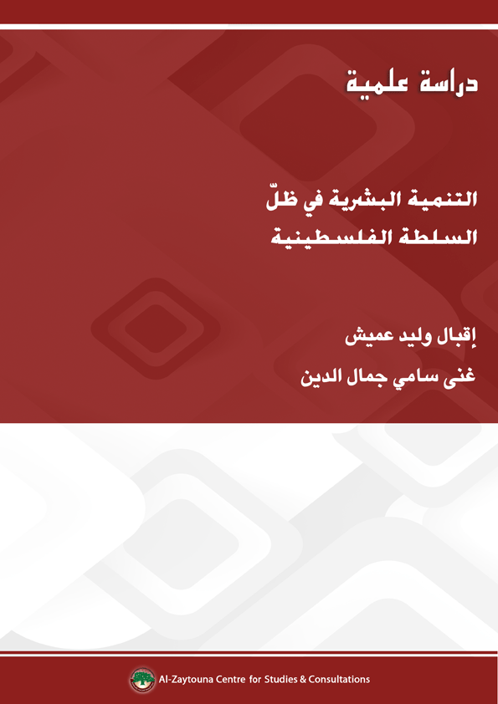

This study is an academic study that was published in the Arabic book of al-Zaytouna “The Palestinian National Authority: A Study of the Experience and Performance 1994–2013,” edited by Dr. Mohsen Mohammad Saleh, 2014.
Iqbal ‘Omeish: Head of the Academic Editing unit at al-Zaytouna Centre for Studies and Consultations. Both ‘Omeish and Ghina Jamal al-Din are researchers at al-Zaytouna. They participated in preparing the demographic, economic & educational indicators in several volumes of the Palestinian Strategic Report series, in addition to preparing the book of Gaza Strip: Development and Construction in the Face of Siege and Destruction. They also participated in the editing of many al-Zaytouna books and publications.
For the 1993 population, see Palestinian Central Bureau of Statistics (PCBS), Palestinian Population: A Proposed Count For Mid-Year 2000 (Ramallah: PCBS, November 2000), www.pcbs.gov.ps/Portals/_PCBS/Downloads/book634.pdf For 2002, see PCBS, Palestine in Figures 2002 (Ramallah: PCBS, May 2003), http://www.pcbs.gov.ps/Downloads/book894.pdf For 2007, see PCBS, Statistical Abstract of Palestine No. 9 (Ramallah: PCBS, December 2008), http://www.pcbs.gov.ps/Downloads/book1526.pdf For 2012, see PCBS, Palestinians at the End of Year 2012 (Ramallah: PCBS, December 2012), http://www.pcbs.gov.ps/Portals/_PCBS/Downloads/book1952.pdf For 2013, see PCBS, Palestinians at the End of 2013 (Ramallah: PCBS, December 2013), http://www.pcbs.gov.ps/Portals/_PCBS/Downloads/book2028.pdf
United Nations Relief and Works Agency for Palestine Refugees in the Near East (UNRWA), Syria Regional Crisis Response 2014: January – December 2014, http://www.unrwa.org/sites/default/files/2014_syria_emergency_appeal.pdf; and UNRWA, Syria Regional Crisis Response Update 74, 4/5/2014, http://www.unrwa.org/newsroom/emergency-reports/syria-regional-crisis-response-update-74
For the Numbers of 2012, see PCBS, Palestinians at the End of Year 2012; and UNRWA, UNRWA in Figures, 1/1/2013, http://www.unrwa.org/userfiles/2013042435340.pdf For 2013, see PCBS, Palestinians at the End of 2013; and UNRWA, UNRWA in Figures, 1/1/2014, https://www.unrwa.org/sites/default/files/2014_01_uif_-_english.pdf
For 2012, see PCBS, Palestinians at the End of Year 2012; and for 2013, see PCBS, Palestinians at the End of 2013.
See PCBS, Mashru‘ al-Nashr wa al-Tahlil li Bayanat al-Ti‘dad: Tafawut Numuw al-Mu’ashirat al-Iqtisadiyyah wa al-Ijtima‘iyyah Bayn al-Muhafazat al-Filastiniyyah 1997–2007 (Dissemination and Analysis of Census Findings: Disparities of Socio-Economic Indicators Among Palestinian Governorates 1997–2007) (Ramallah: PCBS, December 2009), http://www.pcbs.gov.ps/Downloads/book1634.pdf; and PCBS, Palestinians at the End of Year 2011 (Ramallah: PCBS, December 2011), http://www.pcbs.gov.ps/Portals/_PCBS/Downloads/book1815.pdf; and PCBS, Palestinians at the End of 2013; and PCBS, Summary of Demographic Indicators in Palestine by Region, http://www.pcbs.gov.ps/Portals/_Rainbow/Documents/Pop%20Projections_main%20ind_a.htm (in Arabic)
PCBS, Palestinians in Figures 2012 (Ramallah: PCBS, March 2013), http://www.pcbs.gov.ps/Downloads/book1967.pdf
PCBS, Palestinians at the End of 2013.
For 1997, see PCBS, Mashru‘ al-Nashr wa al-Tahlil li Bayanat al-Ti‘dad: Tafawut Numuw al-Mu’ashirat al-Iqtisadiyyah wa al-Ijtima‘iyyah Bayn al-Muhafathat al-Filastiniyaah 1997–2007. As for 2013, see PCBS, Palestinians at the End of 2013.
For the Numbers of Palestinians 2011–2013, see PCBS, Palestinians at the End of Year 2011; PCBS, Palestinians at the End of Year 2012; and PCBS, Palestinians at the End of 2013. As for the number of Jews 2011–2013, see Central Bureau of Statistics (CBS), http://www1.cbs.gov.il/publications14/yarhon0114/pdf/b1.pdf
See PCBS, Palestine in Figures 2013 (Ramallah: PCBS, March 2014), http://www.pcbs.gov.ps/Downloads/book2040.pdf; and see UNdata, Adult Literacy Rate, http://data.un.org/Data.aspx?d=SOWC&f=inID%3A74
PCBS, Palestine in Figures 2013.
For the academic year 1994/1995, see PCBS and Ministry of Education and Higher Education, Education Statistical Yearbook 1994/1995 No (1) (Ramallah: PCBS and Ministry of Education and Higher Education, September 1995), http://www.pcbs.gov.ps/Portals/_PCBS/Downloads/book4.pdf As for the academic year 1999/2000, see Statistical Abstract of Palestine No. (1) (Ramallah: PCBS, November 2000), http://www.pcbs.gov.ps/Downloads/book678.pdf For the academic year 2005/2006, see Ministry of Education and Higher Education, Summary Statistics of Public Education in Palestine 2005–2006, http://www.mohe.gov.ps/stats/statistic.pdf (in Arabic) For the academic year 2011/2012, see Ministry of Education and Higher Education, Annual Educational Statistics 2011/2012 (Ramallah: Ministry of Education and Higher Education), http://www.moehe.gov.ps/ShowArticle.aspx?ID=825 For the academic year 2012/2013 see Ministry of Education and Higher Education, Education Statistical Yearbook for Scholastic Year 2012/2013 (Ramallah: Ministry of Education and Higher Education, June 2013), http://www.wafainfo.ps/pdf/edu_2012-2013.PDF For the academic year 2013/2014 see Ministry of Education and Higher Education, Tables of the Education Statistical Yearbook 2013–2014, http://www.mohe.gov.ps/Uploads/ramamohe/statistics2014.xls
For the academic year 1994/1995, see PCBS and Ministry of Education and Higher Education, Education Statistical Yearbook 1994/1995 No (1). For the academic year 2013/2014 see Ministry of Education and Higher Education, Tables of the Education Statistical Yearbook 2013–2014.
For the academic year 1994/1995, see PCBS and Ministry of Education and Higher Education, Education Statistical Yearbook 1994/1995 No (1). For the academic year 1999/2000, see Statistical Abstract of Palestine No. (1). For the academic year 2005/2006, see Ministry of Education and Higher Education, Summary Statistics of Public Education in Palestine 2005–2006. For the academic year 2011/2012, see Ministry of Education and Higher Education, Annual Educational Statistics 2011/2012. For the academic year 2012/2013, see Ministry of Education and Higher Education, Education Statistical Yearbook for Scholastic Year 2012/2013. For the academic year 2013/2014, see Ministry of Education and Higher Education, Tables of the Education Statistical Yearbook 2013–2014.
For the academic year 1994/1995, see PCPS and Ministry of Education and Higher Education, Education Statistical Yearbook 1994/1995 No (1). For the academic year 2003/2004, see Ministry of Education and Higher Education, Higher Education Statistical Yearbook 2003/2004 (Ramallah: Ministry of Education and Higher Education, August 2004), http://www.mohe.pna.ps/List/Daleel/Daleel2003-2004.pdf For the academic year 2012/2013, see Ministry of Education and Higher Education, Higher Education Statistical Yearbook 2012/2013 (Ramallah: Ministry of Education and Higher Education, August 2013), http://www.mohe.pna.ps/List/Daleel/Daleel2012-2013.pdf
See Ministry of Education and Higher Education, Higher Education Statistical Yearbook 2012/2013.
See Ibid.
For the academic year 1994/1995, see PCPS and Ministry of Education and Higher Education, Education Statistical Yearbook 1994/1995 No (1). For the academic year 2003/2004, see Ministry of Education and Higher Education, Higher Education Statistical Yearbook 2003/2004. For the academic year 2012/2013, see Ministry of Education and Higher Education, Higher Education Statistical Yearbook 2012/2013.
Ibid.
United Nations (UN), United Nations General Assembly (UNGA), The Universal Declaration of Human Rights, Article 25, see http://www.un.org/en/universal-declaration-human-rights/
UNRWA in Figures, 1/1/2014.
Palestinian Health Information Center (PHIC) – Ministry of Health, Al-Taqrir al-Sihhi al-Sanawi 2012 (Health Annual Report 2012) (Palestine: PHIC – Palestinian Ministry of Health, 2013), http://www.moh.ps/attach/501.pdf
PHIC – Ministry of Health, Al-Taqrir al-Sihhi al-Sanawi 2013 (Health Annual Report 2013) (Palestine: PHIC – Palestinian Ministry of Health, 2014), http://www.moh.ps/attach/703.pdf
PHIC – Ministry of Health, Al-Taqrir al-Sihhi al-Sanawi 2012.
CBS, Statistical Abstract of Israel 2013, no. 64, table 6.6, 6.7 and 6.8, pp. 320–321 http://www1.cbs.gov.il/reader/shnaton/templ_shnaton_e.html?num_tab=st06_06&CYear=2013 http://www1.cbs.gov.il/reader/shnaton/templ_shnaton_e.html?num_tab=st06_07&CYear=2013 http://www1.cbs.gov.il/reader/shnaton/templ_shnaton_e.html?num_tab=st06_08&CYear=2013
For 1996 and 2000, see PCBS, Statistical Abstract of Palestine No. (2) (Ramallah: PCBS, November 2001), http://www.pcbs.gov.ps/Portals/_PCBS/Downloads/book731.pdf And for 2005, see PCBS, Statistical Abstract of Palestine No. “7” (Ramallah: PCBS, November 2006), http://82.213.38.42/Portals/_PCBS/Downloads/book1320.pdf As for 2012, see PCBS, Statistical Yearbook of Palestine No. 14 (Ramallah: PCBS, December 2013), www.pcbs.gov.ps/Portals/_PCBS/Downloads/book2025.pdf
For 1996 and 2000, see PCBS, Statistical Abstract of Palestine No. (2). And for 2011, see PCBS, Statistical Yearbook of Palestine No. 14.
PHIC – Ministry of Health, Al-Taqrir al-Sihhi al-Sanawi 2003 (Health Annual Report 2003) (Palestine: PHIC – Palestinian Ministry of Health, 2004), http://www.moh.ps/?lang=1&page=4&id=137
For 2005, see PHIC – Ministry of Health, Al-Taqrir al-Sihhi al-Sanawi 2005 (Health Annual Report 2005) (Palestine: PHIC – Palestinian Ministry of Health, 2006), http://www.moh.ps/?lang=0&page=4&id=9 For 2007–2013, see PHIC – Ministry of Health, Al-Taqrir al-Sihhi al-Sanawi 2013.
See PHIC - Ministry of Health, Al-Taqrir al-Sihhi al-Sanawi 2012.
For more details, see CBS, Statistical Abstract of Israel 2013, no. 64, table 6.16 and table 6.17, http://www1.cbs.gov.il/reader/shnaton/templ_shnaton_e.html?num_tab=st06_16&CYear=2013 http://www1.cbs.gov.il/reader/shnaton/templ_shnaton_e.html?num_tab=st06_17&CYear=2013
PHIC – Ministry of Health, Al-Taqrir al-Sihhi al-Sanawi 2005; and PHIC – Ministry of Health, Al-Taqrir al-Sihhi al-Sanawi 2013.
PHIC – Ministry of Health, Al-Taqrir al-Sihhi al-Sanawi 2013.
Ibid.
PHIC – Ministry of Health, Al-Taqrir al-Sihhi al-Sanawi 2003; and PHIC – Ministry of Health, Al-Taqrir al-Sihhi al-Sanawi 2013.
Ibid.
PCBS, PCBS Issues a Press on the Eve of World Disabled Day, 10/12/2009, http://www.pcbs.gov.ps/Portals/_pcbs/PressRelease/disabled_per_A.pdf (in Arabic); and PCBS, The Occasion of International Disables Day, 3/12/2013, http://www.pcbs.gov.ps/site/512/default.aspx?tabID=512&lang=en&ItemID=969&mid=3172&wversion=Staging
PCBS, The Occasion of International Disables Day, 3/12/2013.
US Dollar.
Palestine Monetary Authority (PMA), Annual Report 2013 (Ramallah: PMA, 2014), p. 126, http://www.pma.ps/Portals/1/Users/002/02/2/Publications/English/Annual%20Reports/PMA%20Annual%20Reports/Annual_Report_2013_Final_En.pdf
For 1997 and 2000, see PHIC – Ministry of Health, Al-Taqrir al-Sihhi al-Sanawi 2003. For 2005, PHIC – Ministry of Health, Al-Taqrir al-Sihhi al-Sanawi 2006 (Palestine: PHIC – Ministry of Health, 2007), http://www.moh.ps/?lang=0&page=4&id=142 For 2012, see PHIC – Ministry of Health, Al-Taqrir al-Sihhi al-Sanawi 2012. For 2013, see PHIC – Ministry of Health, Al-Taqrir al-Sihhi al-Sanawi 2013. Note: The exchange rate of the dollar against the Israeli shekel in 2012 and 2013 was based on the Bank of Israel data, which was 3.8559 and to 3.6107 respectively.
PHIC and Ministry of Health – GS, Al-Taqrir al-Mali al-Sanawi 2013 (Annual Financial Report 2013) (Palestine: Ministry of Health – GS, 2014), http://bit.ly/2tYHDOO Note: The exchange rate of the dollar against the Israeli shekel in 2011 was based on the Bank of Israel data, which was 3.5781.
CBS, Press Release, 17/9/2013, http://www1.cbs.gov.il/www/hodaot2013n/08_13_197e.pdf
Palestinian Center for Documentation and Information (Malaf), The Development of Health Services in Palestine, http://www.malaf.info/?page=show_details&Id=138&CatId=32&table=pa_documents (in Arabic)
Israeli Hospitals Used Old and Mentally Infirm as Human Guinea Pigs, The Telegraph newspaper, 10/5/2005, http://www.telegraph.co.uk/news/worldnews/middleeast/israel/1489723/Israeli-hospitals-used-old-and-mentally-infirm-as-human-guineapigs.html; and see Patients Were Guinea Pigs and Didn’t Know It, Haaretz newspaper, 9/5/2005, http://www.haaretz.com/print-edition/news/patients-were-guinea-pigsand-didn-t-know-it-1.158122
Asharq Alawsat newspaper, London, 2/2/2010; and see Top Sweden Newspaper Says IDF Kills Palestinians for Their Organs, Haaretz newspaper, 22/8/2009, http://www.haaretz.com/news/top-sweden-newspaper-saysidf-kills-palestinians-for-their-organs-1.282166; see also Våra Söner Plundras Påsina Organ, Aftonbladet newspaper, Sweden, 17/8/2009, http://www.aftonbladet.se/kultur/article5652583.ab
Alquds newspaper, 6/12/2010.
Palestinian Centre for Human Rights (PCHR), Statistics Related to the Al Aqsa (Second) Intifada “October 2010 Update,” http://www.pchrgaza.org/portal/en/index.php?option=com_content&view=article&id=3044:statistics-related-to-theal-aqsa-second-intifada-&catid=55:statistics&Itemid=29 See also: PCBS, Martyrs and Wounded in Gaza Strip, 28/1/2009, http://www.pcbs.gov.ps/DesktopModules/Articles/ArticlesView.aspx?tabID=0&lang=ar-JO&ItemID=1411&mid=12059 (in Arabic)
World Health Organization-occupied Palestinian territory (WHO-oPt), Drug Shortages in Gaza: Background Note to the HC, 3/2/2011, http://issuu.com/whoopt/docs/backgroundnote-drugs?mode=window&pageNumber=1; and Khudari: 60 Percent of Gaza Children Suffer Malnutrition and Anemia, site of The Palestinian Information Center (PIC), 5/4/2010.
UN to Examine Israel’s Torture Record, The Jerusalem Post newspaper, 5/4/2009, http://www.jpost.com/Israel/Article.aspx?id=141057; and site of Aljazeera.net, 3/3/2010.
The Arab Orient newspaper, The Arab Orient Center for Strategic and Civilization Studies, London, 20/3/2004, http://www.asharqalarabi.org.uk/paper/s-akhbar-20a.htm, citing Media and Information Center. (in Arabic)

