The Conditions and Issues of Palestinian Refugees in the Arab World

Dr. Mohsen Mohammad Saleh
General Manager of al-Zaytouna Centre for Studies and Consultations

Riyadh, 17-19/11/1436 AH
Corresponding to 1-3/9/2015 AD

Table of Contents

Summary..……………………………………………………………….………4
Introduction: The Emergence of the Palestinian Refugees Issue………..….…..5
First: Palestinian Refugees (General Statistical Overview):.…………………....7
1. Palestinians in the World…………………………………..…………….....7
2. Palestinian Refugees in the World……………………………………….…8
3. The Number of Palestinians Registered with UNRWA………………….…9
4. The Number of Palestinians Living in the Arab World……………………10
Second: Palestinian Refugees Conditions and Issues:.…………………………13
1. Jordan……………………………………………………..…………….…13
2. Syria…………...………………………………………..…………………14
3. Lebanon……………………………………………………..………..……18
4. KSA……………………………………………………..…………………24
5. Iraq………………………………………...…………..………..…………25
6. Libya ……………………………………………………..…………..……28
7. Kuwait……………………………………………………..………………30
Conclusions and Recommendations………………………………………..…34

Summary
The Conditions and Issues of Palestinian Refugees in the Arab World

The issues of Palestinian refugees emerged in the wake of the Arab-Israeli war in 1948, when the Zionist gangs, which created Israel on around 77% of the land of Palestine, forcibly displacing around 800 thousand Palestinians, or 57% of the total population of Palestine at the time. The problem of the refugees grew worse when Israel occupied the remainder of Palestine in the war of 1967, where around 300 thousand Palestinians were displaced.
The issue of the Palestinian refugees is the most prominent refugee crisis in terms of the number of refugees per capita of the total population. Furthermore, it is the longest-lasting refugee crisis in modern history and has yet to be resolved, more than 67 years later. The Palestinian refugee question has also drawn the highest number of international resolutions, with resolution 194 regarding the right of return for Palestine refugees being reaffirmed more than 120 times.
More than half of the Palestinian people live outside historical Palestine. More than 88% of Palestinians in the Diaspora live in Arab countries, the natural host for the Arab Palestinian people. Palestinian refugees are concentrated in the countries bordering Palestine, with up to 80% of Palestinian refugees in the Arab world living in Jordan, Syria, and Lebanon. A large number of Palestinians also live in the Arab Gulf countries, particularly the Kingdom of Saudi Arabia (KSA).
The Palestinian refugee question in the Arab world has taken on national, nationalist, Islamic, and humanitarian dimensions. The Arab countries have borne their share of the burden of liberating Palestine, supporting the Palestinian people, and working for the return of the refugees. At the same time, the refugees issue took on political, economic, social, and security dimensions: In addition to the political and economic burdens borne by the Arab host countries, the Palestinian people’s quest for return and liberation, and their adoption of armed struggle, led to a lot of friction and conflict in the host countries, especially those that border Palestine. These countries sought to crackdown on Palestinian action in accordance to their vision to their national interests and security needs.
The policy of the Arab regimes in dealing with the refugees ranged from giving them full citizenship rights like in Jordan, to complete denials of all civil rights like in Lebanon. Some Arab regimes tried to take political and military advantage of the presence of Palestinian refugees in their territories, and of the difficulty of their conditions and needs. In other cases, the Palestinians fell victim to internal, local, or inter-Arab disputes. A number of countries, meanwhile, had a net gain from Palestinian refugee presence, where Palestinians had important roles in their development and renaissance.
The Conditions and Issues of Palestinian Refugees in the Arab World

Introduction: The Emergence of the Palestinian Refugees Issue

The Zionists declared the state of Israel on the evening of 14/5/1948. They seized around 77% of historical Palestine (20,770 km²), and forcibly displaced 800 thousand Palestinians outside the territories that became the state of Israel, out of 925 thousand Palestinians who lived there (the total number of Palestinians at the end of 1948 was approx. 1.4 million people). In other words, the Zionist movement displaced around 57% of the Palestinian people from the territory it occupied in 1948. The Zionists displaced 30 thousand others into other areas of the territories occupied in 1948. The number of refugees had increased to 900 thousand by the time the United Nations Relief and Works Agency for Palestine Refugees in the Near East (UNRWA) was established in 1951. The Zionists destroyed around 400 Palestinian villages out of 585 villages that existed in the occupied territory, carrying out 34 massacres in 1948 against Palestinian civilians in the process of dispossessing them, most notoriously the Deir Yassin massacre on 9/4/1948. In that massacre, as the Zionists themselves had admitted, 254 men, women, and children were killed. As for the rest of Palestine, Jordan annexed the West Bank (WB) officially (5,876 km²) and Egypt placed the Gaza Strip (GS) under its control (363 km²).
The war of 1948 tore the social and economic fabric of the Palestinian people, who found themselves homeless and exposed, after 4,500 years of inhabiting their land.
On 11/12/1948, the UN General Assembly issued resolution 194, calling for the return of Palestinian refugees to their native land and homes. The choice in this matter was placed in the hands of the refugees and not others to decide on their behalf or prevent their return, which was construed as an act of aggression. The resolution also created a UN conciliation commission to facilitate the return of the refugees to their homes and rehabilitate them economically and socially, as well as providing them with reparations.
This resolution was emphasized repeatedly over the years, as Israel continued to oppose its implementation. However, the UN, specifically the Security Council, took no action to pressure or compel Israel to implement the resolution. The UN admitted Israel as a member state, provided that it would allow the return of Palestinian refugees, something that Israel has never agreed to do.
Since 1948, what we know as the Palestinian refugee crisis started. Here, we note the following points:
First: The number of Palestinian refugees is the largest, relative to the size of the population. The initial figure of 800 thousand refugees out of 1.4 million represents a ratio of 57%.
Second: We are facing the longest and largest refugee crisis in the modern era that is yet to be resolved. The Palestinian refugee issue is now around 67 years old, while most other refugee crises have been resolved or on their way to being resolved, from Afghanistan to Bosnia, Somalia, and Armenia and others. No one prevents these refugees from returning home and exercising their civil and political rights.
Third: This issue is backed by international consensus. This means it does not reflect just a Palestinian desire, but international institutional consensus on the right of return. A large number of international resolutions has been issued regarding the Palestinian refugee issue, vastly outnumbering any resolutions regarding other similar issues. Resolution 194 regarding the right of Palestinian refugees to return to their lands and their homes (in the land occupied in 1948) was reaffirmed more than 130 times.
The UN General Assembly established UNRWA on 8/12/1949, but it did not start its work until May 1950, in order to secure aid for Palestinian refugees.

First: Palestinian Refugees (General Statistical Overview)

1. Palestinians in the World
With the end of 2014 and the start of 2015, the number of Palestinians according to the Palestinian Central Bureau of Statistics, was about 12 million and 96 thousand inhabitants. Approximately 6 million and 17 thousand people live outside of Palestine (49.7%), while 6 million and 79 thousand live in historic Palestine (50.3%). These statistics are accurate to a large extent in Palestine, but they are estimates outside of Palestine, based on a set of data and statistical indicators.

Table 1: Palestinian Population Worldwide Estimate According to Place of Residence at the End of 2014 (thousands)
Place of residence |  | 2014
 |  | Population estimate | Percentage (%)
Palestinian territories  occupied in 1967 | WB | 2,684.4 | 23
 | GS | 1,790 | 15
Palestinian territories occupied in 1948 (Israel)* |  | 1,462.5 | 12
Other Arab countries |  | 5,341.5 | 44
Foreign countries |  | 675.3 | 6
Total |  | 12,095.7 | 100
* For the Palestinian population in the 1948 occupied territories; the number does neither include the Palestinians in the 1967 occupied territories, including Jerusalem, nor does it include Arab Syrians, Lebanese or non-Arab Christians or those classified as “Others.”

Palestinian Population Worldwide Estimate According to Place of Residence at the End of 2014 (%)

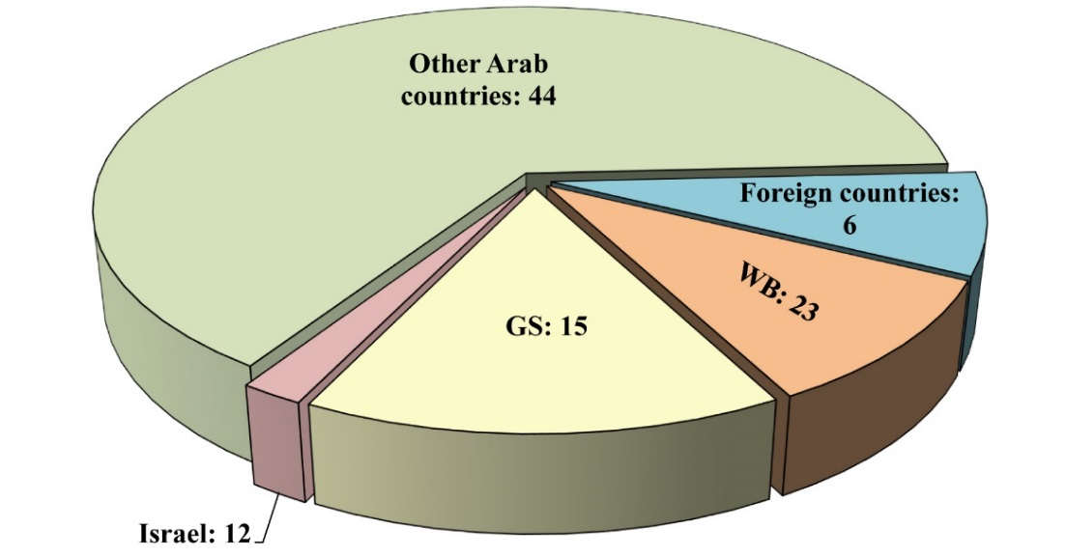
2. Palestinian Refugees in the World
There is confusion oftentimes regarding the definition of Palestinian refugees, and the determination of their number. To clarify this we point out the following:
- Palestinian refugees are not only all the Palestinians residing outside Palestine, since there are Palestinian refugees residing inside Palestine.
- Not all Palestinian refugees were displaced in 1948. Some were displaced in 1967, and others were displaced for various other reasons then prevented from retuning.
- Palestinian refugees do not solely comprise those living in the WB, GS and the Diaspora. There are Palestinian refugees who were displaced but still live in other areas of the Palestinian territories occupied in 1948.
- The Palestinian people outside Palestine are a mixture of 1948 and 1967 refugees.
Generally speaking, if we count the Palestinians living abroad with the Palestinian refugees living in Palestine, the overall figure will be 8.156 million at the end of 2014, of whom 27% are in historical Palestine and 73% outside historical Palestine. We note from this figure that around 67.8% of the people of Palestine are refugees, the largest proportion of refugees compared to the general population in the world. We also note that most Palestinians living abroad reside in Arab countries, especially so-called ring countries (adjacent to Israel).

Table 2: Palestinian Refugees Worldwide; Population Estimates in 2014 (thousands)
Place of residence |  | 2014
 |  | Population estimate | Percentage (%)
Palestinian territories  occupied in 1967 | WB | 772.2 | 10
 | GS | 1,216.8 | 15
Palestinian territories occupied in 1948 (Israel)* |  | 150 | 2
Other Arab countries |  | 5,341.5 | 65
Foreign countries |  | 675.3 | 8
Total |  | 8,155.8 | 100
* Estimated number.

Palestinian Refugees Worldwide; Population Estimates in 2014 (%)

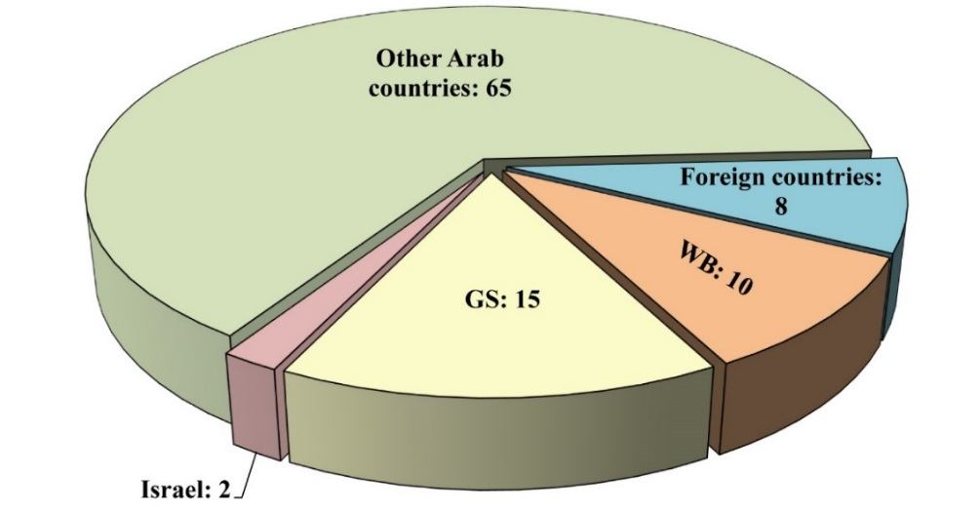

3. The Number of Palestinians Registered with UNRWA
UNRWA’s statistics cover only the Palestinians who registered themselves as refugees in the areas where the agency operates, namely: WB, GS, Jordan, Syria, and Lebanon. Thus, it must be noted that UNRWA figures do not accurately reflect the real number of Palestinian refugees in the world, having excluded many Palestinian refugees residing outside its areas of operation. The figures also excluded many who do live in these areas, but did not register with the agency. UNRWA figures also exclude up to 330 thousand Palestinian refugees displaced during the 1967 war, and other refugees who were forced to leave for reasons other than war and prevented from returning.
UNRWA figures cannot be dealt with as accurate figures on the numbers of refugees displaced in 1948, perhaps with the exception of refugees in Syria and Lebanon to some extent. Rather, these figures reflect the numbers of those who voluntarily registered themselves to receive aid and services from UNRWA.

Table 3: UNRWA Registered Palestinian Refugees, 1/7/2014
Region | Refugees | %
WB | 925,191 | 17
GS | 1,328,351 | 24
Lebanon | 488,213 | 9
Syria | 564,074 ⃰ | 10
Jordan | 2,187,286 | 40
Total | 5,493,155 | 100

* This figure is the UNRWA registered refugees IN Syria, and not
who actually stayed of them in Syria.
UNRWA Registered Palestinian Refugees, 1/7/2014 (%)

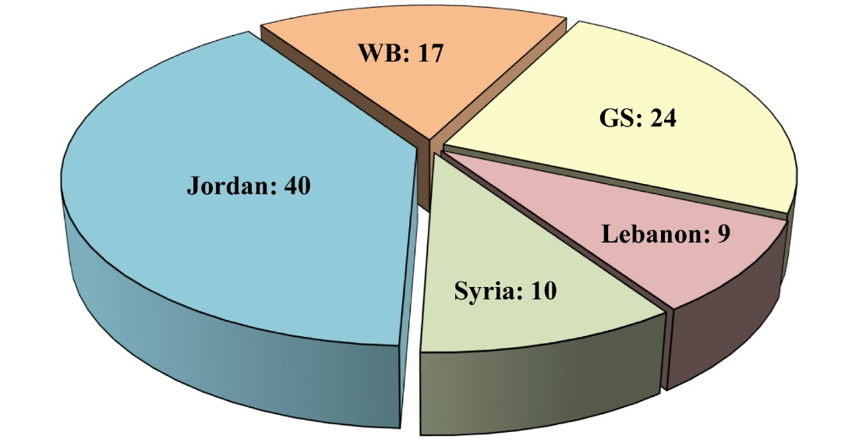

4. The Number of Palestinians Living in the Arab World
The Arab world is the natural host region for Palestinian refugees, home to 5.34 million Palestinian refugees or 89% of all Palestinians abroad. Palestinian refugees are concentrated in the areas surrounding Palestine, with more than 80% of Palestinian refugees living in Jordan, Syria, and Lebanon. This indicates Palestinians remain close to their land to which they still aspire to return.
Huge difficulties hinder the close estimation of the number of Palestinians abroad. Most Palestinians carry Jordanian passports, and it is difficult to separate them statistically from their trans-Jordanian co-citizens. Most Arab countries do not provide official statistics on Palestinians, while many Palestinians hold foreign passports, American, European, Australian, etc. The table we included is approximate, based on a number of sources led by the Palestinian Central Bureau of Statistics, UNRWA, and estimates prepared by Salman Abu Sitta, an expert on Palestinian refugee issues, among others.
Concerning the number of Palestinians in Jordan, they were estimated based on figures from the Palestinian Central Bureau of Statistics estimates at the end of the year 2009. Their number reached 3.24 million at that year, while the numbers from the subsequent years were extrapolated based on annual growth rates released by the Jordanian Department of Statistics, which is estimated at 2.2%.
In Lebanon, the number of Palestinian refugees totaled according to UNRWA records in the middle of 2014 about 488 thousand. However, most field estimates indicate the actual figure in the past several years did not exceed 300 thousand , due to the migration of many of them while they remained registered with UNRWA, added to them about 40 thousand who joined them from the Palestinians in Syria.
The number of Palestinian refugees in Syria, according to UNRWA records in mid-2010 was about 478 thousand, and about 564 thousand in mid-2014. However, UNRWA indicates that around 100 thousand were displaced outside Syria during the Syrian conflict. In general, if the number of refugees registered with UNRWA are added to around 50 thousand Palestinians who were not registered or who came to Syria after the exodus in 1948, the number in 2010 would be around 525 thousand in 2010 and 515 thousand in 2014.
Inevitably, some estimates provided by these sources contain some overlap due to people being counted more than once, as some officially reside in one area while actually residing in another because of movement of people for various reasons.

Table 4: Number of Palestinians Living in Arab Countries at the End of 2010 in Comparison with the End of 2014 (thousand)
Region | Year
 | 2014 | 2010
Jordan | 3,613 | 3,311
Lebanon | 340 | 300
Syria | 515 | 525
Egypt | 70 | 68
KSA | 460 | 390
Kuwait | 60 | 52
UAE | 160 | 125
Qatar | 50 | 40
Iraq | 10 | 15
Libya | 22 | 25
Other Arab Countries | 40 | 26
Total | 5,340 | 4,877

Number of Palestinians Living in Arab Countries at the End of 2010 in Comparison with the End of 2014 (thousand)

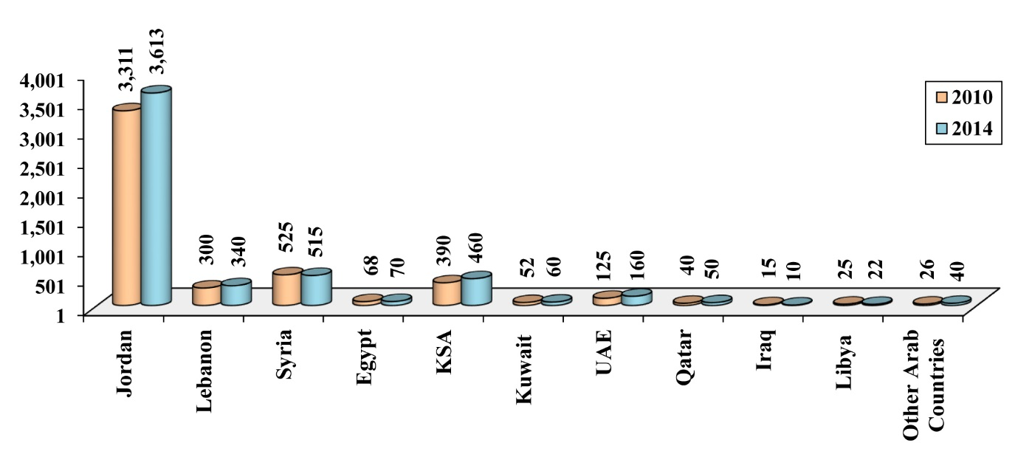

Number of Palestinians Living in Arab Countries at the End of 2014 (thousand)
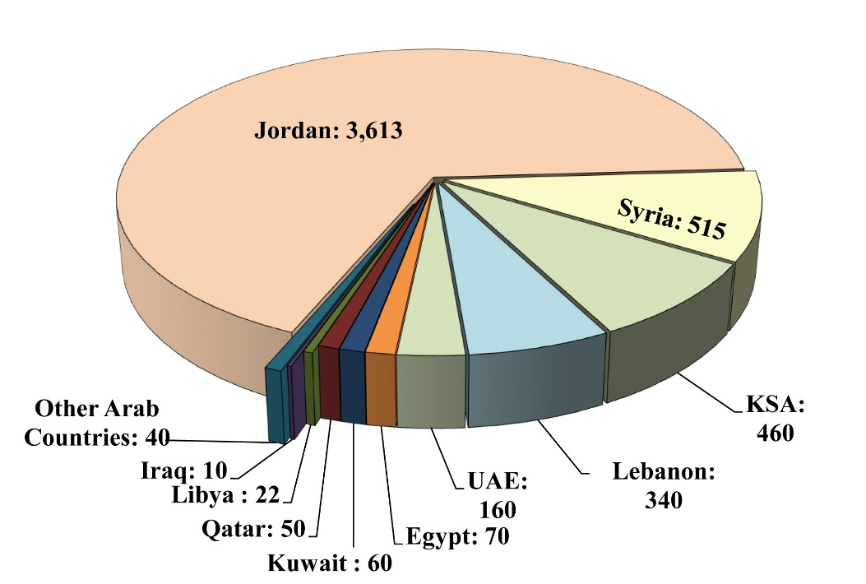

Second: Palestinian Refugees Conditions and Issues

We highlight in this section the conditions of Palestinian refugees in a number of Arab countries and how these countries deal with them.
In general, the issue of Palestinian refugees in the Arab world has taken on national, nationalist, Islamic as well as a humanitarian dimension. The Arab countries have borne their share of responsibility in the quest for the Liberation of Palestine, supporting the Palestinian people and seeking to return the refugees. The refugees issue took on political, economic, social and security dimensions. In addition to the political and economic burdens borne by the Arab host countries, the Palestinian people’s quest for return and liberation, and their adoption of armed struggle, led to a lot of friction and conflict in the host countries, especially those that border Palestine (Jordan, Egypt, Syria and Lebanon). These countries sought to crackdown on Palestinian action in accordance to their vision to their national interests and security needs. This has made the security dimension paramount for a number of Arab governments.
The policy of the Arab regimes in dealing with the refugees ranged from giving them full citizenship rights like in Jordan, to complete denials of all civil rights like in Lebanon. Although fears of permanent settlement of Palestinians would be imposed on the country was a huge concern for Lebanese decision makers, to the extent that this was mentioned in the preamble to the Lebanese constitution, powerful entities in the countries granted Lebanese citizenship to thousands of Palestinians on sectarian and religious bases.
Some Arab regimes tried to take political and military advantage of the presence of Palestinian refugees in their territories, and of the difficulty of their conditions and needs, as happened in Syria, Iraq, and Libya. In other cases, the Palestinians fell victim to internal, local, or inter-Arab disputes, as happened in Iraq, Kuwait, Syria, and Lebanon. Palestinians sometimes paid the price of mistakes made by their own leaders, while a number of countries had a net gain from Palestinian refugee presence, where Palestinians had important roles in their development and renaissance, especially in Jordan and the Gulf.

1. Jordan
Palestinians in Jordan were officially granted Jordanian citizenship and all associated rights, from working, purchasing property, and building, to voting, running in elections, and participating in the government, following the unification of the WB with the East Bank of the Jordan River in 1950 under the rule of King Abdullah Bin al-Hussein. Several Palestinians served as prime minister, including Samir Rifa‘i, Sulayman al-Nabulsi, and Taher al-Masri. However, the regime’s relationship with the Palestinians or their representatives saw some turbulences, most notably the issue of official Palestinian representation after the creation of the Palestine Liberation Organization (PLO) in 1964, which officially became the sole legitimate representative of the Palestinian people in accordance to the Arab summit resolutions in Rabat in 1974, giving rise to a kind of duplication in representation.
The number of Palestinians in Jordan at the end of 2014 was estimated to be around 3.613 million. According to data from 2010, the average size of the Palestinian family in Jordan was 4.8 people, and the annual population growth rate was 2.2%. According to UNRWA statistics in mid-2014, there are 2.187 million registered refugees, about 18% of them live in refugee camps.
One of the most dramatic turning points was the Israeli occupation and annexation of the WB in June 1967, causing Jordan to lose actual control and sovereignty over the territory. Jordan continued to consider the WB part of its territory until King Hussein Bin Talal issued in the summer of 1988 a decision to disengage from the WB, leaving the PLO alone in charge of attempting to represent the WB, while it was still under Israeli occupation. In truth, the events of September 1970 caused a huge rift between the Jordanian government and factions of the PLO. The fighting that erupted between the two sides paved the way for the Jordanian army to crush Palestinian resistance movements in Palestine, which now lost their influence in the kingdom. This was reflected in a negative way how the regime dealt with Palestinians in general, causing their influence in government institutions to wane despite the fact that their constitutional rights remained unchanged from the official point of view.
There are no accurate statistics in Jordan on the number of Palestinian citizens of Jordan, but estimates suggest they account for around 60% of Jordanians, a figure corroborated by American and European sources. However, the manner in which electoral districts are gerrymandered prevents Palestinians from ever forming a parliamentary majority. In the elections of 1997, 13 Palestinians were elected MPs out of 80 MPs, or 16.25%. Note: We consider the Palestinians and Jordanians to be one people, and that achieving justice for all is a natural right that does not prejudice other rights.

2. Syria
Before the conflict erupted in Syria in the spring of 2011, around 560 thousand Palestinians lived in the country, most of them originally displaced in 1948. This number was expected to reach 620 thousand in 2015 were it not for the bloody turn of events.
The Syrian authorities granted Palestinian refugees all rights associated with citizenship with the exception of political rights. The Palestinians were not given Syrian passports but only Syrian travel documents, and they were not given the right to nominate or elect. Palestinians in Syria, however, have the freedom to work, reside indefinitely, and move, and are required to join national armed service. They were also allowed to actively participate in Syrian society at all levels, economic, social, political, and cultural, and generally live in similar conditions as Syrians.
Law No. 260 issued on 10/7/1956 can be seen as the main reference point governing the legal conditions of Palestinian refugees in Syria. The law stipulates that Palestinians living in Syria at the time of this law have the same duties and responsibilities as Syrian citizens in education, work, trade, work with public sector and military services, but keep their [non-Syrian] nationality.
There are ten official refugee camps in Syria for Palestinians, but accommodate only 29.2% of these refugees. Although the largest concentration of Palestinians exists in the Yarmouk refugee camp, previously home to around 160 thousand refugees, UNRWA does not consider it an official camp but offers its services there! The number of Palestinian refugees registered with UNRWA in Syria reached in late 2014 about 560 thousand refugees, concentrated in the capital Damascus and its countryside (about 80%). While UNRWA pledged to provide educational, health and social services, the Syrian government assumed responsibility for the provision of basic facilities in the refugee camps.
Historically, the Syrian authorities officially dealt with the Palestinian issue from an Arab nationalist perspective, and on the basis of the central role of Syria in the conflict with Israel, support for the resistance line, and the leadership of Refusal Front. The Syrian government tried to varying degrees to become an actor in the Palestinian issue, especially in its areas of influence in Syria and Lebanon. In addition, the Syrian government supported or opposed Palestinian resistance factions depending on how much they converged or diverged in terms of political calculations. The Syrian regime even created a Palestinian faction, Al-Sa‘iqah.
The relationship between the Syrian government and the PLO/Palestinian factions had many ups and downs. However, the Syrian regime under Hafez al-Assad and the Baath party remained in control of the situation, preventing Palestinian refugee camps in Syria from going out of control. Furthermore, Palestinian resistance action across the Syrian border against Israel was mainly a function of the willingness of the Syrian authorities to allow it or prevent it.
The fluctuating relations with the Palestinian factions reached the extent of arresting Yasir ‘Arafat, Khalil al-Wazir and scores of other Fatah leaders in February 1966, and the arrest of the founder of the Popular Front for the Liberation of Palestine (PFLP), and the symbol of the Arab Nationalist Movement George Habash in 1968. Following the direct Syrian military intervention in Lebanon in 1976, tension increased between Fatah and the Syrian regime. In 1983, the Syrian regime backed a splinter faction in Fatah, creating Fatah al-Intifadah, expelling ‘Arafat from Damascus and Tripoli’s refugee camps. On the other hand, a number of Palestinian factions found cover and protection through the Syrian regime, such as the PFLP–General Command, and Fatah al-Intifadah.
On the other hand, after Jordan closed Hamas’s offices in 1999, the movement found refuge in Syria, where the regime welcomed it on the basis of supporting resistance and opposing the Oslo Accords. The movement became active among Palestinian refugees, rising in popularity. However, its presence in Syria did not reach the level of organized work, and was rather confined to building relations and placing supporters in general and executive frameworks without an organizational structure, with its political bureau dominating its work. Hamas was forced to leave Syria after the uprising in 2011, sacrificing its most important base of work abroad, to be better true to itself in supporting the aspirations of the Syrian people, and to prevent its presence in Syria from being used as political cover for the regime’s policies against its people.
When the Syrian uprising broke out in 2011, the vast majority of Palestinians in Syria were keen not to interfere in Syrian affairs and side with any party against the other openly. Nonetheless, Palestinians did their humanitarian duty, sheltering the displaced and assisting those in need. At the same time, parties in the Syrian opposition and the regime sought to take advantage of Palestinian presence. Some Palestinians indeed supported the opposition or the regime depending on their convictions, especially as polarization between the two sides intensified.
However, the Palestinian situation entered a new dangerous phase when the regime, using warplanes, bombed on 16/12/2012 the ‘Abdul-Qader al-Husseini Mosque in the Yarmouk refugee camp, which was sheltering more than 500 displaced persons, mostly children and elderly people. The incident was a turning point in Palestinian humanitarian role vis-à-vis Syrian refugees, as more than 80% of the residents of Yarmouk refugee camp were disposed along with Syrian refugees sheltering there from the war. The Syrian government later said the air strike was the result of an error, an error that killed 36 civilians in the mosque. Other sources put the death toll at over 160.
In early July 2013, regime forces imposed a full blockade on Yarmouk refugee camp and nearby camps. The residents of these refugee camps thus paid a price for their humanitarian support for their Syrian brethren, with many kidnapped or executed at checkpoints, etc. Palestinian refugee camps in Syria in general also suffered from the lack of the bare minimum of the basics of life, from bread and fuel to electricity, communication, and medical care. UNRWA soon declared that around 90% of Palestinian refugees were in need of urgent aid.
The conflict caused repeated displacement in Palestinian refugee camps and communities, striking the social fabric of Palestinians in Syria, and forcing many to flee to other countries. By February 2015, UNRWA had estimated around 234 thousand Palestinian refugees are internally displaced in Syria, as the following table shows:

Table 5: Distribution of Palestinian Refugees who were Displace Inside Syria, February 2015
Region | Damascus | Dera‘a | Aleppo | Homs | Latakia | Hama | Total
Number | 200,000 | 13,100 | 6,600 | 6,450 | 4,500 | 3,050 | 233,700

In February 2015, UNRWA said the number of Palestinian refugees who fled outside Syria exceeded hundred thousand, broken down as follows:

Table 6: Distribution of Palestinian Refugees who were Displace Outside Syria, February 2015
Country | Lebanon | Jordan | Egypt | Gaza | Turkey & Europe | Total
Number | 44,000 | 15,000 | 4,000 | 1,000 | 40,000 | 104,000
The number of Palestinian casualties during the Syrian war up until 16/4/2015 was 2,820 documented deaths (in addition to a number of undocumented deaths). There were 272 Palestinians missing by then, and 831 detention according to the Action Group for Palestinians of Syria.

3. Lebanon
The Lebanese authorities and the Lebanese in general deal with much sensitivity regarding the prospect of permanent resettlement of Palestinian refugees in Lebanon. There is a near consensus on rejecting resettlement and on the need for Palestinians to return to their occupied land in implementation of UN resolution 194. Rejection of Palestinian resettlement has been included in the Taif Accord signed in 1989, and inserted in the preamble of the Lebanese constitution stating, “no fragmentation, partition, or settlement of non-Lebanese in Lebanon.” However, the Lebanese authorities, under cover of fear of resettlement, implements policies that aim at putting Palestinians in difficult living conditions, putting pressure on them to emigrate from Lebanon. These policies violate the principles of human rights and international law, as well as Lebanon’s national and pan-Arab commitments.
The various segments of Lebanese society have differed over how to deal with Palestinian refugees. Some saw them as guests, neighbors, and brethren who must be honored, cared for, and protected until their return. Others saw them as “uninvited or undesirable” guests. Others still believed the Palestinian refugees were a ticking “time bomb” that needed to be defused before it detonates the country’s delicate sectarian, demographic, and political balances, or invites Israeli revenge and retaliation.
The demographics of Lebanon’s sects and political weights play essential roles in the structure and configuration of the government, the forms of representation in it, and the decision-making process. In Lebanon, there are 11 Christian sects and 5 Islamic sects, each often concerned about its size and its ability to influence being affected in the event a foreign group is resettled or naturalized in the country.
On the other hand, the faction most opposed to the resettlement of Palestinians in Lebanon and to giving them civil rights were the first to pursue or at least not object to wide-scale naturalization of Palestinian Christian refugees. Up to 15 thousand Palestinian refugees, mostly Christians, in the period that followed their displacement to Lebanon after 1948. On 2/6/1994, a decree was issued granting citizenship to the residents of the “seven villages,” who are all Shia Muslims save for the village of Ibl al-Qameh, two thirds of whose residents are Shia while the rest are Christians. Some estimates indicate that the number of those naturalized was around 35 thousand. At the same time, 3–4 thousand Ghawarina Arabs (of the Houla area) who carried Palestinian travel documents were naturalized, most of whom Sunni Muslims.
At any rate, an analysis of the sectarian dimension does not show that rejecting resettlement of Palestinians is necessarily about respect for sectarian balance, or patriotic attitudes. Rather, it has been used as a tool to serve one sect at the expense of another, or as part of the game of political alliances and balances in the country.
On the other hand, a survey of Palestinian refugees in Lebanon by al-Zaytouna Centre carried out under strict academic standards in May 2006, and supervised by this writer, showed that 81.5% are certain of their return to Palestine in one way or another, while 98.3% did not see resettlement in Lebanon as a solution to their problem, and 79.6% rejected any solution other than returning to the villages they were expelled from. In other words, while there a majority of Lebanese are against resettlement, there is Palestinian near consensus against resettlement. Palestinians continue to train their eyes on their usurped original home. Accordingly, if both Lebanese and Palestinians are against resettlement, it is time to put aside this pretext when dealing with the refugees’ humanitarian issue.
Political balances and alliances, which are necessary in Lebanon to run the state and its institutions, are often an element of control if not disruption in decision-making. Despite the fact that there is considerable support for giving Palestinians civil rights among many political forces in Lebanon (including Hizbullah, Amal movememt, the Future Movement, the Progressive Socialist Party, etc), some of these powers do not raise this issue strongly. For either there are other priorities, or to accommodate existing political alliances with other forces that are in favor of continued denial of Palestinians’ civil rights, and other factors related to the lack of Palestinian, Arab, and international pressure in this regard.
For example, the decisions issued in the aftermath of the Israeli invasion of Lebanon in 1982, increasing the number of jobs and trades off-limits to Palestinians to 72, were not amended or reversed despite the fact that many are convinced of their injustice. In June 2005, Hizbullah-affiliated Labor Minister Trad Hamadeh issued a decision allowing Palestinians to practice 50 out of 72 trades previously off limits to them. However, his decision remained a ministerial decree easily abolished or amended, rather than a law in parliament, given the local complexities, calculations and delicate balances.
The Lebanese-Palestinian Dialogue Committee was formed, headed by Ambassador Khalil Makkawi, who stated its goal was to improve the humanitarian conditions of the Palestinians, until their return is made possible with the implementation of resolution 194. On the other hand, the outcomes of the Lebanese national dialogue between the March 8 and March 14 camps issued on 13/3/2006 called for improving the conditions of Palestinian refugees and disarming Palestinian factions outside the refugee camps. Despite all the agreements referred to here, the issue of improving the living conditions of the Palestinians remains a low priority in Lebanon.
It is worth mentioning that the Palestinians who fled to Lebanon after the 1948 war brought with them around 150 million pounds sterling, equivalent to nearly $15 billion today according to some estimates. They also contributed to Lebanese economic upswing, at a time when Lebanon’s ports and airports became the region’s hub, after Israel seized the port of Haifa and Lod airport.
Many Palestinians in Lebanon rose to brilliance, fueling the country’s prosperity, such as Yusuf Beidas, founder of Intra Bank, Middle East Airlines and the cinema production company Studio Baalbek. Hassib Sabbagh and Said Khoury founders of Consolidated Contractors Company; Rif‘at Nimr, founder of the Federal Arab Bank then Beirut Commerce Bank; Bassim Faris and Badr al-Fahum, founders of The Arab Company for Insurance; Zuheir Alami, founder of Khatib and Alami; Kamal al-Shair, founder of Dar al-Handasa; Raymond Audi, founder of Audi Bank, and many others. Wealthy Palestinians opened the door to employment to many Lebanese, prompting the Lebanese government to naturalize many of these Palestinians regardless of their sectarian affiliations.
Strong Palestinian armed presence in Lebanon, especially after the Cairo Agreement of 1969 organizing Palestinian militant work, constituted a powerful factor influencing Lebanese conscious and subconscious attitude towards the Palestinian issue. This greatly contributed to the involvement of Palestinian forces, willingly or otherwise on their part, in the Lebanese civil war that killed thousands of victims and created countless alliances, enmities, and grudges with sides often switching allegiances and positions.
Israel, meanwhile, adopted a police that sought to eliminate Palestinian resistance in Lebanon, by making it a great burden on Lebanon’s government and people. Israel invaded and attacked Lebanese infrastructure, villages, towns and areas that sheltered Palestinian resistance.
Although the Palestinian resistance was forced to reduce its armed presence in Lebanon, especially after the Israeli invasion of Lebanon in 1982, but found itself compelled to maintain its arms in the refugee camps and a number of positions outside them, either to defend itself against some sectarian Lebanese militias or against possible Israeli invasions. The Palestinian resistance had not received guarantees of protection from the Lebanese government, while the Lebanese authorities continued to voice alarm at the spots of Palestinian militant presence outside their control or that could act as a haven for outlaws.
These experiences and backgrounds created mutual mistrust, and fueled anti-resettlement sentiment among the Lebanese and more stringent measures by the authorities.
Meanwhile, the Palestinians have for long lost their representative cover (since 1982) in Lebanon that spoke for their interests, and defended their rights in the country following the departure of the PLO from Lebanon. The PLO’s office was not reopened until mid-May 2005. However by then, there was a state of division in Palestinian representation between those forces affiliated to the PLO and those that are not, weakening the Palestinians’ ability to defend their interests collectively.
The decline of the Palestinian issue and the weakness of the Palestinian, Arab, and Islamic positions in recent years has led to increased fears the US and Israel could impose their visions with respect to resettlement of Palestinians in Lebanon. Developments that followed the Oslo Accords of 1993 raised serious concerns regarding the future of the refugees, as interest by the PLO declined in Lebanon’s Palestinians: a lot of aid was cut, as well as retirement allocations, free services, scholarships, and jobs.
The regional factor also played a role in influencing Lebanese decision-making with regard to the Palestinians, in particular as concerns the roles of Syria, KSA, Egypt, and Iran. The influence exerted by these countries compliment or resist international influences, especially from the US and France. Lebanon’s delicate political and sectarian balances allow such pressures to filter through, in such a way that nothing could happen without the Lebanese being in accord regarding a given issue. However, the increase or decrease in the influence by some foreign entities allows some local forces to adopt specific measures vis-à-vis the refugees. And while Lebanon’s official position on the resettlement and return of refugees is consistent with the general Arab position, it is not consistent with the general Arab approach to Palestinian civil rights.
Legally, the United Nations has endorsed the Palestinian right of return in resolution 194 issued in 1948. This resolution was reaffirmed in different forms on more than 110 occasions. This resolution continues to be re-issued with a majority vote every year, despite all attempts by Israel and the US to stop the vote. However, the UN and the major powers took no practical measures to implement the resolution. In recent years, the US has been increasingly talking about the “Jewishness” of the state of Israel with other Western nations slowly following suit. Even former UN chief Kofi Annan endorsed the idea before his term ended.
The United States had early on adopted the idea of resettling Palestinian refugees where they resided, proposing to carry out development projects and pay reparations to the refugees and host countries. Among these projects were the Johnston Project 1953–1955 and the Dulles Plan in 1955 among others. On 14/4/2004, then-US President George W. Bush in a letter to Israeli Prime Minister at the time Ariel Sharon affirmed that “The United States is strongly committed to Israel’s security and well-being as a Jewish state. It seems clear that an agreed, just, fair, and realistic framework for a solution to the Palestinian refugee issue as part of any final status agreement will need to be found through the establishment of a Palestinian state [i.e., in the WB and GS], and the settling of Palestinian refugees there, rather than in Israel.”This means that the US wants to write off the right of the refugees to return to the territories occupied in 1948, which practically means all Palestinian refugees in Lebanon.
Lebanon’s official policy toward the Palestinians in Lebanon was based on the following:
- Imposing Lebanese control and sovereignty over the refugees and refugee camps, and the gradual restoration of control that was lost as a result of the presence of the Palestinian revolution and its factions. This included the issues of organizing Palestinian arms, and the legal, municipal, administrative, economic, and medical responsibilities of the state towards these camps. The priority and the approach of tackling these issues is contentious among Lebanese and Palestinian factions, as are the powers that each side should have, and the guarantees that no misapplication would occur.
- Rejection of resettlement, which is subject to a Lebanese-Palestinian consensus.
- Undertaking legal, economic, and administrative measures to restrict the lives of Palestinians in Lebanon, with a view to push the largest number possible to emigrate.
The first two policies are declared, while the third is not, but it is almost visible to everyone in the daily life of the Palestinians. This policy has led to the denial of civil rights to many Palestinian refugees. The opponents of civil rights for Palestinians claim they do not want to antagonize anti-Palestinian segments in the country, and also cite the fear that this could encourage resettlement as an internationally favored solution and a practical solution approved by the PLO and the Palestinian Authority (PA) in final status negotiations.
The Lebanese state has for long dealt with the Palestinian issue as a security issue, ignoring the humanitarian aspects. Lebanon failed to pass laws regulating Palestinian presence in accordance to international law, but gave room for some ministers and senior civil servants (especially in the security establishment) to issue decisions partially tackling refugee issues. Furthermore, most resolutions issued by the Arab League regarding the treatment of Palestinian refugees, particularly the Casablanca Agreement of 1965, were ignored by Lebanon.
Official restrictions on Palestinians include:
1. Housing: Including:
- Ban on the rebuilding of destroyed refugee camps.
- Ban on the establishment of new refugee camps.
- Ban on construction in vacant land adjacent to the refugee camps.
- Ban on UNRWA-led reconstruction except in limited cases.
- Ban on the entrance of building materials and restoration of a number of refugee camps.
- Abolition of of the right to property ownership in accordance to the law issued on 5/4/2001, which prevented Palestinians from owning or inheriting real estate
2. Work: There are severe restrictions on Palestinian employment. From the outset, Palestinians were barred from practicing many trades, and were asked to obtain permits for most remaining ones. The situation became more complex thanks to a series of decisions issued after the Israeli invasion of 1982, which raised the number of jobs off limits to Palestinians to 72.
3. Health Services: where refugees are deprived of government health services, as the state does not provide health services in the refugee camps.
4. Education: where there are tight restrictions on Palestinian education in public schools.
5. Social Security: Where Palestinians are barred from social security, even if they get permission to work, and security contributions are deducted from their salaries.
6. The Right of Movement: in various periods, different restrictions on the movement of Palestinians were imposed and on the issuance of travel documents for them. A decision was issued by the Interior Minister on 23/9/1995 preventing refugees living outside Lebanon from returning except with a visa. Thus, around 100 thousand Palestinians were practically expelled from Lebanon, as they did not meet visa requirements for Lebanon. The decision was abolished on 12/1/1999 after long deliberations.
7. Travel documents or residencies of Palestinians who obtained other passports were cancelled. Some estimates put the number of Palestinians affected at 25 thousand up until 1995. The General Directorate of Political Affairs and Refugees said that these measures had since been suspended, while Palestinian sources say otherwise.
8. Professional Syndicates: The Palestinians in general are barred from the Bar Association, doctors’ syndicate, pharmacists syndicate, and engineers’ syndicate, and thus deprived of the ability to work legally in these trades.
These policies led to the exodus of tens of thousands of Palestinians from Lebanon to the Gulf and western countries. Although UNRWA estimates indicate there are around 488 thousands Palestinians registered in Lebanon, the actual figure according to a number of sources is no more than 340 thousands, including around 40 thousands Palestinians from Syria.

4. KSA
The KSA is considered the Arab country most supportive of the Palestinian people, leading the Arab world in terms of support for the PA. For example, the 2010–2013 Saudi annual support for the PA ranged from 38.1% to 67.7% of total Arab support. In 2013, KSA provided $261.3 million to the PA. It also led the Arab countries in terms of UNRWA support. In August 2015, KSA rushed to plug UNRWA’s deficit, which almost left hundreds of thousands of Palestinian students missing their school year.
KSA opened its arms to Palestinian refugees to pursue a decent life and stability. Unlike other Arab countries, Palestinians in KSA did not suffer from restrictions or political exploitation of their cause. Thus, the life of Palestinians in KSA has been largely one of stability and freedom of work, leaving little problems for us to discuss.
Some estimates indicate that there are around 200 thousand Palestinians in KSA in 1990. The figure rose to around 365 thousand in 2008, and 460 thousand by 2014, meaning KSA is host to the third largest Palestinian community in the Arab world after Jordan and Syria.
5. Iraq
Statistics available indicate the number of Palestinian refugees who arrived in Iraq in 1948 were 3–5 thousand refugees. For its part, the United Nations High Commissioner for Refugees (UNHCR) estimates the number of Palestinian refugees in Iraq in 2003 by 34–42 thousand refugees.
Palestinian refugees were distributed initially into six housing complexes in Baghdad, one in Basra, and another in Mosul. Their main concentration was in the beginning in Shuaiba refugee camp in Basra, transferred later to Baghdad.
The government of Iraq, from the outset, defined a Palestinian refugee as a person who entered Iraq and resided there between 1948 and 1950. According to this definition, Palestinians who came after this date were not added to the refugees’ registrar. Before the fall of the regime of Saddam Hussein, the definition was changed to include every Palestinian who entered and resided in Iraq before 1958.
Since Palestinian presence there in 1948, no clear law regulated how Iraqi governments should deal with Palestinian refugees. Although the Iraqi government declared that it treated Palestinians like Iraqis, it regularly issued exceptions, amendments, and clarifications that places restrictions on the Palestinians. In 2001, the Revolutionary Command Council issued a clear decision equating Palestinians and Iraqis in rights and duties with the exception of nationality, military service, and political rights. The 202 decision issued in 2001 punished any civil servant who fails to respect the previous decision.
The Iraqi government provided all services provided by UNRWA to Palestinian refugees in other areas, including comprehensive health care. The Iraqi government also provided educational opportunities at all levels of primary, secondary schools and university.
The Iraqi Baathist regime attempted to exploit the Palestinian issue politically in line with the declared national policies, and established the Arab Liberation Front, a Palestinian resistance action. The Palestinians paid the price for the regime’s policies when members of this group were deployed during the invasion of Kuwait, despite the objection of the overwhelming majority of Palestinians in Kuwait to this occupation.
After the US-led invasion and occupation of Iraq in 2003, the Palestinian refugees were like everyone else affected by the catastrophic conditions that ensued, especially when they were classified ethnically and religiously as Arab Sunnis. As a result, some tried to portray them as followers of the deposed Baathist regime, including the US occupation forces and other sectarian forces.
The US occupation engaged in all kinds of violations and assaults against them, from oppression and intimidation, to killing and arbitrary detention. Following the invasion of Iraq, the US occupation forces raided the Palestinian embassy in Baghdad breaking its doors, and arresting the acting ambassador and a number of employees, who were then detained for over a year in Umm Qasr. US forces also bombed the largest housing complex of Palestinians in the municipal area with cluster bombs and rockets, and US forces arrested Muhammed Ahmad ‘Abbas (Abu al-‘Abbas), Secretary General of the Palestine Liberation Front, who died on 9/4/2004 in US custody.
In early December 2004, US occupation forces raided the headquarters of the Palestinian National Commission in Iraq, arresting several of its members and hunting down others. US forces also assaulted the Palestinian Child House, the Palestinian Women’s Association, and the Haifa Nursery and The Computer Center.
Since Baghdad fell to the US occupation, the Iraqi Ministry of Migration and Displacement took charge of Palestinian refugees. Palestinians faced problems related to renewing their residence permits, which needed renewal every three months after a complicated and lengthy bureaucratic process. Many hold post-invasion Iraqi governments, especially those led by Ibrahim al-Jaafari and Nouri al-Maliki, responsible for part of the process of targeting Palestinian presence in Iraq. They were subjected to arbitrary arrests by Interior Ministry forces in collusion with militias that kidnapped and killed Palestinians, bombed their communities, incited against them in the media all with support from the sectarian governments in Iraq. Thus, powerful political entities proceeded to attack and marginalize Palestinian presence, reneging on agreements concluded by previous governments, and denying them the legal status they previously enjoyed as permanent residents of Iraq.
For example, in October 2005, the Iraqi minister of immigration and the displaced held a press conference saying she called on the cabinet and the ministry of interior to return Palestinian refugees in Iraq to the occupied Palestinian territories. She also said she called for Palestinians to be expelled from the country on account of their involvement in terror attacks, as she claimed.
Armed militias (affiliated to Shia militias) killed hundreds of Palestinians in attacks that almost became an open-ended war. The spokesperson for the UNHCR at the time Ron Redmond said the Iraqi factions consider Palestinians, as Sunni Muslims, among their enemies, despite the fact that they are not involved in internal conflicts.
In a report published by the International Middle East Media Center (IMEMC), the National Network for the Assistance of Palestinians of Iraq estimated that, as of early 2007, the number of Palestinians killed in Iraq was more than 320. On the 24/1/2007, the representative of the PLO in Lebanon sent Amnesty International a list of the names of more than 500 Palestinians who were killed in Iraq as of 2003. The UNHCR declared that between April 2004 and January 2007, 186 Palestinians were confirmed dead in Baghdad.
As a result of assassinations, torture and displacement, large numbers of Palestinian families left. But they faced various types of hardships and remained in camps at the borders unable to return to Iraq where assassinations and death were awaiting them. They were unable to enter any Arab country. More than one camp was created to temporarily house them, most notably al-Awda camp, Ruwaished refugee camp, al-Karama refugee camp, Turaibil camp, al-Hol camp, Tanf camp, and al-Walid camp. The Palestinian refugees who left Iraq were distributed among 30 countries, including Australia, Finland, the Czech Republic, Turkey, USA, UK, France, New Zealand, and others.
Statistics carried out by international organizations and other non-official statistics estimate that the number of Palestinian refugees in Iraq following the US invasion was around 14 thousand. While some sources say that the number of Palestinians who stayed in Iraq was around ten thousand .
6. Libya
Palestinians started to come to Libya following its independence in the early 1950s; three thousand Palestinians went there. These included Haifa native Mahmud al-Maghribi who assumed several important posts during the reign of King al-Sanousi, then becoming the first Prime Minister following Muammar al-Gaddafi’s revolution in early September of 1969. A new wave of Palestinians came during the early 1970s with increasing oil production and the expansion in development of Libyan state-building. There were large numbers of doctors, engineers and college professors, in addition to laborers and professionals.
The number of Palestinians in Libya was around 30 thousand. The community suffered from the temperamental policies of Colonel Gaddafi and from the deterioration of the administrative system and services, in addition to the repercussions of the economic sanctions that were enforced by the Security Council on Libya in 1992. On the official level, the Libyan state treated Palestinians similar to Arab Libyans in health, education, work and residency. However, actual implementation of declared directions was afflicted with implementation problems, as well as administrative obstruction, bribery and other issues.
A large percentage of Palestinians in Libya had travel document and had lost their right for residency in their native towns, whether in regions occupied by Israel or in neighboring Arab countries. Naturally, they had to reside in Libya since no other country was willing to welcome them.
Following the 1993 Oslo Accords, Palestinians in Libya were used as fodder for political pressure and for quarreling with the PLO leadership. Since 1994, the Libyan regime expressed desires for expelling the Palestinians, allegedly in protest over the announcement of the peace principles between the Palestinians and Israelis. In September of 1994, Libyan authorities did not permit entry to hundreds of Palestinians who were spending summer vacation abroad. When Egypt refused to allow them to pass through its territory without confirming the possibility of their return to Libya, many Palestinians found themselves stuck at the Egyptian-Libyan borders or the Egyptian-Israeli borders.
In his speech during the celebration of al-Fateh Day in September of 1995, Colonel Gaddafi announced his plans to expel all Palestinians. Gaddafi repeated this statement in his speech in al-Salloum on September 4th. And as of early September, thousands of Palestinians were put on ships and boats and were kicked outside of the borders. And during the third week of October 1995, the number of residents in al-Salloum refugee camp reached its peak: 600 residents, despite the fact that previous news reports mentioned that there were more than a thousand. The location is a barren desert that is not habitable, not even temporarily.
The Libyan regime named it “Al-Awda (Return) Camp.” However, Palestinians preferred to call it “Al-‘Ar (Shame) Camp.” Following Gaddafi’s announcement on October 27th, and as a result of a lot of pressure and after extensive official and public calls (both Arab and international), he announced that Palestinians can stay in Libya for a period of 3–6 months at the most. The condition was for their leadership to find a solution for them. This announcement was followed by the decision to allow those stuck on boats or in the desert at the borders to return to Libya.
Palestinians residing in Libya rejoiced in Gaddafi’s fall, and some of them participated in the revolution. However, the instability that followed the revolution meant that the situation of the Palestinians became worrisome and unsafe. They were subjected to accusations by the clashing parties. And on 15/1/2015, the Ministry of Interior in the Libyan government in Tubrok, headed by ‘Abdullah al-Thani (recognized by the international community) prohibited the entry of Sudanese, Syrian and Palestinian nationals into Libyan territories.
The Palestinian community in Libya by the end of 2014 numbered around 22 thousand. Part of the Palestinians’ suffering in Libya is related to the inability of most of them to travel, because they only have travel documents that don’t permit them entry to most countries of the world.
7. Kuwait
Kuwait embraced the Palestinians even when the country was under British mandate. At the time of its independence in 1961, there were around 37 thousand Palestinians living in Kuwait, making up around 18.5% of expatriates (non-Kuwaitis). In the 1960s and 1970s, especially after the 1967 war that led to the occupation of the WB and GS, the numbers of Palestinians increased greatly, reaching 204 thousand in 1975. They made up 29.7% of foreigners residing in Kuwait. The high percentage of Palestinians was constant in comparison to other foreigners up until the Iraqi occupation of Kuwait in the summer of 1990. That is, Palestinians constituted 27.9% of the total of foreigners (430 thousand). Palestinians continued to make up the largest Arab community in Kuwait since its independence, up until the Iraqi invasion.
What attracted the Palestinians was the understanding and hospitality of the Kuwaiti people, as well as the wide margin of freedoms, an elected national council, active journalism, decent job opportunities, and the safety and stability, which they are rarely ever found anywhere else. The Palestinians actively contributed to Kuwait’s revival and its prosperity in all sectors (administrative, governmental, and private sector). That is, their role was not restricted to marginal jobs; they were present at the heart of the Kuwaiti revival. They had a prominent role in creating a competent and professional workforce in ministries and governmental institutions, including teachers, doctors, pharmacists, engineers, accountants, and writers, etc. Their role did not decline except when large numbers of young Kuwaitis graduated, and when the government implemented the Kuwaitization policy. For example, in 1965, 49% of public school teachers were Palestinians. Up until the year 1975, they constituted a quarter of all teachers.
Various Palestinian movements had an acceptable margin of freedom for activities without any remarkable governmental interference, with the exceptions of incidents that threatened the security and stability of the country. Therefore, it was not strange for the PLO to rise and thrive in Kuwait, and for many of Hamas’s leaders to stand out in Kuwait.
Palestinians had a viable role in the local economy. Contrary to other expatriates, most Palestinians spent their salaries and incomes in the local market. Their revenues were invested in the local domestic economic cycle. The reason is that most of them reside with their families and spend their monthly incomes to support their family members. Their sense of stability led them to settle in the country. They would spend their salaries inside the country itself (to Kuwaiti beneficiaries mostly), in the form of rent, car purchases, and living necessities. A small percentage of them who have financial surpluses or responsibilities continued to send regular money transfers to outside of Kuwait.
In addition to that, the social stability and the Palestinians’ residency with their families helped decrease the problems that are usually characteristic of unmarried foreign workers. In general, Palestinians were of the foreigners who rarely ever breached security or violated laws.
The Palestinians didn’t reside in refugee camps. However, there were large residential gatherings inside the city of Kuwait where the overwhelming majority lived, such as the suburbs of al-Naqra, Hawalli, Khaitan, and Farwaniya, constituting one of the largest Palestinian gatherings in the world. This enabled Palestinians to enjoy extensive social interaction, as well as political activities related to the Palestinian issue. Furthermore, they managed to preserve their customs, traditions and accent. The Palestinians were positively open with the Kuwaitis and the rest of the expatriates.
In the early 1980s, the circumstances of the Palestinians began to deteriorate, as a result of the worsening economic situation in Kuwait following the drop in oil prices, the adoption of the Kuwaitization policy, and the attempt to control the influx of foreign workers. Palestinian families suffered particularly from issues related to education, when they were no longer permitted to enroll their children in public schools unless they were born in Kuwait. Also, it was not permitted for anyone over 21 years of age to reside in Kuwait, except those who have work residencies. This forced thousands of students living abroad to end their residencies, which led to the dispersion of their families. Palestinian families suffered from the increase in rental fees (along with all foreign families in general) which very often constituted more than half of their monthly salaries.
The tragedy that affected the Palestinian community in Kuwait as a result of the Iraqi invasion and the following incidents was monumentally catastrophic. This community that had more than 90% of its members suddenly and harshly expelled from what represented the largest Palestinian gathering (outside of Palestine) in the world with the exception of Jordan. The number of its members exceeded that of Syria, Lebanon, KSA and other countries.
Till this day, the discussion of this tragedy is handled with a great deal of sensitivity and hesitation. The invasion brought on enormous campaigns of political and media incitement. Many of those who dealt with the matter used sensational speech that was characterized with generalization, distortion of facts and even hatred. So much so that it became difficult to handle the matter with a methodological scientific and objective approach. Here we would like to make a few notes in this regards, hoping to create a better understanding of this tragedy.
Saddam Hussein’s decision to occupy Kuwait was an example of a decision taken by a reckless and ruthless dictatorship. The decision was a miscalculation that had drastic consequences for Iraq, Kuwait, the Palestinian issue and the entire region. One of the most obvious aspects of the invasion was the deliberate confusion by Saddam’s regime between its problems and its disagreements with Kuwait and a larger plan for Arab unification, liberation of Palestine and confrontation with the Israelis and Americans. However, Saddam did not have a genuine vision for unity and liberation, and he did not own the neither the tools, nor the capabilities or infrastructure needed to achieve his goals. Further to that, his regime was unable to attract and unite people. That is why he used the Palestinian issue to bring popular support. He succeeded in receiving vast sympathy especially in Palestine and Jordan, where people’s hopes are often linked to whoever campaigns for the Palestinian cause and declares animosity towards Israel and the US.
The PLO, led by Yasir ‘Arafat, stood by Saddam Hussein in the war against the International-Arab coalition led by the US that aimed to kick out Iraqi forces from Kuwait. As a result, the position of Kuwaitis, Gulf countries and even some Palestinians became very negative towards the PLO.
The vast majority of Palestinians in Kuwait opposed Iraqi occupation of the country. That is, what they witnessed was not an indicator of neither a unification nor a liberation roadmap. They were unhappy to see their Kuwaiti brothers suffering as a result of the deterioration of the security situation, the infrastructure and the services. Their economy and their jobs were disrupted and they no longer received their monthly salaries. Even banks closed. Palestinians and other foreigners were unable to withdraw their savings. Meanwhile, Kuwaitis had their services network that supplied them with their financial needs.
Many Palestinians, especially those working in the education field, were pressured by the Iraqi regime to resume teaching, and were simultaneously pressured by the Kuwaitis to go on strike and to paralyze public life. As a result, more than half of the Palestinians (200–250 thousand) were obliged to leave, mostly to Jordan, prior to the Iraqis’ withdrawal from Kuwait. Also, 30 thousand Palestinians went back to the WB and 7 thousand went back to GS.
On the other hand, Palestinians played an important role in providing necessary services in Kuwait, such as electricity, water, medical, etc. That was what helped Kuwaitis survive amidst the exceptional circumstances. Many Palestinians risked their lives hiding and protecting Kuwaiti friends or saving sensitive files and archives. Some of them participated with the Kuwaiti resistance or supported it. Statistics show that Iraqi forces arrested as much as five thousand Palestinians during their stay in Kuwait for various reasons.
The extensive media incitement contributed to creating a bleak image of the Palestinians in the minds of most Kuwaitis. When Kuwaitis retrieved power, many Palestinians in Kuwait were prosecuted for the stances of the PLO leadership, even though they neither adopted nor had any relation with those stances. The rest of the Palestinians lived in difficult economic and security circumstances. Most of them were not allowed to return to their jobs. Some Palestinian sources noted that around six thousand Palestinians were arrested during the following months following the liberation of Kuwait. In a period of one year, around 150–200 thousand others had to leave; only 30 thousand Palestinians remained in the country. Some observers considered the pressure exerted against the Palestinians a deliberate policy by some parties that were worried about plans to naturalize Palestinians in their countries of residency.
Syrian and Egyptian laborers largely replaced Palestinian ones. Statistics produced by the General Department of Immigration in the Kuwaiti Ministry of Interior and published by Alanba’ Newspaper on 11/12/2014 showed that the number of residing Jordanians was 59 thousand persons (10th ranking among other foreigners). It also showed that the number of Palestinians holding Egyptian, Lebanese and Syrian papers was around seven thousand persons. Some other 626 persons were holding “Palestine” passports issued by the PA. Assuming that most Jordanians in Kuwait were of Palestinian decent, the estimated number of Palestinians would be around 60 thousand, taking into consideration that there were some Palestinians who held European, American, and Australian passports. Generally speaking, the percentage of Palestinian workforce out of the overall foreign workforce (2.451 million) would not exceed 2.5%, which was less than one tenth of what used to be in 1990.
However, the Kuwaiti community eventually overcame its negative stance towards the Palestinians and started to treat them properly. Al-Aqsa Intifadah and the heroic Palestinian resistance contributed to the recovery of the relationship between the Kuwaitis and the Palestinians, and to the return of Palestinians to their jobs in Kuwait.

Conclusions and Recommendations

The Palestinian issue is an Arab and Islamic cause with humanitarian dimensions, supported by international law and human rights charters. It is at the heart of the Arab-Israeli conflict, and it constitutes the central issue of the Arab national security.
The Palestinian people are part of the Arab and Muslim nation. By supporting and assisting them and hosting their refugees, Arab countries would be playing their role in confronting the Israeli aggression. They would be supporting the Palestinians’ right for freedom, return and independence.
Undoubtedly, the Palestinian refugees issue in the Arab world has many political, economic, social and security aspects. However, it is not possible to consider it from the security angle alone despite the fact that it is one of the criteria that must be taken into consideration, in addition to respecting the sovereignty of Arab countries and their internal affairs.
Some of the important recommendations that should be stressed in this paper are the following:
- Supporting the Palestinian refugees’ right to return to their homeland, and to consider it a natural and legitimate right (individual and collective), that is implementable and must never be waived.
- The Arab approach towards Palestinian refugees must be based on nationalistic and Islamic responsibility, rather than security or economic issues.
- Creating decent job opportunities and respectful livelihoods for Palestinian refugees in Arab countries. Some aspects must be taken into consideration: their circumstances, their resistance, the sovereignty and stability of Arab countries and their internal matters. They ought to be treated as an “added value” because of their capabilities, instead of being treated as a “burden” that should be dispensed of.
- Giving Palestinians of Lebanon their civil rights, and not to push them to immigrate, nor to naturalize them.
- Not taking advantage of Palestinian refugees in political or security agendas or in internal or regional conflicts.
- Not blaming refugees or Palestinian communities for individual mistakes, and not to punish them or deport them as a result of political activities of some factions and leaderships which don’t accurately express their positions.

This paper was presented in the conference “Refuge and the Security, Political and Social Dimensions” that was organized by Naif Arab University for Security Sciences in collaboration with the Office of the United Nations High Commissioner for Refugees, held in Riyadh, KSA, on 17-19/11/1436 AH corresponding to 1–3/9/2015 AD.
See Mohsen Mohammad Saleh, The Palestinian Issue: Historical Background & Contemporary Developments (Beirut: Al-Zaytouna Centre for Studies and Consultations, 2014), pp. 69–70.
United Nations Relief and Works Agency for Palestine Refugees in the Near East (UNRWA) website, Who We Are, http://www.unrwa.org/who-we-are
See Palestinian Central Bureau of Statistics (PCBS), Palestinians at the End of 2014 (Ramallah: PCBS, December 2014), http://www.pcbs.gov.ps/Downloads/book2096.pdf
See Ibid.
UNRWA in Figures, 1/7/2014, http://www.unrwa.org/sites/default/files/in_figures_july_2014_en_06jan2015_1.pdf
See PCBS, Palestinians at the End of Year 2009 (Ramallah: PCBS, December 2009), http://www.pcbs.gov.ps/Downloads/book1625.pdf
See UNRWA in Figures, 1/7/2014.
See for example: Ali Huwaidi, “Geographic and Demographic Distribution of Palestinian Refugees in Lebanon,” in Mohsen Mohammad Saleh (editor), Awda‘ al-Laji’in al-Filastiniyyin fi Lubnan (Conditions of the Palestinian Refugees in Lebanon), 2nd edition (Beirut: Al-Zaytouna Centre for Studies and Consultations, 2012), pp. 28–30.
Anadolu Agency website, Ankara, 22/8/2015.
See UNRWA in Figures, 1/7/2014; and UNRWA, Syria Regional Crisis… Emergency Appeal 2015, 15/2/2015, http://www.unrwa.org/sites/default/files/syria_regional_crisis_ emergency_ appeal_2015_english.pdf
Ibid.
See Mohsen Mohammad Saleh, Dirasat Manhajiyyah fi al-Qadiyyah al-Filastiniyyah (Methodological Studies on the Palestinian issue) (Cairo: Arab Media Center, 2003), p. 129.
Tariq Hammoud, “Palestinian Refugees’ Attitudes in Syria Towards UNRWA After Sixty Years of Work,” a working paper submitted to the “International Conference Marking UNRWA 60th Anniversary- London”, Palestinian Return Community (Wajeb) website, 16/12/2009, http://www.wajeb.org/index.php?option=com_content&task=view&id=5493&Itemid=333 (in Arabic)
Immigration and Refugee Board of Canada, “Syria: The legal rights and obligations of a Palestinian who has been issued a Syrian travel document, including whether they must report for military service; whether the rights and obligations apply to Palestinians that have resided outside of the country for the majority of their life and only visited it briefly (2009-November 2013),” 22/11/2013, SYR104658.E, http://www.refworld.org/docid/532024234.html
See Nabil Al-Sahli, “Palestinian Refugees in Syria: Demographic Facts,” Alittihad newspaper, Abu Dhabi, 8/1/2000 (in Arabic); and Al Mugtama magazine, Kuwait, No. 1378, 30/11/1999 (in Arabic); and about refugees, see Taysir ‘Amr, “The Problem of Palestinian Refugees and Displaced Persons,” in Jawad al-Hamad (editor), Al-Madkhal ila al-Qadiyyah al-Filastiniyyah (Introduction to the Palestinian Issue), Studies Series No. 21 (Amman: Middle East Studies Center, 1997), pp. 593–614.
UNRWA, UNRWA Launches 2015 Syria Regional Crisis Response Plan, 18/12/2014, see http://www.unrwa.org/newsroom/press-releases/unrwa-launches-2015-syria-regional-crisis-response-plan
Bilal Abdel-Hafiz Salaymeh, “Palestinian Refugees in Syria and the Syrian Revolution,” paper presented as part of the requirements of the Refugee Studies Diploma 2011–2012, The Refugee Studies Academy-London, al-Zaytouna Centre for Studies and Consultations website, 27/7/2012, http://www.alzaytouna.net (in Arabic)
UNRWA, Where We Work, Syria, http://www.unrwa.org/where-we-work/syria
Yasser Arafat Foundation website, www.yaf.ps
Al-Ayyam newspaper, Ramallah, 17/12/2012.
UNRWA, Syria Regional Crisis... Emergency Appeal 2015, 15/2/2015.
Ibid.
Statistics and Graph, Action Group for Palestinians of Syria, 14/4/2015, http://www.actionpal.org.uk/en/statistic-and-charts/3/8/map/statistic-tables-and-charts-of-victims-detainees-and-missing-people
Rex Brynen, Sanctuary and Survival: The PLO in Lebanon (Boulder: Westview Press, 1990), http://www.arts.mcgill.ca//MEPP/PRRN/papers/sanctuary/ch2.html; and see The Daily Star, Lebanon, 28/11/1998. See also, Elia Zreik, Al-Laji’un al-Filastiniyyun wa al-‘Amaliyyah al-Silmiyyah (Palestinian Refugees and the Peace Process), translated by Mahmud Shraih, 2nd edition (Beirut: Institute for Palestine Studies, 1998), p. 46.
See Suheil Natour, “The Palestinians and the Developments in Lebanon: A Legal Discussion of the Effects of Resolution 1559,” in Dirasat Baheth magazine, Issue 11–12, Summer–Autumn 2005, pp. 16–21 (in Arabic); and Annahar newspaper, Beirut, 1/3/2007; as well as: The Issue of the Seven Villages to the Fore, Bint Jbeil website, http://www.bintjbeil.org/News-Bintjbeil/korra%20lsab3/index.htm (in Arabic)
See Mohsen Saleh, “The Palestinian Refugees in Lebanon: Survey of Their Opinions and Attitudes on the Return and Resettlement and Arms,” in Majallat al-Dirasat al-Filastiniyah (Journal of Palestine Studies), Issue 67, Summer 2006, pp. 95–111.
See al-Mustaqbal newspaper, Beirut, 14/3/2007.
Al-Mustaqbal, 15/3/2006.
See Saqr Abu Fakhr, “Palestinian Labor Force and the Lebanese Economy: Integration not Rivalry,” Assafir newspaper, Beirut, 20/1/2006.
Ibid.
Letter From President Bush to Prime Minister Sharon, The White House website, Office of the Press Secretary, 14/4/2004, http://georgewbush-whitehouse.archives.gov/news/releases/2004/04/20040414-3.html
See Rosemary Sayegh, “Palestinians in Lebanon: The General Situation and the Scene in Ein el-Hilweh,” in Majallat al-Dirasat al-Filastiniyah, Issue 23, Summer 1995, p. 75; and Suheil Natour, op. cit., pp. 16–21.
Palestinian National Authority, Ministry of Finance, Monthly Financial Reports, http://www.pmof.ps/41
UNRWA, 19/8/2015.
“Palestinian Refugees in Iraq.. Continuous Suffering,” Palestinian Association for Human Rights-Witness, a note to the world public opinion to act urgently to protect Palestinian refugees in Iraq, Beirut, 25/5/2005, http://www.pahrw.org/Default.asp?ContentID=31&menu ID=9 (in Arabic)
Sa‘id Salamah, “The Tragedy of The Palestinian Refugees in Iraq Began Half a Century Ago and Did Not End,” Department of Refugee Affairs, Palestine Liberation Organization (PLO), 21/2/2007, http://www.plord.org/wsh/iraq/pictures/saidpaper.htm#_ftnref10 (in Arabic)
Sadiq Abu al-Saud, “Palestinian refugees in Iraq and the Search for New Exiles,” Al-Quds Center for Political Studies, 23/5/2009, http://www.alqudscenter.org/uploads/std_23-5-2009.pdf (in Arabic)
Ibid.
Muhammad Muhammadi, “Palestinians in Iraq Between the Jaws of the Pliers, What is the aim of the Political Asylum Law in Iraq?,” Al Awda magazine, Beirut, Issue 24, Year 2, September 2009.
“Palestinian Refugees in Iraq.. Continuous Suffering,” Witness Association.
Sadiq Abu al-Saud, “Palestinian refugees in Iraq and the Search for New Exiles.”
Palestinians in Iraq website, A Summary of the Abuses Suffered by the Palestinian Refugees in Iraq, http://www.paliraq.com/index.php?option=com_content&task=category&sectionid=12&id=21&Itemid=54
Ibid.
Ahmad al-Yusuf, Palestinians of Iraq Between Diaspora and Death: A Summary of Violations Suffered by Palestinians at the Hands of the Occupation Forces and Sectarian Militias, (Committee for the Defense of Ahl al-Sunna Doctrine - Palestine), p. 145 (in Arabic). See also “Nowhere to Flee,” Report of Human Rights Watch on Palestinian refugees in Iraq, 9/9/2006, https://www.hrw.org/report/2006/09/09/nowhere-flee/perilous-situation-palestinians-iraq
“Nowhere to Flee,” Report of Human Rights Watch, 9/9/2006.
“Nowhere to Flee,” Report of Human Rights Watch, 9/9/2006; and Ayman al-Hashemi, Palestinian Refugees in Iraq, Al-Seyassah newspaper, Kuwait, 28/7/2009.
Site of The International Middle East Media Center-IMEMC, 14/2/2007, http://www.imemc.org/index.php?obj_id=53&story_id=47012
Iraq: Human Rights Abuses Against Palestinian Refugees, report issued by Amnesty International 30/9/2007, https://www.amnesty.org/en/documents/mde14/030/2007/en/
Sadiq Abu al-Saud, “Palestinian refugees in Iraq and the Search for New Exiles.”
Ibid.
Palestinian Return Centre (PRC), 5/8/2009, http://www.prc.org.uk/index.php?module=centre_news&id=f0617f35429293694cd9c2121fb21820&offset
Sadiq Abu al-Saud, “Palestinian refugees in Iraq and the Search for New Exiles.”
Assafir, Palestine Supplement, April 2011, http://palestine.assafir.com/Article.aspx?ChannelID=151&ArticleID=1847
Check for example, Restriction Examples, Aljazeera.net website, 13/7/2009, http://www.aljazeera.net/news/reportsandinterviews/2009/7/13/-%D8%B1%D8%B3%D9%88%D9%85-%D8%A7%D9%84%D8%A5%D9%82%D8%A7%D9%85%D8%A9-%D8%AA%D8%AD%D8%AA%D8%AC%D8%B2-%D8%A7%D9%84%D9%81%D9%84%D8%B3%D8%B7%D9%8A%D9%86%D9%8A%D9%8A%D9%86-%D8%A8%D9%84%D9%8A%D8%A8%D9%8A%D8%A7 (in Arabic) And Aljazeera.net, 7/8/2010, http://www.aljazeera.net/news/reportsandinterviews/2010/8/7/%D9%84%D9%8A%D8%A8%D9%8A%D8%A7-%D8%AA%D8%B6%D9%8A%D9%82-%D8%A7%D9%84%D8%AE%D9%86%D8%A7%D9%82-%D8%B9%D9%84%D9%89-%D8%A7%D9%84%D9%81%D9%84%D8%B3%D8%B7%D9%8A%D9%86%D9%8A%D9%8A%D9%86 (in Arabic)
Albawaba News website, 13/3/2007, http://www.albawaba.com/ar/%D8%A3%D8%AE%D8%A8%D8%A7%D8%B1/%D9%84%D9%8A%D8%A8%D9%8A%D8%A7-%D8%AA%D9%87%D8%A7%D8%AC%D9%85-%D8%A7%D9%84%D9%85%D8%A8%D8%A7%D8%AF%D8%B1%D8%A9-%D8%A7%D9%84%D8%B9%D8%B1%D8%A8%D9%8A%D8%A9-%D9%88%D8%AA%D8%B7%D8%B1%D8%AF-%D8%A7%D9%84%D9%81%D9%84%D8%B3%D8%B7%D9%8A%D9%86%D9%8A%D9%8A%D9%86-%D9%85%D9%86%D8%B9%D8%A7-%D9%84%D8%AA%D9%88%D8%B7%D9%8A%D9%86%D9%87%D9%85 (in Arabic)
Albawaba News Website, 13/3/2007; Mawsu‘at al-Nakbah website, http://www.nakba.ps/conrefugees-details.php?id=6
Sama News Agency, 5/1/2015.
For information related to Kuwait, see Mohsen Mohammad Saleh, Dirasat Manhajiyyah fi al-Qadiyyah al-Filastiniyyah, pp. 137–138. See also Philip Mattar, Encyclopedia of the Palestinians, Kuwait, pp. 288–290; and Hassan Elnajjar, The Gulf War: Overaction & Excessiveness (USA: Amazon Press, 2001). The formulation of the written material was generally taken from an article titled “Palestinians in Kuwait: A Quarter Century After the Iraqi Invasion” written by Mohsen Mohammad Saleh, published on Aljazeera.net on 25/8/2015. (in Arabic)

